TACOMA COMMUNITY COLLEGE
PEOPLESOFT BUDGET INQUIRY INSTRUCTIONS
TABLE OF CONTENTS

Introduction 2
Log In Page 2
ctcLink Gateway Home Page 3
Main Menu Page 3
How to Navigate to Budgets Overview 4
Creating Your Budget Overview Inquiry 4
Budget Overview 6
Selecting Ledger Groups 6
CC_ORG Ledger Group 6
Create an Excel Spreadsheet 11
The Excel Download 12
Drill Down To Detail 13
Show Budget Transaction Types 13
Show Budget Details 14
Source Inquiry 18
Actions 18
View Attachments 18
Review Accounting Entries 22
Match Workbench 25
Payment Information 26
Voucher Details 28
Review Document Status 29
Requisition ID 30
Purchase Order ID 31
Payment Doc ID 33
Detail_KK Ledger Group 36
Project_KK Ledger Group 47
Glossary 55

INTRODUCTION
The following instructions are a guide for navigating within the Commitment Control (budget) module and drilling down to EXPENSE detail in ledger groups CC_ORG (Commitment Control Organizational Budgets), DETAIL_KK (Activity Budget), and PROJECT_KK (Grants and Projects Budgets). These instructions can be used to answer such questions as:
What accounts are budgeted in my department?
What are the budget amounts?
What has been charged against my budget?
What is the balance remaining in my budget?
What vendor was paid, when, how much, what was the check number?
How much has been charged against my grant/capital project?

LOG IN PAGE
Log in to ctcLink
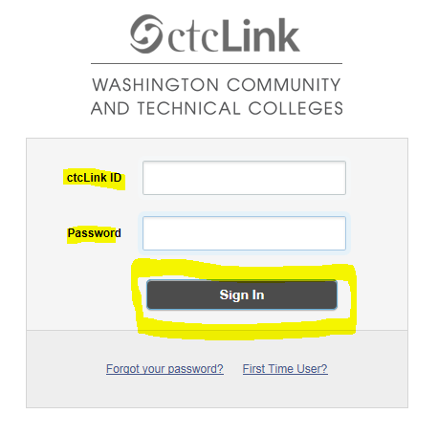

ctcLINK GATEWAY HOME PAGE
Click FSCM – Financial Supply Chain Management
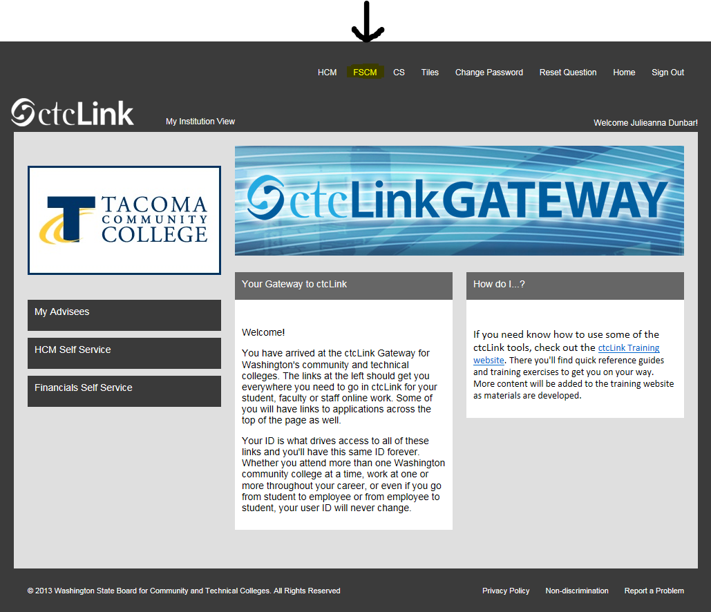

MAIN MENU PAGE
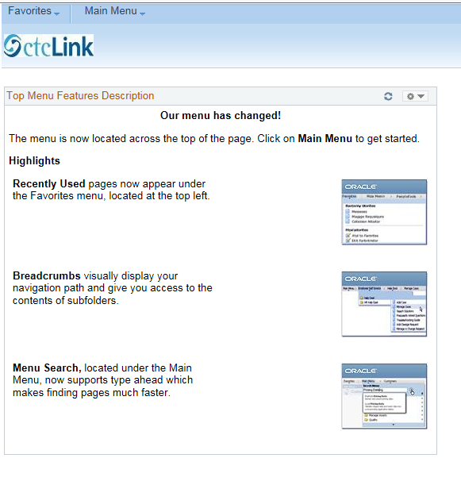
HOW TO NAVIGATE TO BUDGETS OVERVIEW

Navigate to Budgets Overview: Main menu > Commitment Control > Review Budget Activities > Budgets Overview. Commitment Control is synonymous with “Budget” in PeopleSoft. (Note: menu options will vary based on employee role. Not every employee will have the menu choices shown below.)

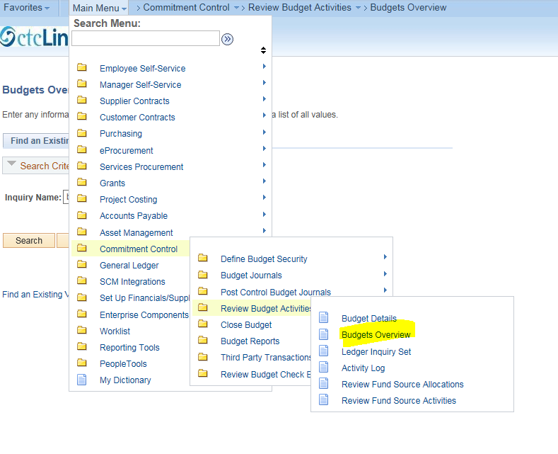

CREATING YOUR BUDGET OVERVIEW INQUIRY
To access budget overview data, you need to set up (add) an Inquiry.
Click “Add a New Value”
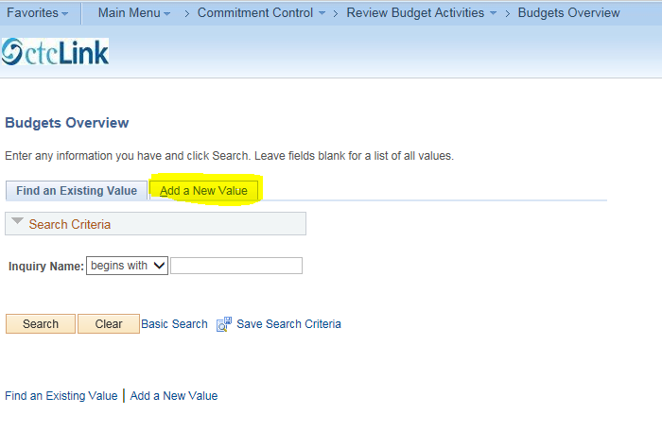
Create an Inquiry Name. Can be alpha, numeric or both, with a 10 character maximum, no blank spaces (underline is ok). For example the inquiry could begin with your initials, then followed by text that will help you remember the type of inquiry it is. The inquiry name will be saved. Next time, the budget overview screen should default to “Find an Existing Value.” Click Search, then you will be taken directly to your most recent inquiry as indicated on the Budget Overview screen.
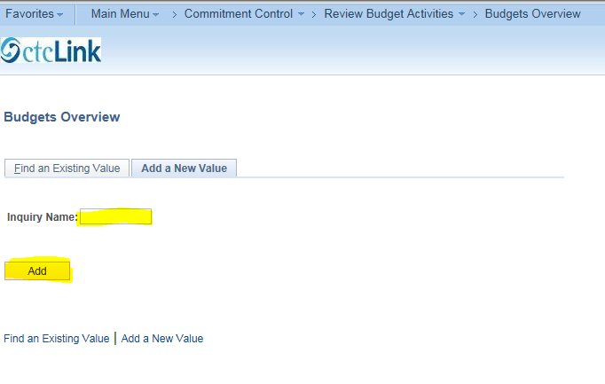

Click “Add” to create your inquiry.

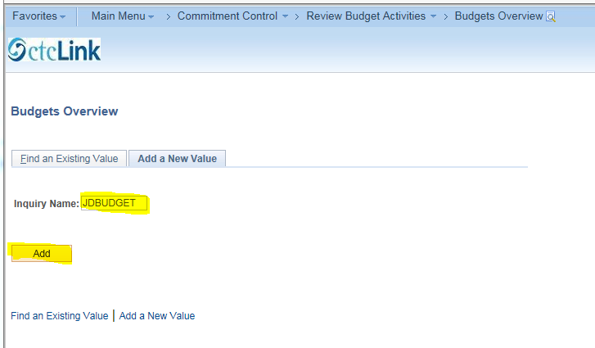
Next we will go to the Budget Overview screen.

BUDGET OVERVIEW
On the Budget Overview screen (shown below), verify your inquiry name, add an optional description (40 character max). Verify the Business Unit (default for TCC is: WA220), and Ledger Group/Set, (default: Ledger Group), then select a Ledger Group.
SELECTING LEDGER GROUPS
There are several ledger groups in PeopleSoft. The three ledger groups that will be explained in this set of instructions include: CC_ORG (non-capital project, non-grant award), DETAIL_KK (grant award) and PROJECT_KK (capital projects). Note that “CC” and “KK” are references to the Commitment Control (budget) in PeopleSoft.
CC_ORG LEDGER GROUP
First, we will navigate through Ledger Group, “CC_ORG” (Commitment Control Organization Budgets). Click the Ledger Group search icon (under the black arrow) and select “CC_ORG”.
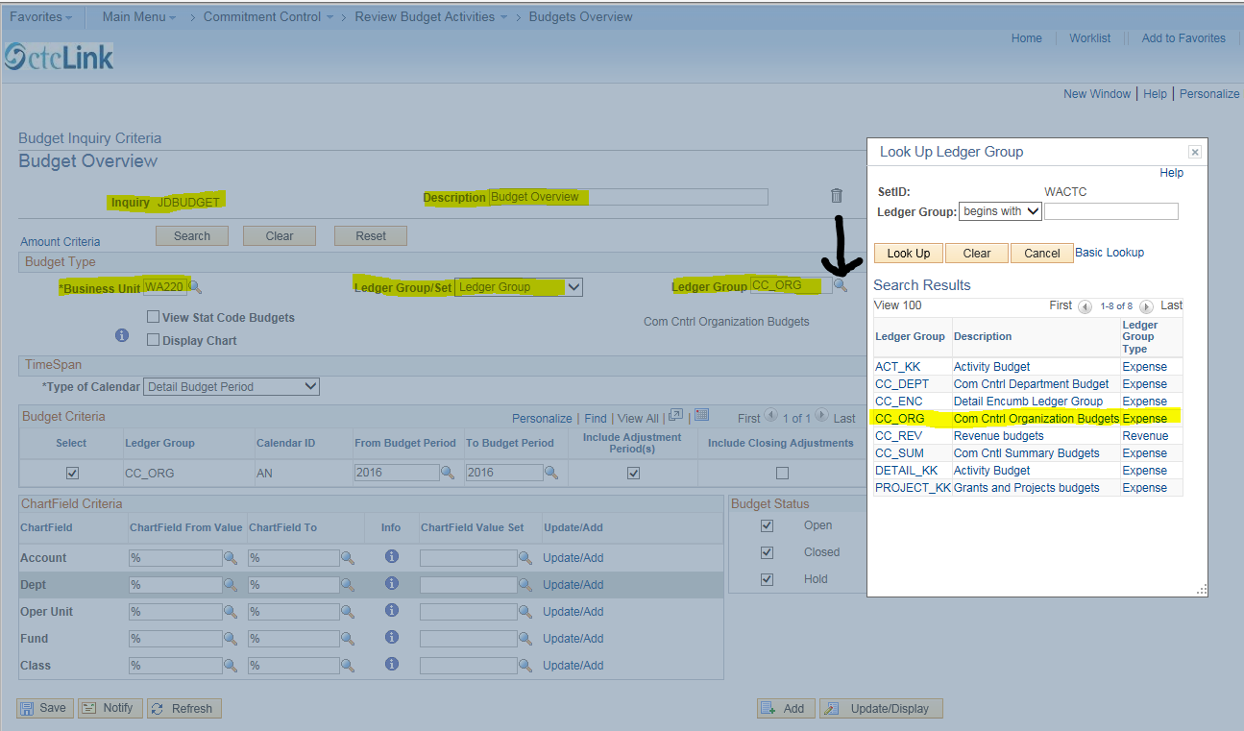
Specify your budget criteria. Enter the desired budget period. For the budget period July 1, 2015 to June 30, 2016 (which is the 2016 fiscal year), enter 2016 in the “From Budget Period” and in the “To Budget Period.” Click “Save.”

To select the department(s) you are inquiring about, go the Chartfield Criteria section and enter the first couple digits of the department number in the fields by “Dept.” Click the search icon to bring up a list of departments, and select the department or the range of departments that you need information for. Note that this feature can be used for the other chart fields as well (Account, Fund, Class, etc.). The “%” sign is used as a wild character to use if you do not know all the characters in a chartfield.

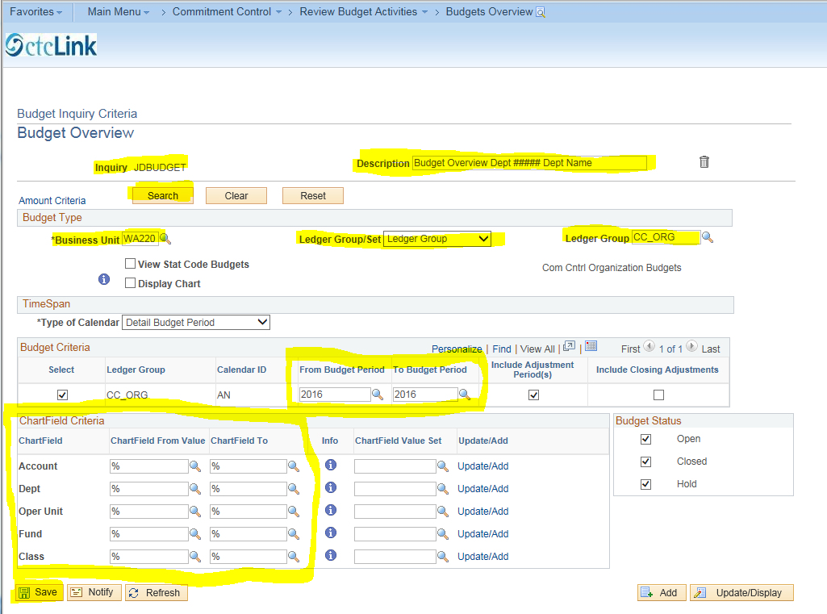

Here is an example of the drop down list for department numbers that begin with 47
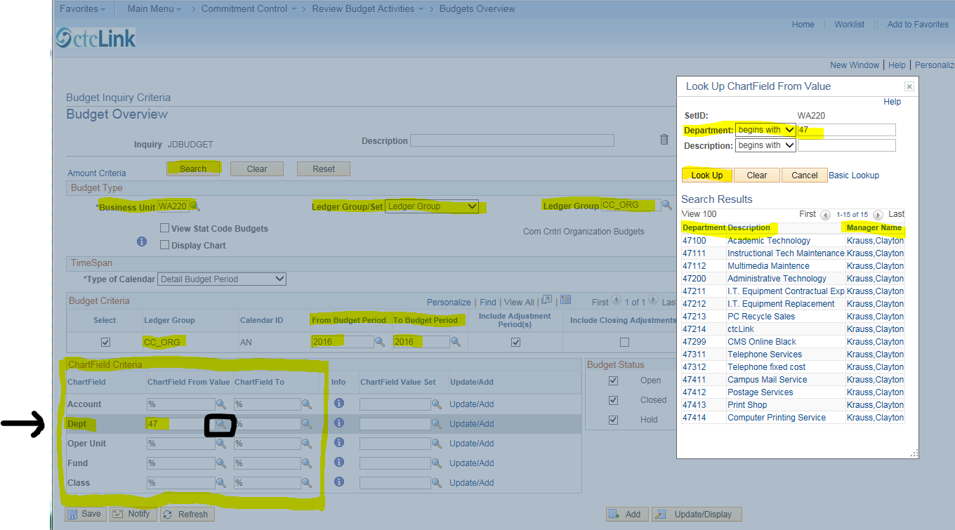
Once your search criteria has been entered, click “Search”
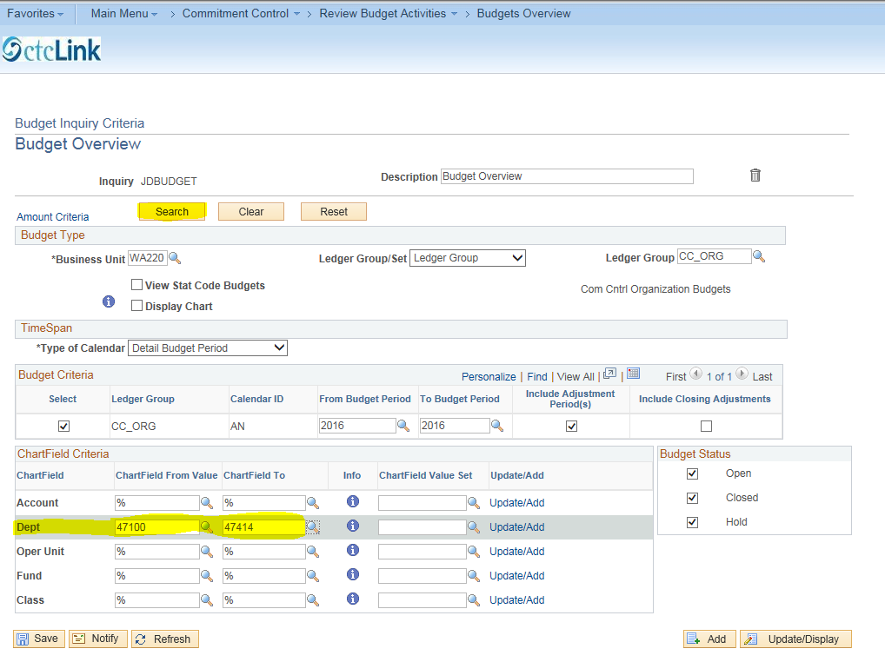

If the inquiry results in more than 100 rows of data, the following Message box appears. Click “ok”.
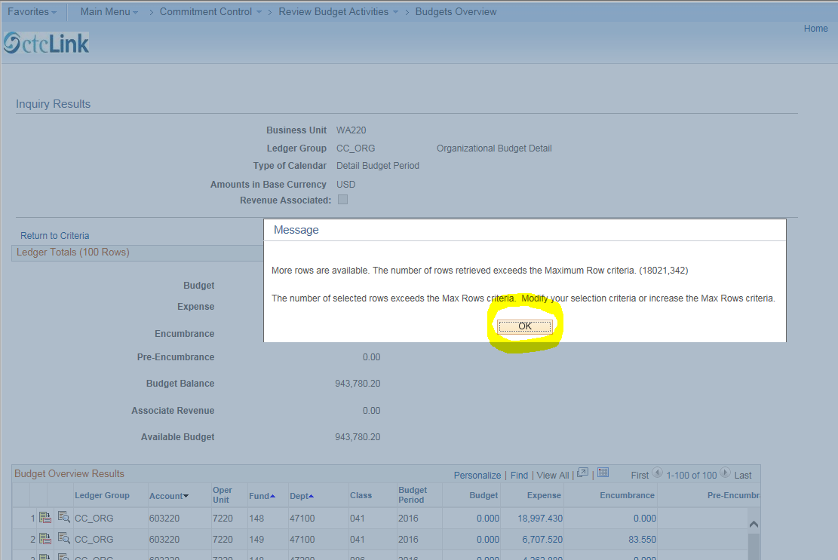

Take note of the information provided in the Ledger Totals section – Budget, Expense, Encumbrance, Pre-Encumbrance, Budget Balance, Associated Revenue and Available Budget. (Note that Pre-Encumbrances do not affect the Available Budget amount as they are not a legal obligation of funds, but are amounts that are expected to be expended. A requisition that has been entered into PeopleSoft is an example of a pre-encumbrance.)
The Ledger Totals data is specific to the search criteria you entered. For example, in the Chartfield Criteria section (referred to in an earlier screenshot), if you entered the same department number in both the Chartfield From and To fields, then the Ledger Totals will provide data only for that department. The same applies for the other specified chartfields such as Account.
Next, enter 99999 for the max rows, then click “Search”. The screen shows the first 100 rows of data and indicates how many total rows result from your search. Before we drill down further into the data, we will learn how to download the data to Excel.
First, click the download icon in the Budget Overview Results section. (See icon under the black arrow).

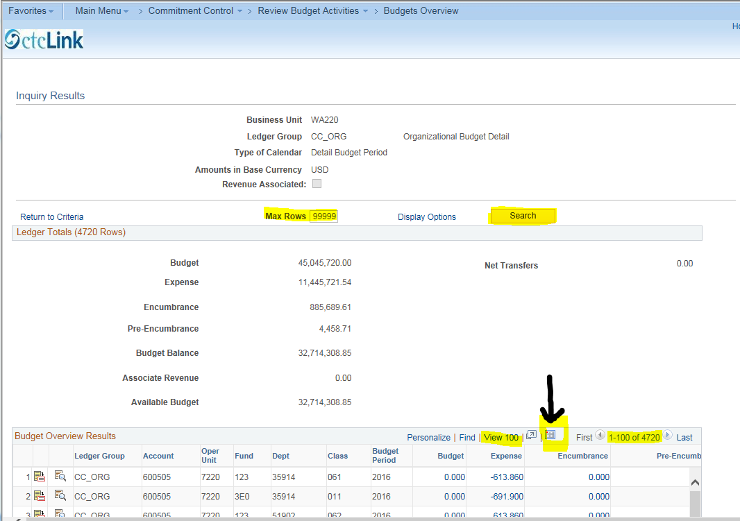

CREATE AN EXCEL SPREADSHEET
After clicking the download icon, click “Save.” This is the quick way to download the data. You can then save the download if you wish.
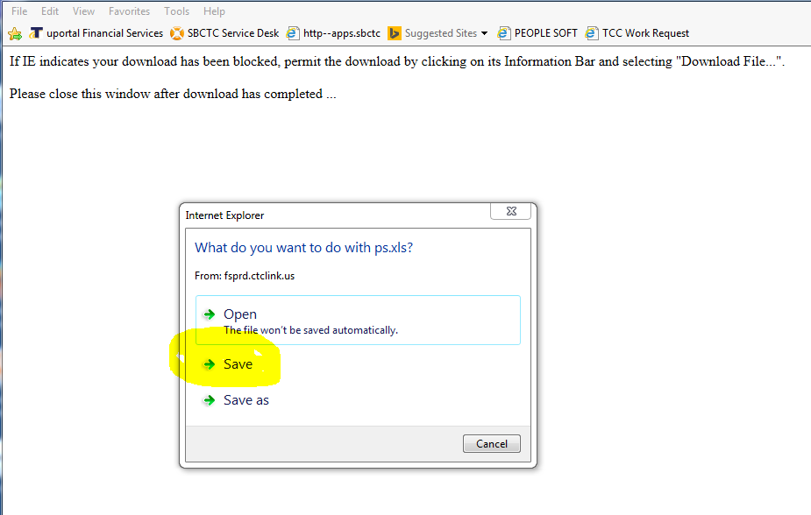

Click Open

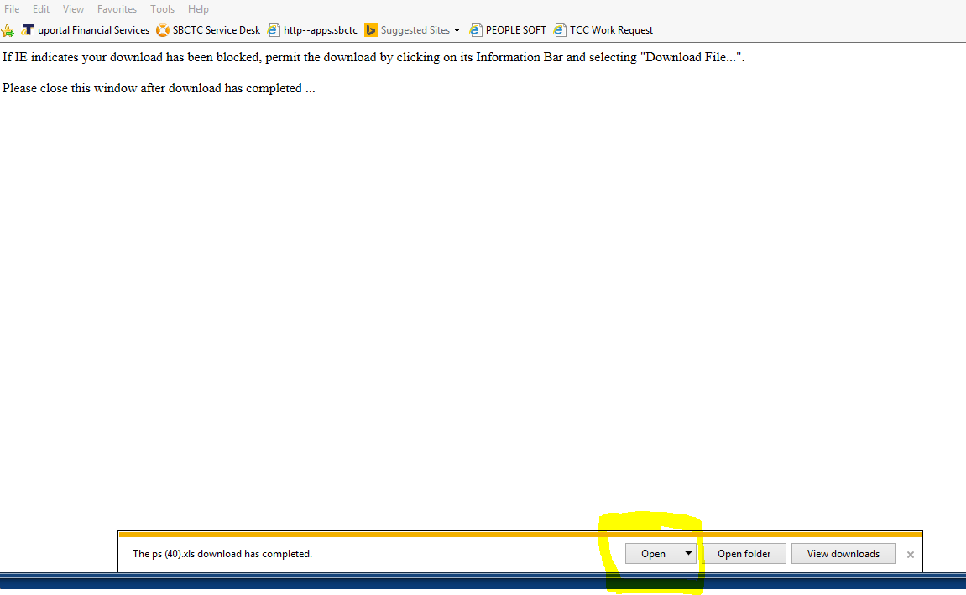

Click Yes
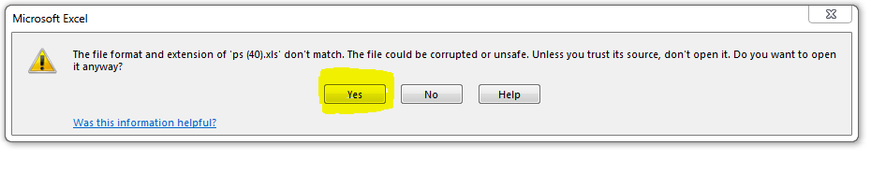
THE EXCEL DOWNLOAD
Here is what the download looks like. This is a condensed view of the total download. The number of rows downloaded to Excel will depend on your search criteria. There may be no rows of data, or there may be thousands of rows of data.
Once downloaded to Excel, the structure of the data can be reformatted to suit your needs. Columns and rows can be added/deleted, data can be sorted, filtered, etc. Note that at this time: 1. Expense data is not complete. Not all data has been brought into the PeopleSoft general ledger, and 2. The available budget amount (column N), equals Budget less Expense less Encumbrance. Pre-encumbrances if any, DO NOT affect the available budget amount.
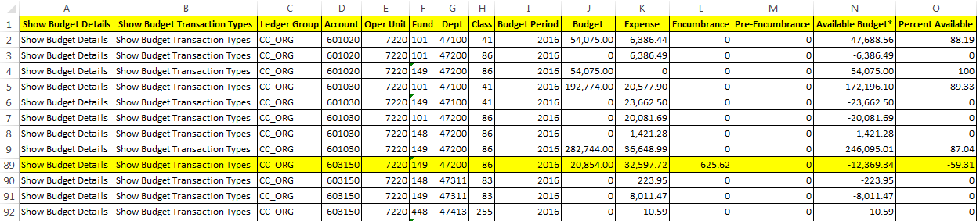
As you can see there are several columns of data in the download. Columns D, F, G, & H are part of what is called the “Chartfield”. The chartfield is a string of fields that define where data is stored in PeopleSoft. There are several fields in the chartfield such as Account, Fund, Dept. and Class. Noted below are brief explanations of some of the fields in the chartfield, and where you can find the descriptions:
Column D – Account: These are six digit, general ledger “account” numbers. Expense account numbers begin with the number 6. In the old system, expense account numbers were alpha “sub-objects”, sometimes with numeric “sub-sub objects”, for example, EA-10 was Supplies & Materials-Office Supplies General. Sub-objects and sub-sub objects are no longer being used, however, sub-objects can be used as a cross reference to the new PeopleSoft expense account numbers.
To find the title of the new PeopleSoft six digit account numbers, go to the tab titled “Account # list” in your budget manager packet. For example, the highlighted account above, 603150 is “Purchased & Contractual Services.”
Column F – Fund: These are three digit, general ledger “fund/appropriation” numbers.
Column G – Dept: These are five digit, general ledger “department” numbers, all numeric. In the old system, department numbers were “Org” numbers, and were numeric or a combination of alpha/numeric. Org numbers are no longer being used except as a cross reference.
To find the description of the new PeopleSoft department numbers and how they correspond to the old Org numbers, go to the tab titled “Dept # list” in your budget manager packet.
Column H – Class: These are three digit, general ledger “class” numbers, all numeric. In the old system,” class” numbers were “Pro” numbers. If the class number is preceded by a zero, and when the data is downloaded from PeopleSoft to Excel, PeopleSoft drops the preceding zero, which is why you see two digit class numbers above. When coding documents (requisitions, etc.), class numbers must be three digits, remember to include the preceding zero.

DRILL DOWN TO DETAIL
The following instructions explain how to drill down (access lower levels of detail in a database) within PeopleSoft.
On the “Inquiry Results” screen, and in the Budget Overview Results section (see screenshot below), there are two drill down choices each with their own icon: 1. Show Budget Details (icon is highlighted in yellow), and 2. Show Budget Transaction Types (icon in the black box). First, we will discuss the drill down choice, “Show Budget Transaction Types” (icon in the black box).
SHOW BUDGET TRANSACTION TYPES
By clicking on the icon in the black box below, “Show Budget Transaction Types”, you can view budget related transactions that have posted for this account (chartfield). The $20,854 budget below was posted as a Transfer Adjustment (see next screenshot) – the budget amount was transferred from another account (chartfield). Generally, however, most budget transaction types will be “Original”. The Budget Transaction Types inquiry can done in any ledger group (e.g., CC_ORG, DETAIL_KK, PROJECT_KK).
Here is the “Inquiry Results” screen. Click the “Show Budget TransactionTypes” icon.
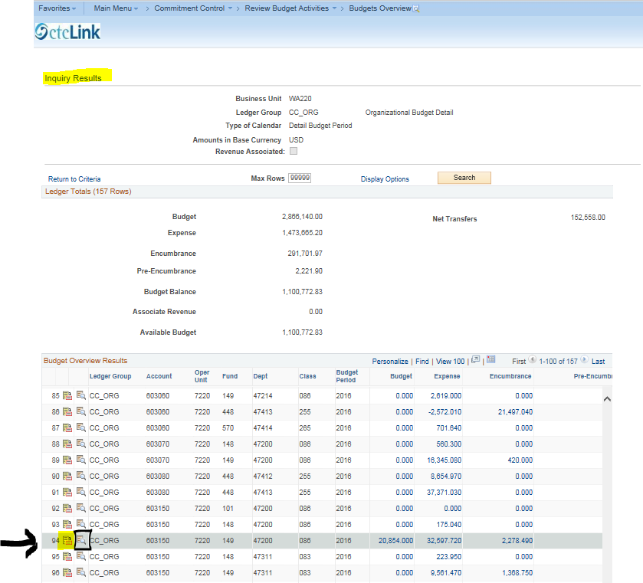

Here is the “Budget Transaction Types” screen showing the $20,854.00 budget amount as a transfer adj. To go to the next section, close the Budget Transaction Types screen by clicking “Return” or the “X”.
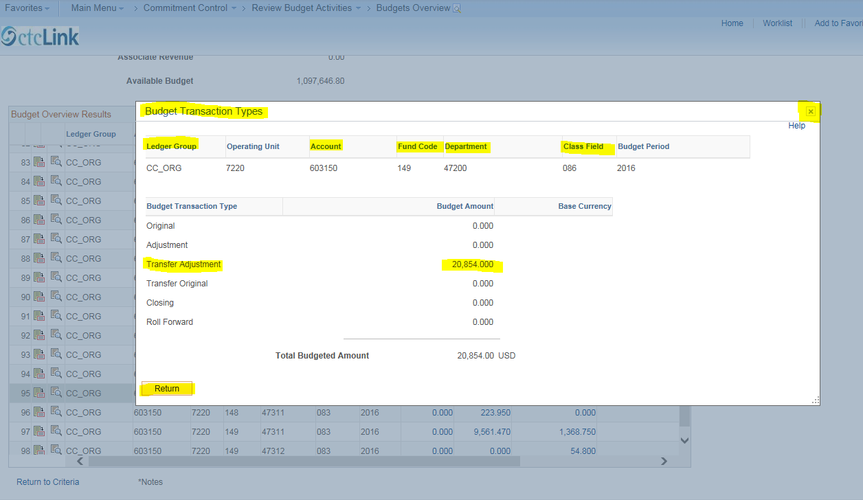

SHOW BUDGET DETAILS
Next, click the “Show Budget Details” icon (highlighted in yellow).
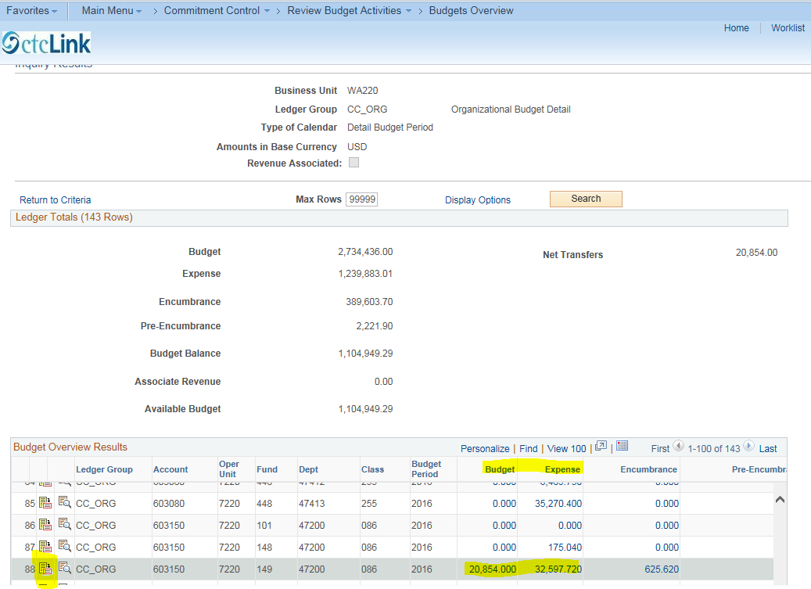

Here is the “Budget Details” screen. Click the “Drill to Ledger” icon for the $32,597.72 expense amount.
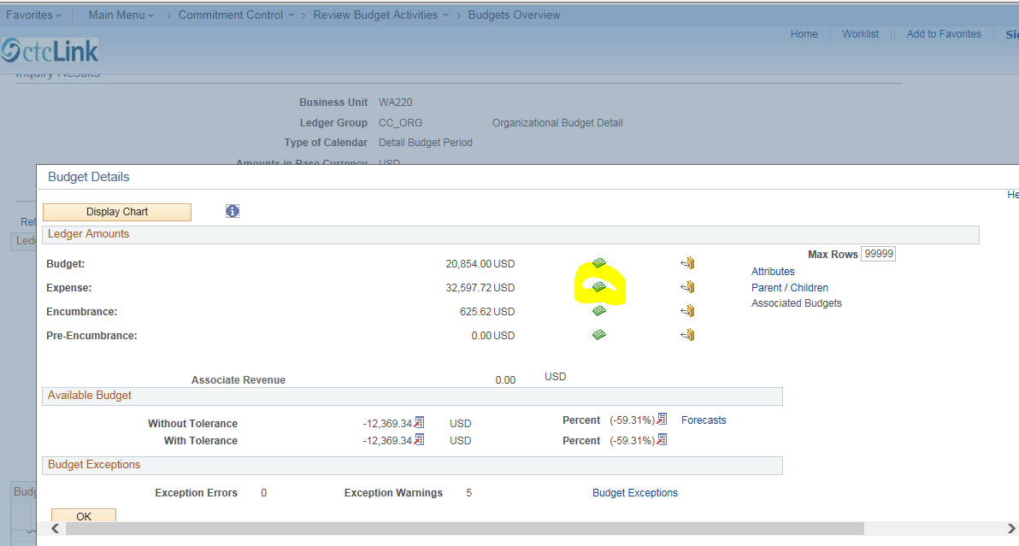

Click the “Show All Columns” icon to expand the view to include dollar amounts associated with each line. (See next screenshot.)

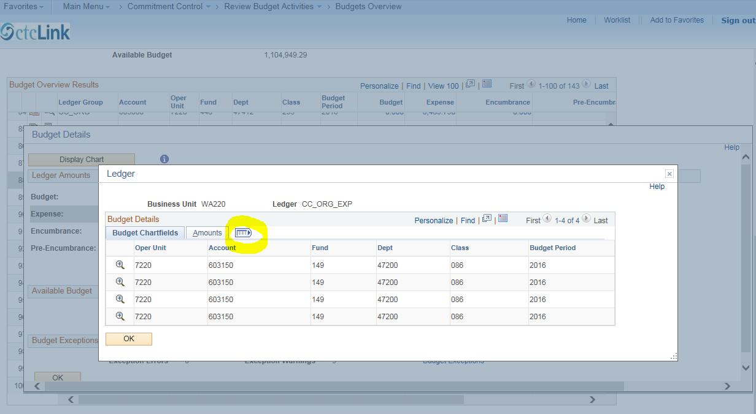

Here are the dollar amounts that comprise the $32,597.72 total expense amount. In this example, we will drill to the details surrounding the $22,209.51 charge.
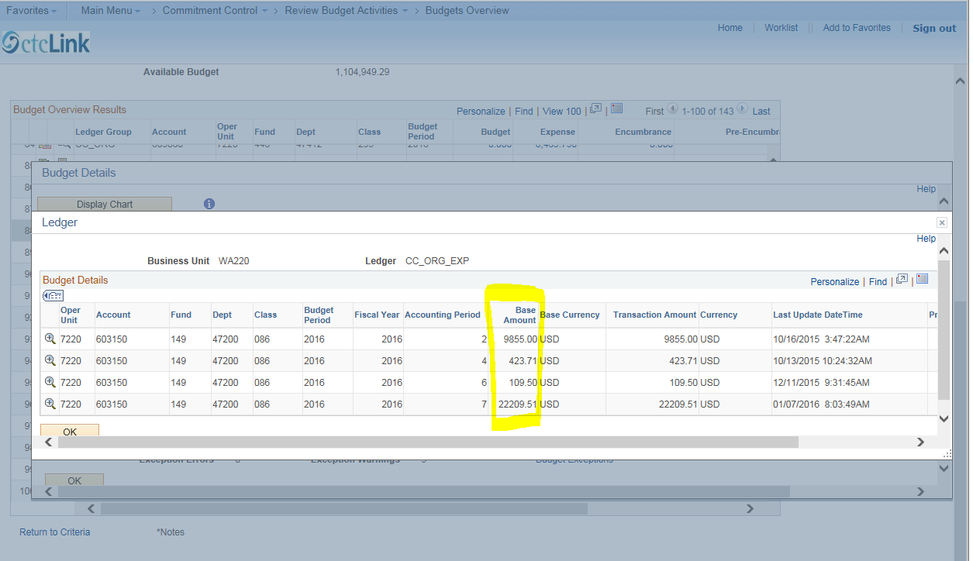

Click the “Drill Down” icon to go to the Activity Log to view details about the $22,209.51 charge. Note that the $22,209.51 charge as shown here, includes both the invoice amount and the use tax.
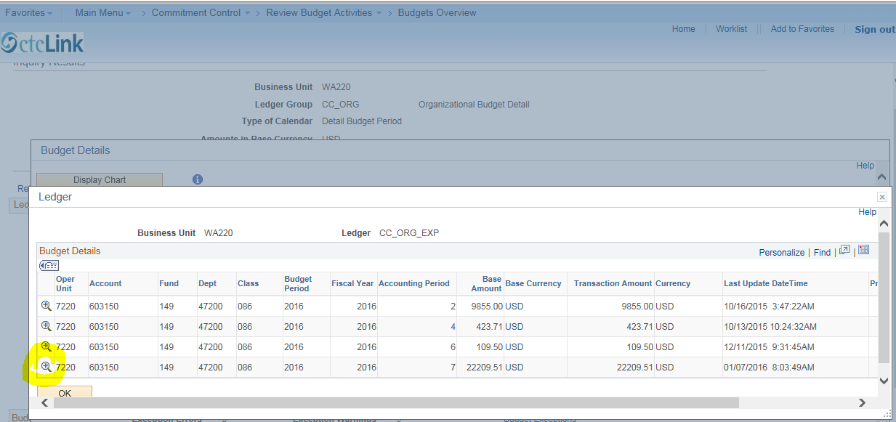

Next, click the drill down icon to go to the “Payables Voucher Line Drill Down” screen.
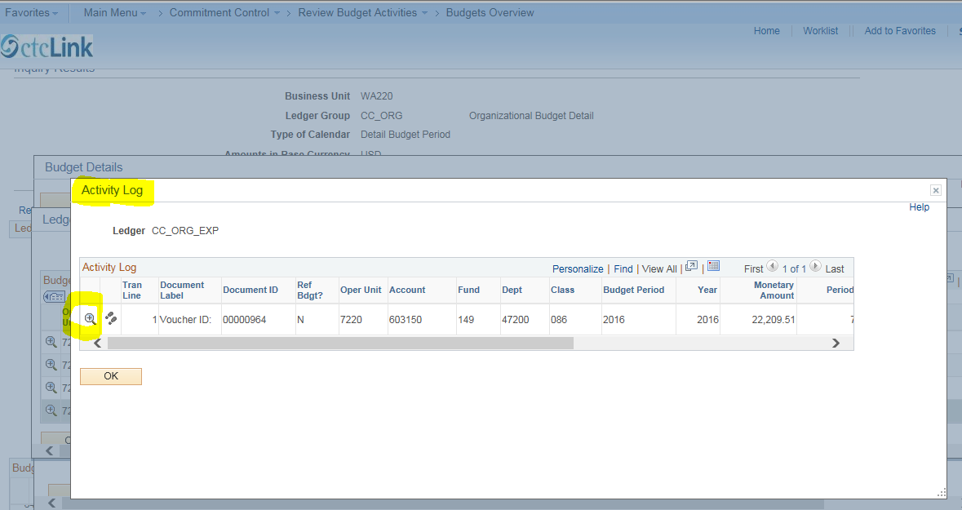

Here is the “Payables Voucher Line Drill Down” screen. Click on the “Voucher ID” icon for further information.
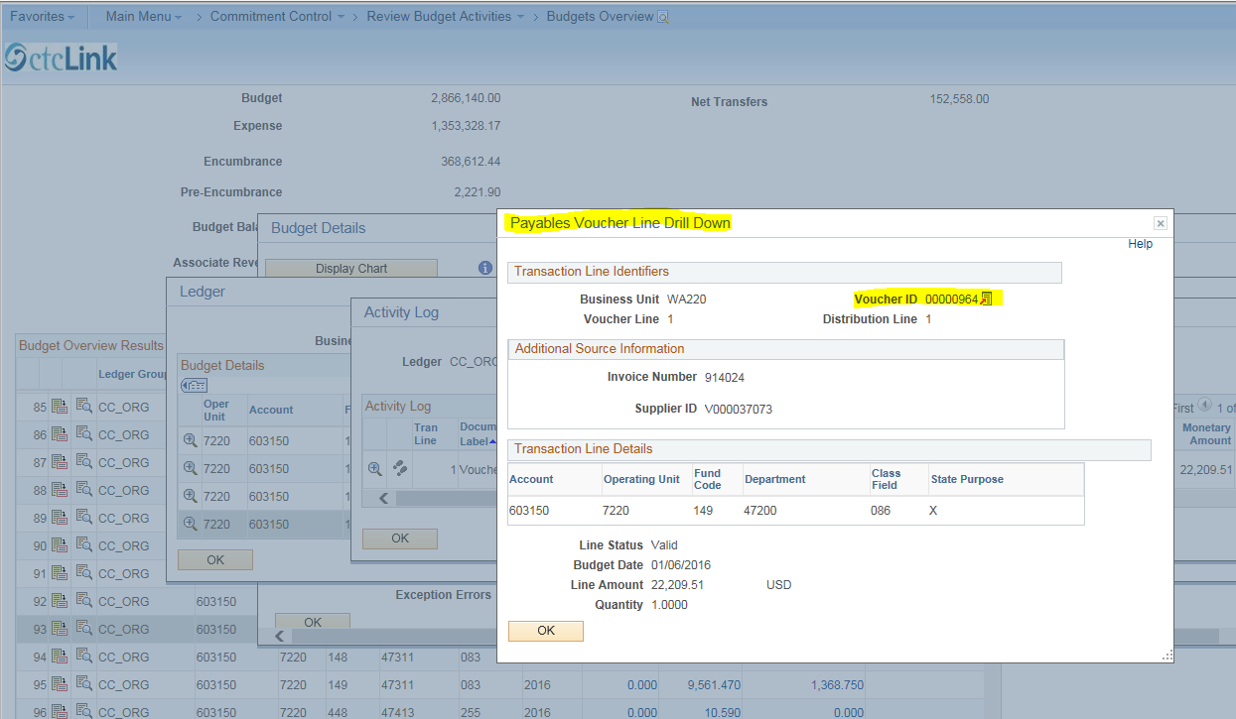

SOURCE INQUIRY
Click “Source Inquiry” to go to the Voucher Inquiry screen.
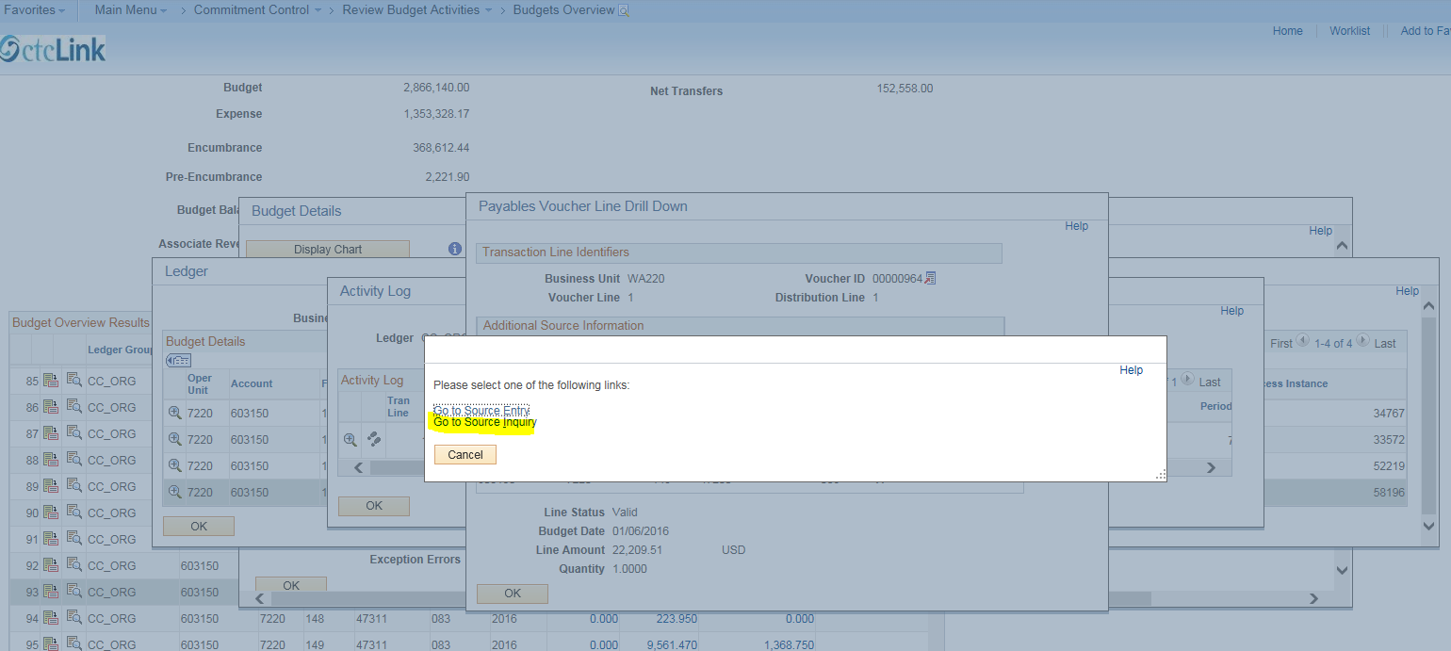

ACTIONS
VIEW ATTACHMENTS
Here is the Voucher Inquiry screen. Click “Actions” to view a list of inquiry options.
Click “View Attachments”.
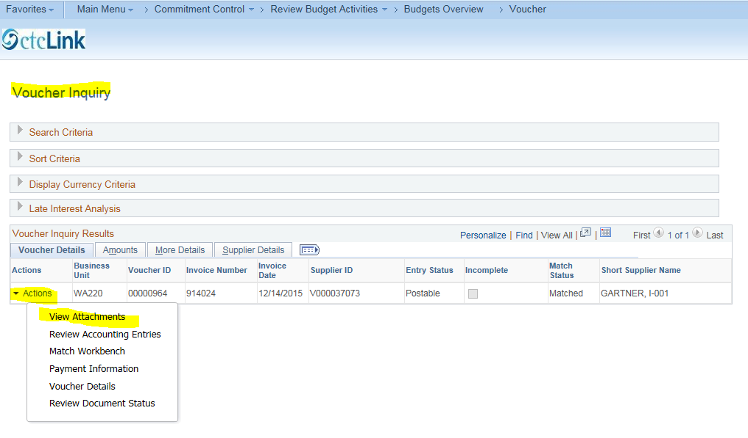

Here is the Voucher Attachments Screen. Click the PDF link to view the attachments.
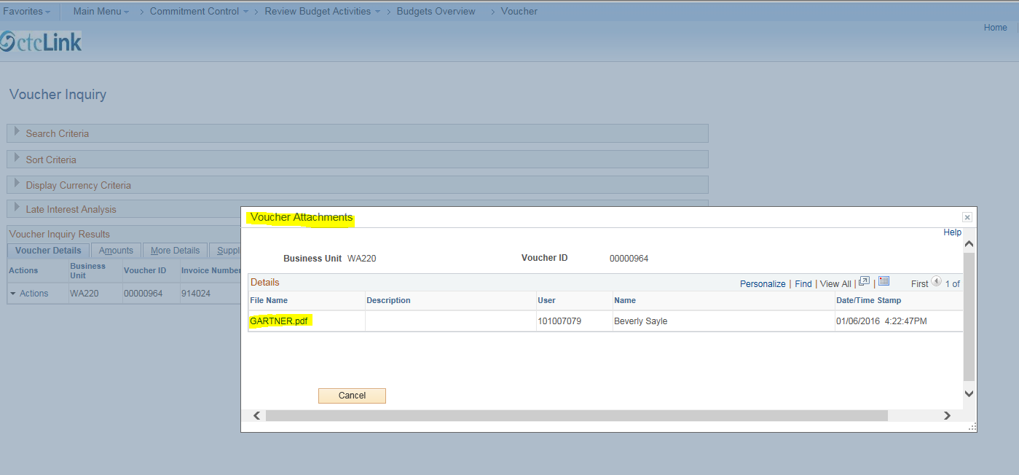

Here is the scanned invoice.
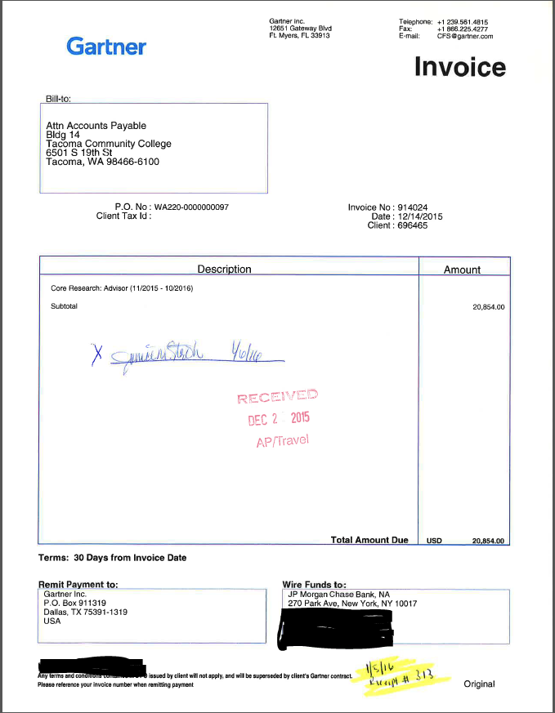

After viewing the attachment, return to the Voucher Inquiry screen by either clicking on the browser tab for “Voucher” or by closing the attachment viewing window.
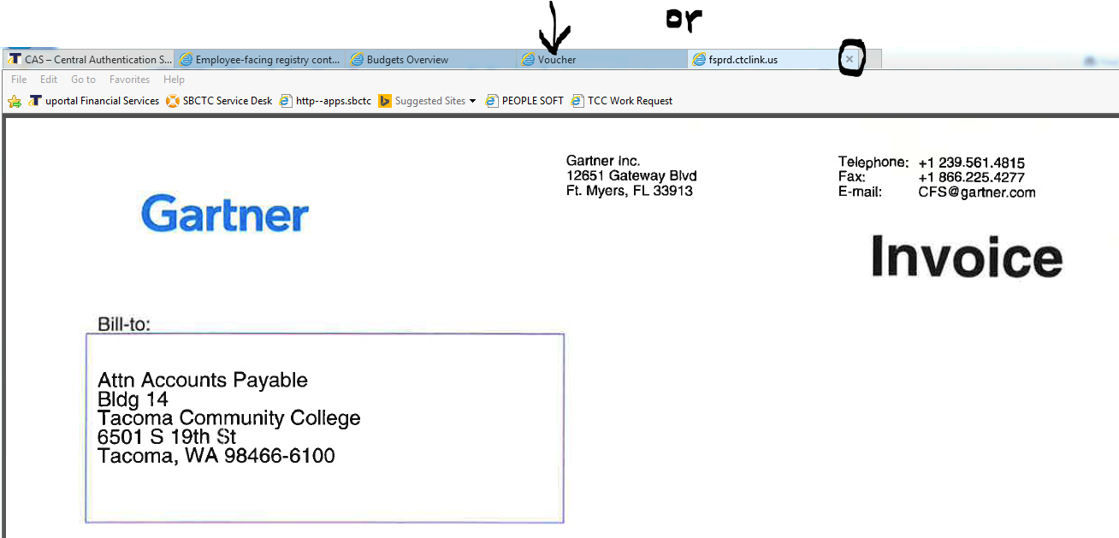
On the Voucher Attachments screen click “Cancel” or the “X” to return to the Voucher Inquiry screen.
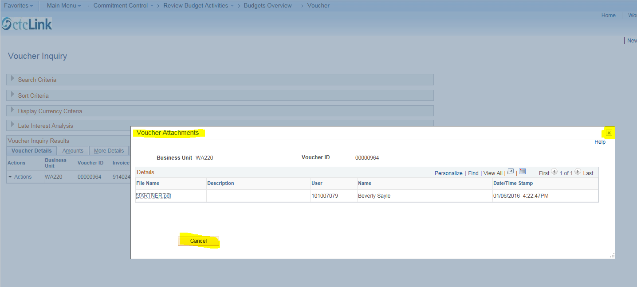

REVIEW ACCOUNTING ENTRIES
On the Voucher Inquiry screen click “Actions” then click “Review Accounting Entries”
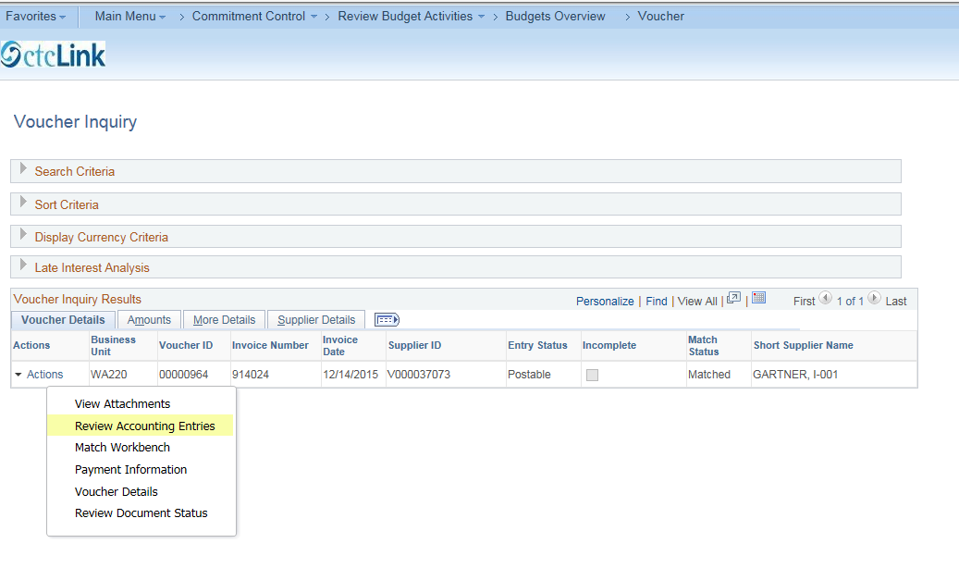
Here is the “Voucher Accounting Entries” screen.
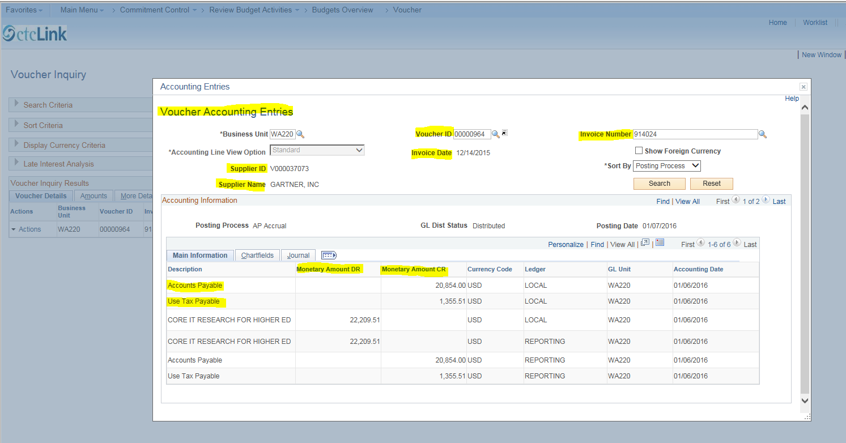

Click the “Show All Columns” icon to view related chartfield information (see next screenshot).
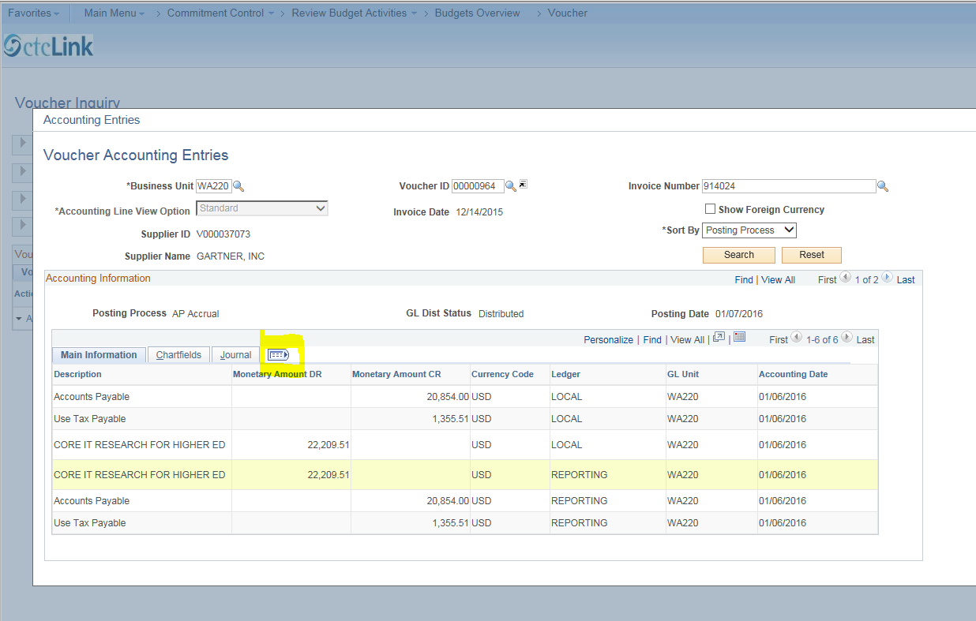

The screenshot below is the left half of the information. Access the remaining columns by moving the scroll bar at the bottom of the screen to the right.
(If you click on the column headings, you can sort the order of the data within the column. You can also click and drag on the column headings to personalize the order of the columns themselves.)
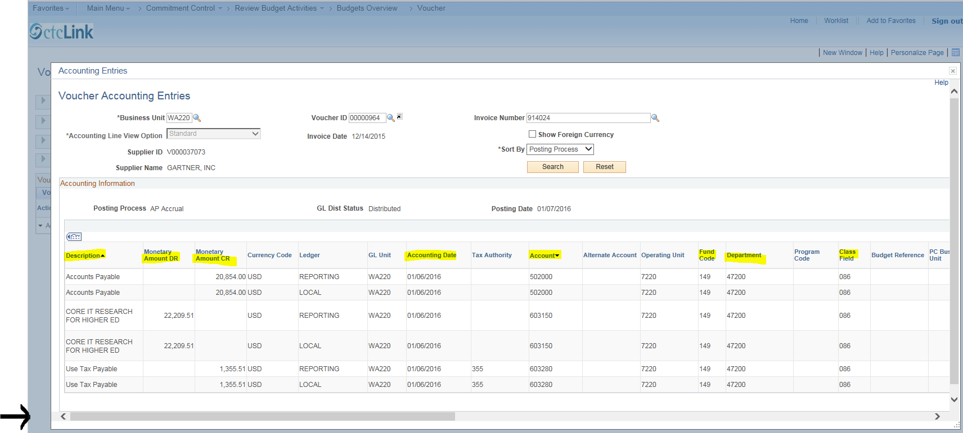
This is the far right view of the “Show All Columns” screen (note that there are additional columns in between the two screenshots provided here, that are not shown).
Next, click “Personalize.”
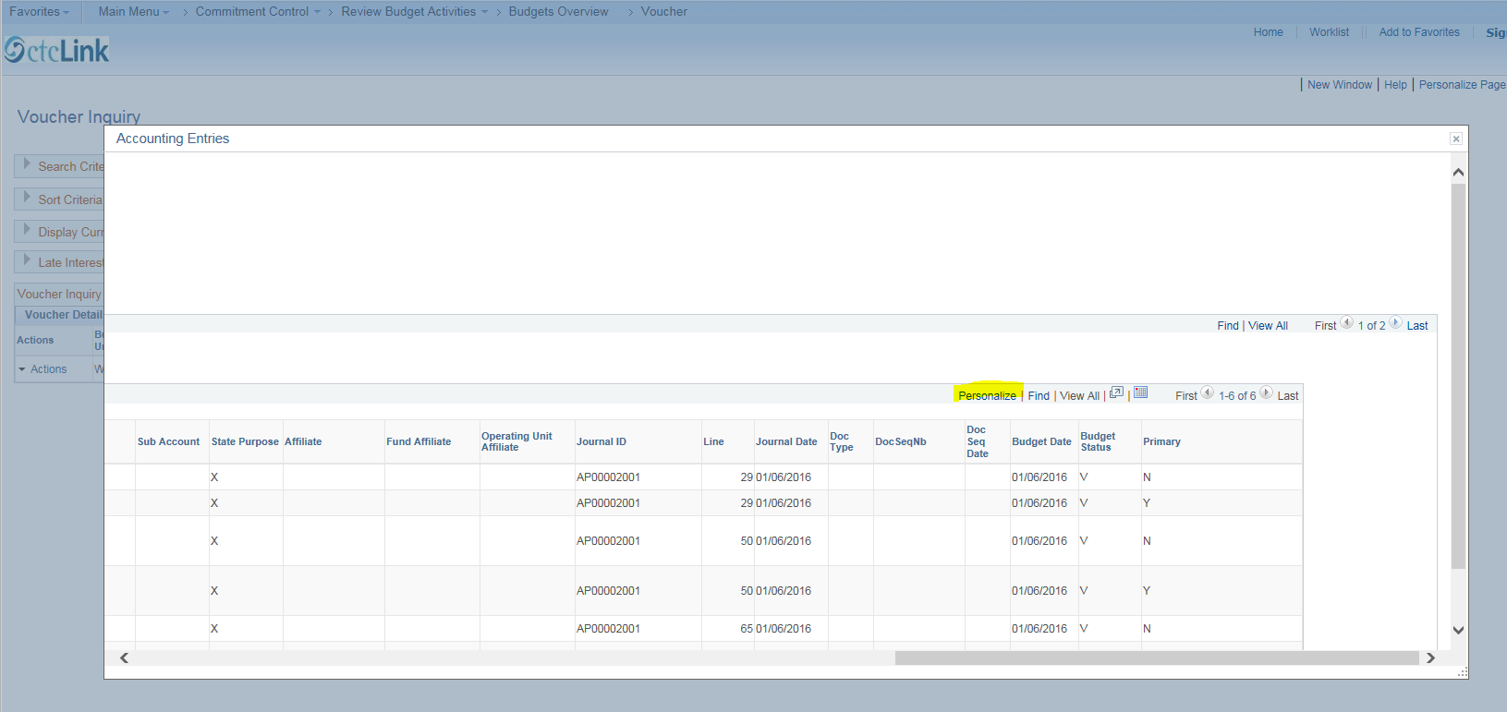
This option provides an opportunity for you to personalize and sort how you wish to view the data. Simply follow the instructions indicated on the screenshot below. Next, click “Cancel” to return to the “Voucher Accounting Entries” screen.
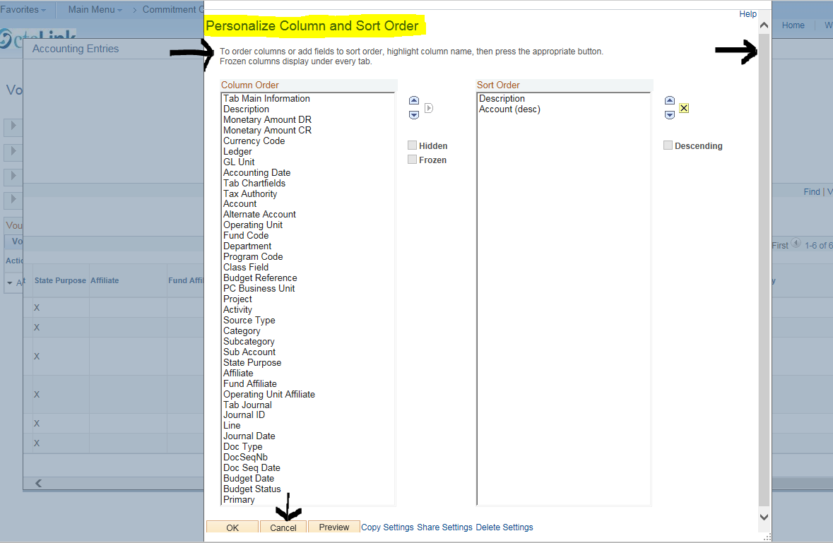

Next, click the “Go To Voucher Inquiry” icon under the black arrow. 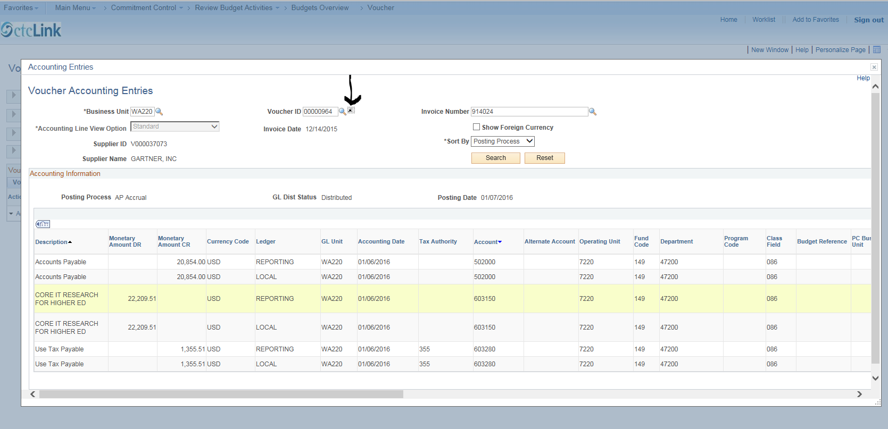
MATCH WORKBENCH
Match Workbench provides information on Match Rules and Overrides. These instructions will not go into detail about this Action.
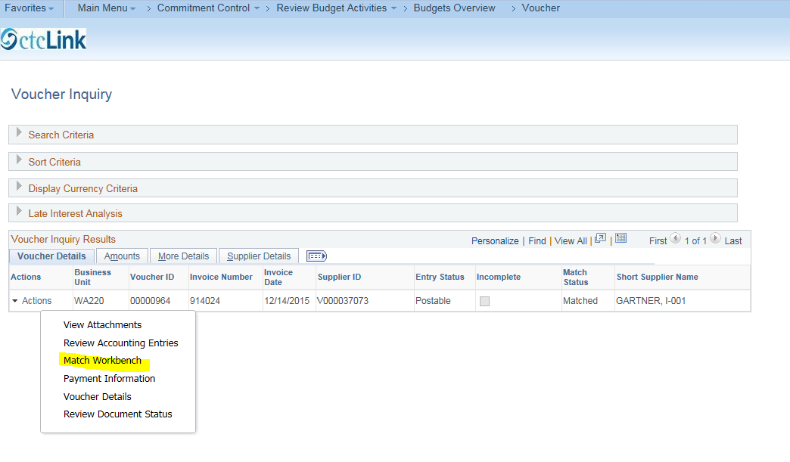

PAYMENT INFORMATION
On the “Voucher Inquiry” screen, click “Actions”, then click “Payment Information.”
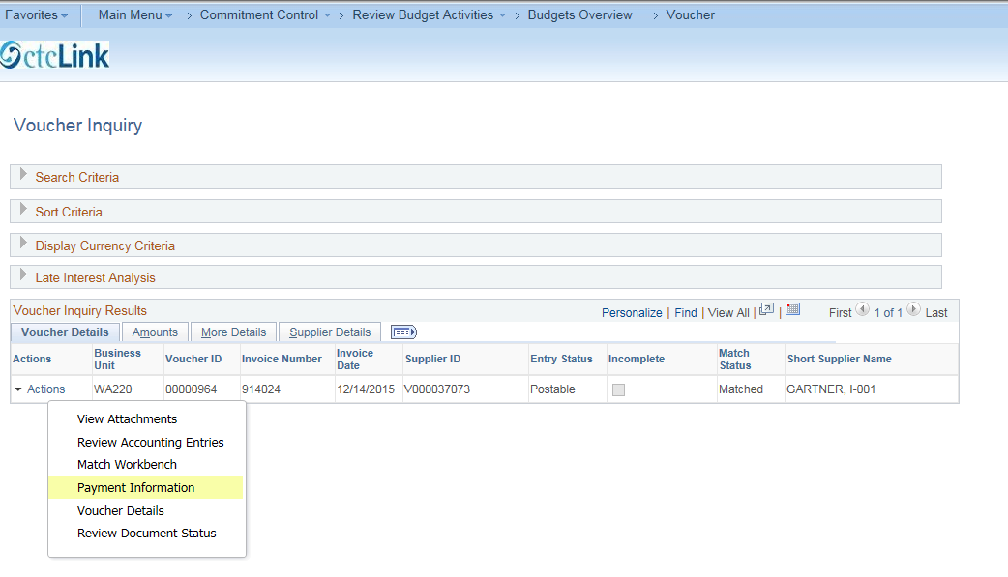

The Payment Information screen below shows the Supplier Name, Gross Invoice Amount, Invoice number, and other details – for example, the check number is shown in the “Payment Reference ID” column. Click on the check number to go to the “Payment Inquiry” screen.
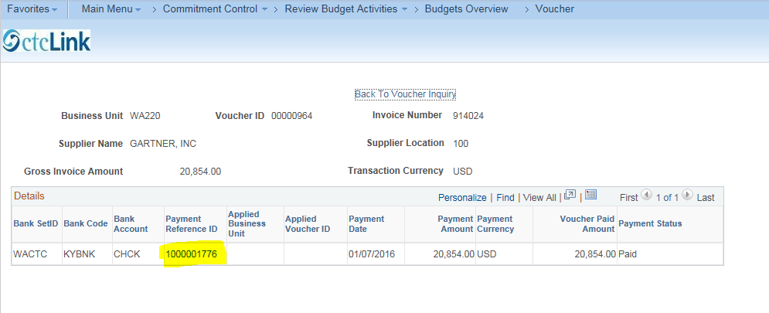

In the Payment Inquiry Results section at the bottom of this page is the Payment Reference ID (check number), Payment Date, Payment Status, and other information. Once you’re finished reviewing this information, click “Back to Voucher Payments” which returns you to the Payment Information screen.
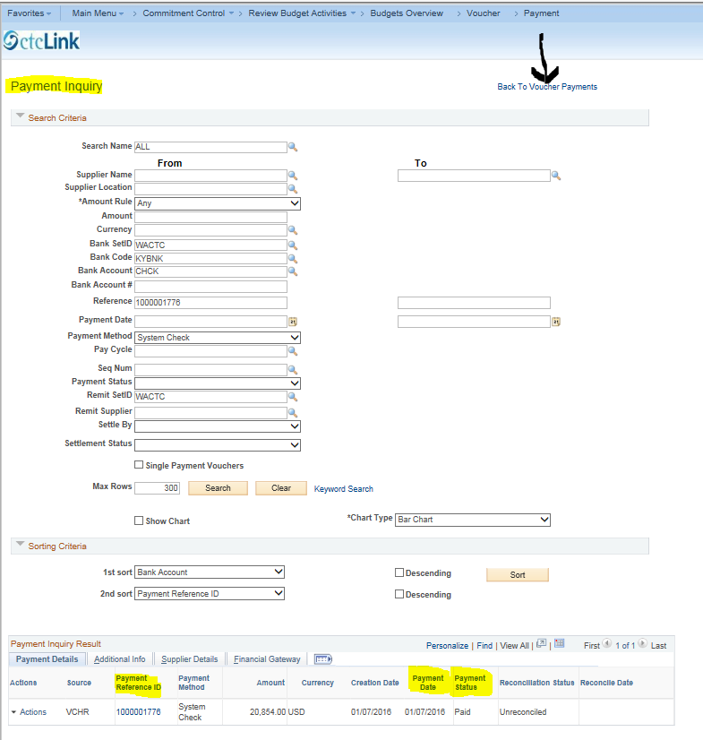

We have now returned to the Payment Information screen. Click “Back to Voucher Inquiry”.
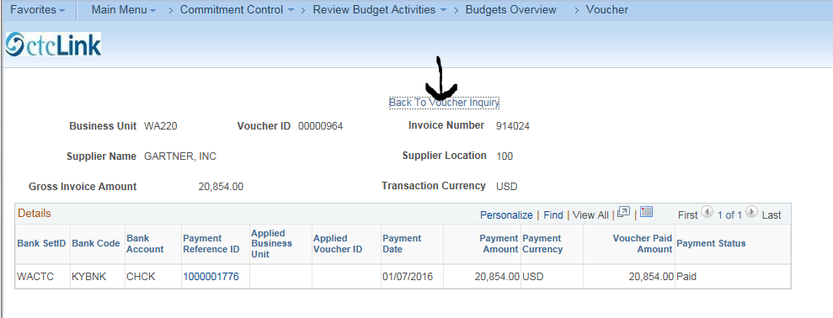
VOUCHER DETAILS
Click “Actions”, then “Voucher Details”.
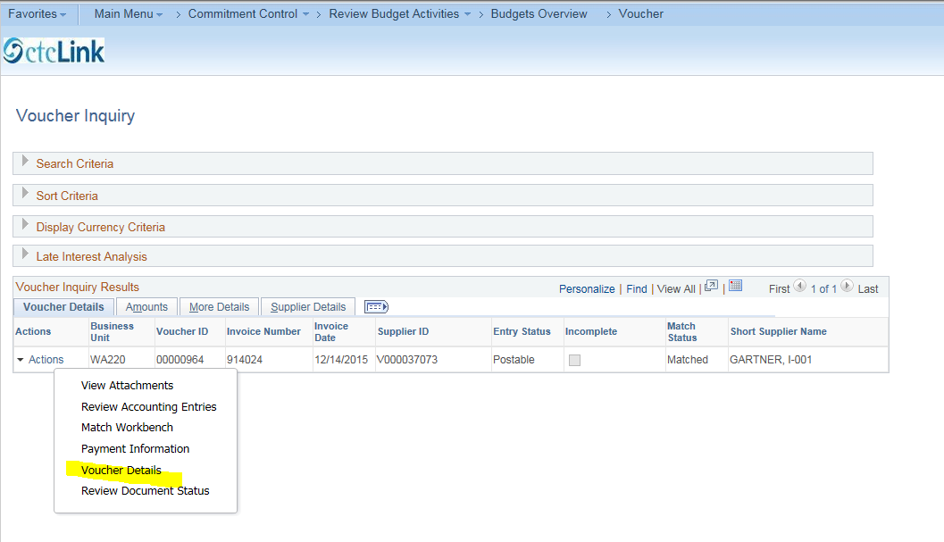

This is the “Voucher Line Details” screen. Note: the Gross Amount is the amount that was paid directly to the vendor. The Misc. Charges in this case represent sales tax paid directly to the State. When finished viewing, click “Cancel” on the lower left of screen, or the “X” in the upper right to return to the “Voucher Inquiry” screen.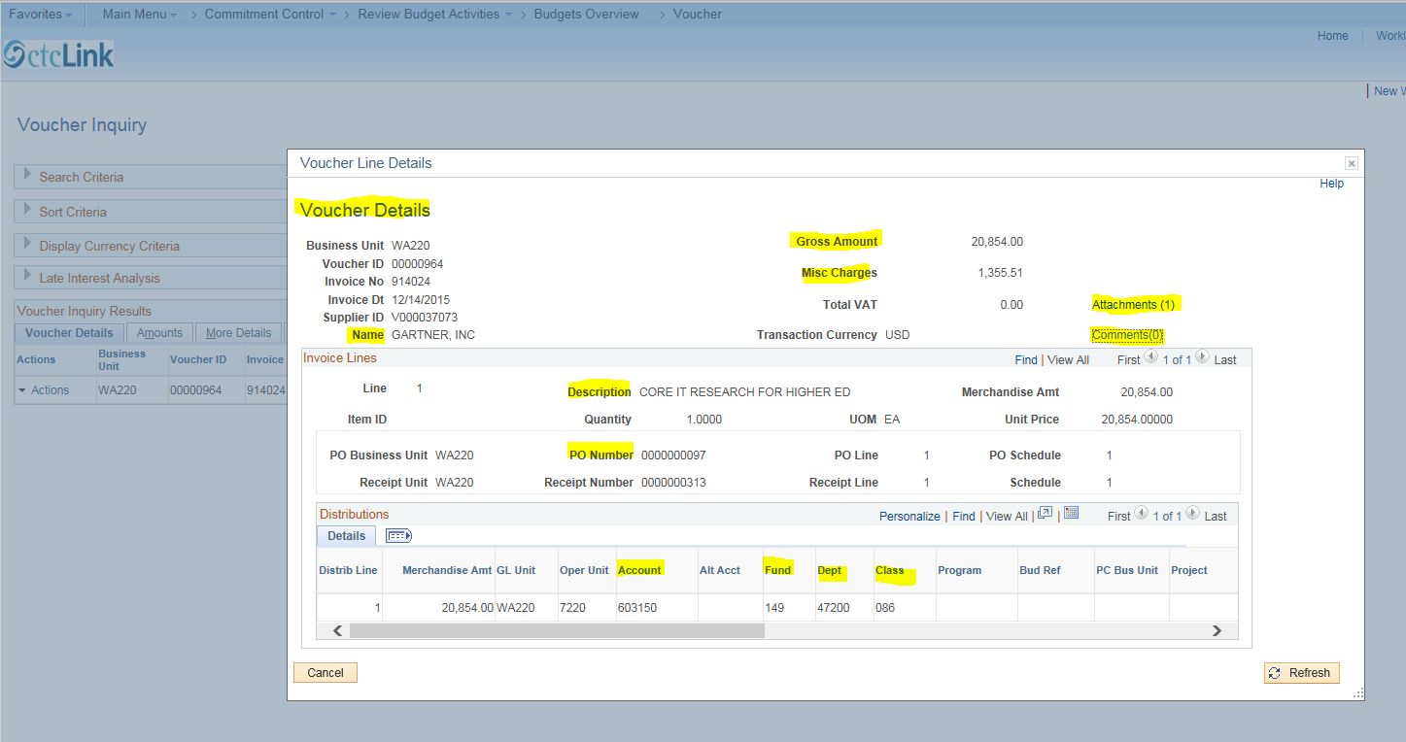

REVIEW DOCUMENT STATUS
On the “Voucher Inquiry” screen, click “Actions”, then “Review Document Status.” There is a small delay while PeopleSoft loads the information.
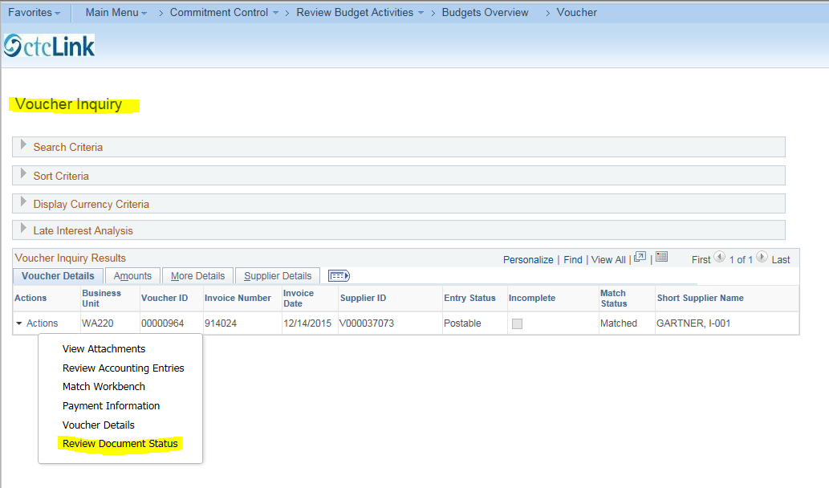
On the “Review Document Status” screen, the Voucher Document Status shows the history of the transactions for this voucher (Requisition, Purchase Order, Receipt and Payment). You can drill to detail for each Document Type by clicking the relevant DOC ID number. For this example click Requisition DOC ID 0000000101.
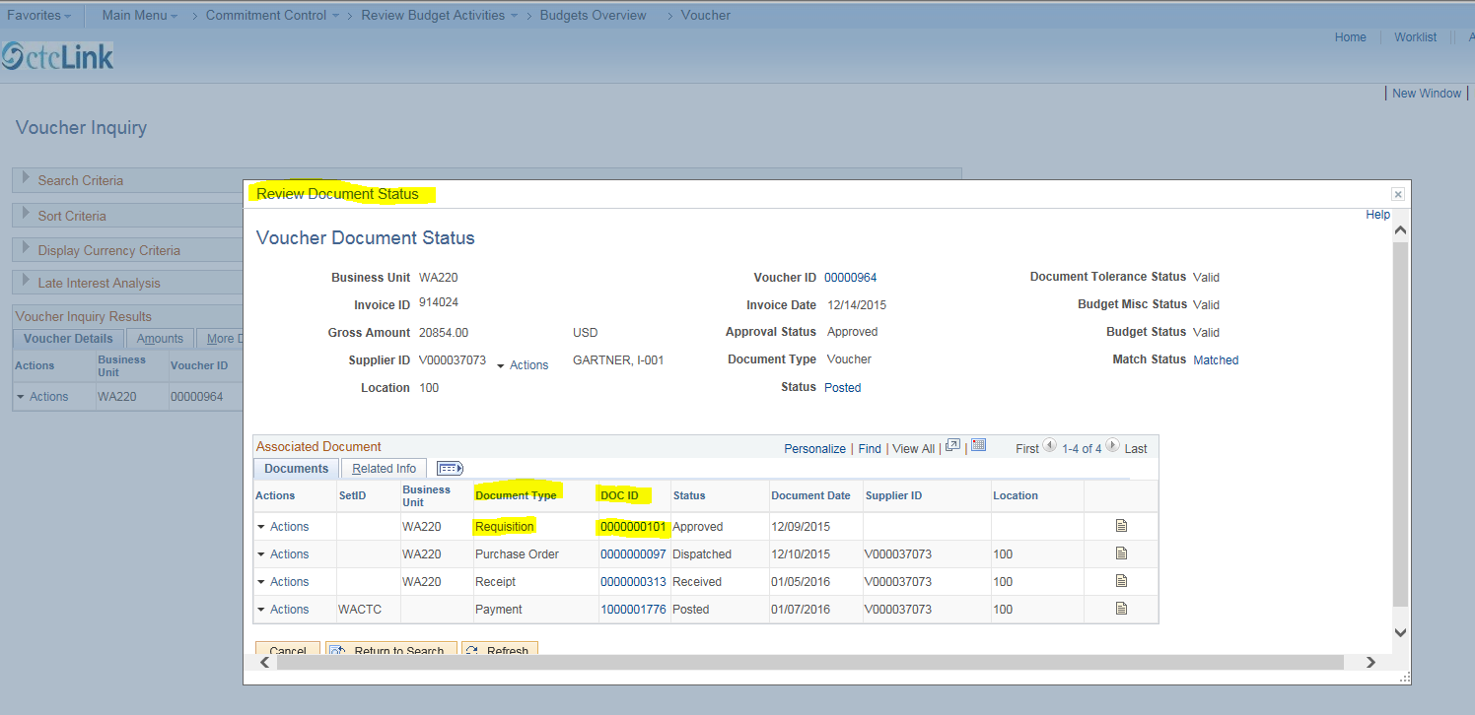

REQUISITION ID
Here is the “Requisitions” screen. Click on the Requisition #.
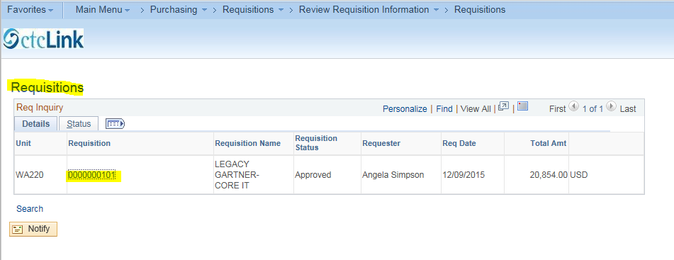
Here are the details to the requisition. To return to the Requisitions screen, click “Return”. 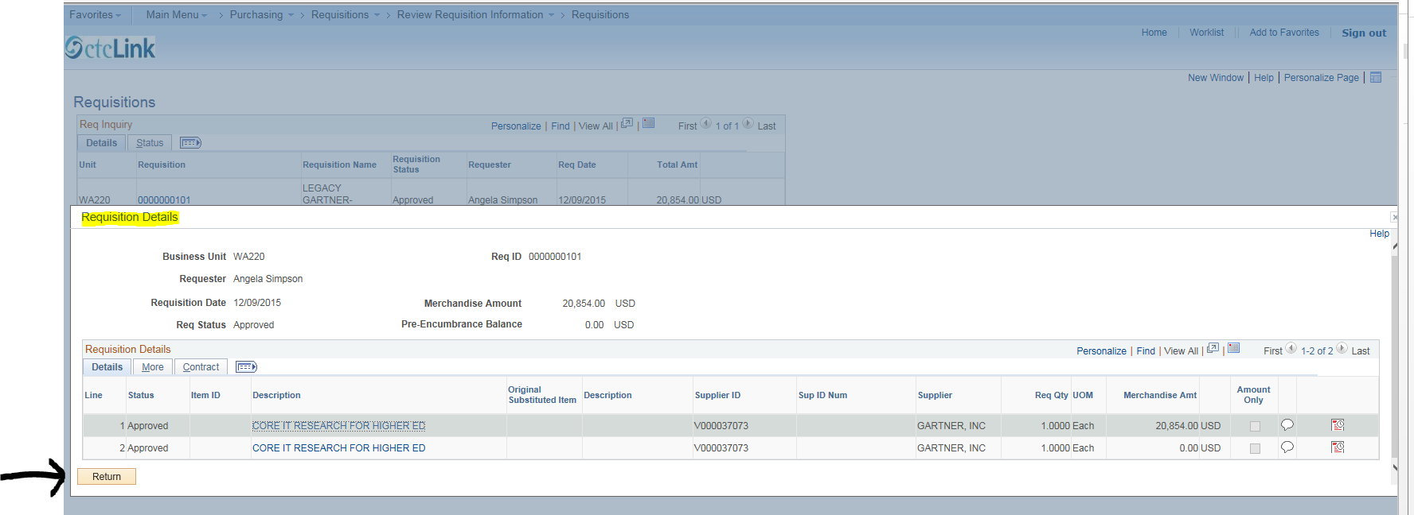

Next, click the browser tab for “Voucher” to return to the Voucher Document Status screen.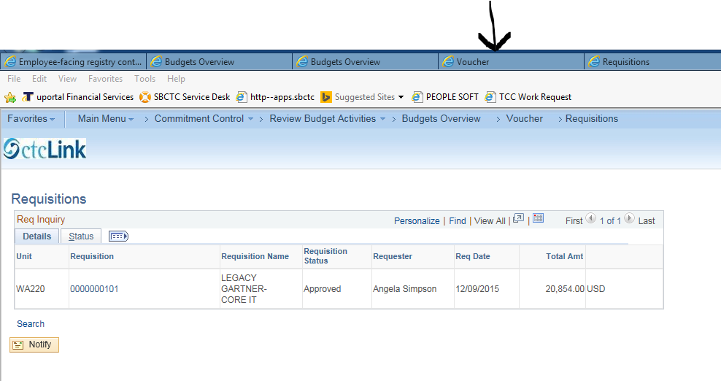

PURCHASE ORDER ID
On the “Voucher Document Status” screen, click the Purchase Order DOC ID you would like to view.
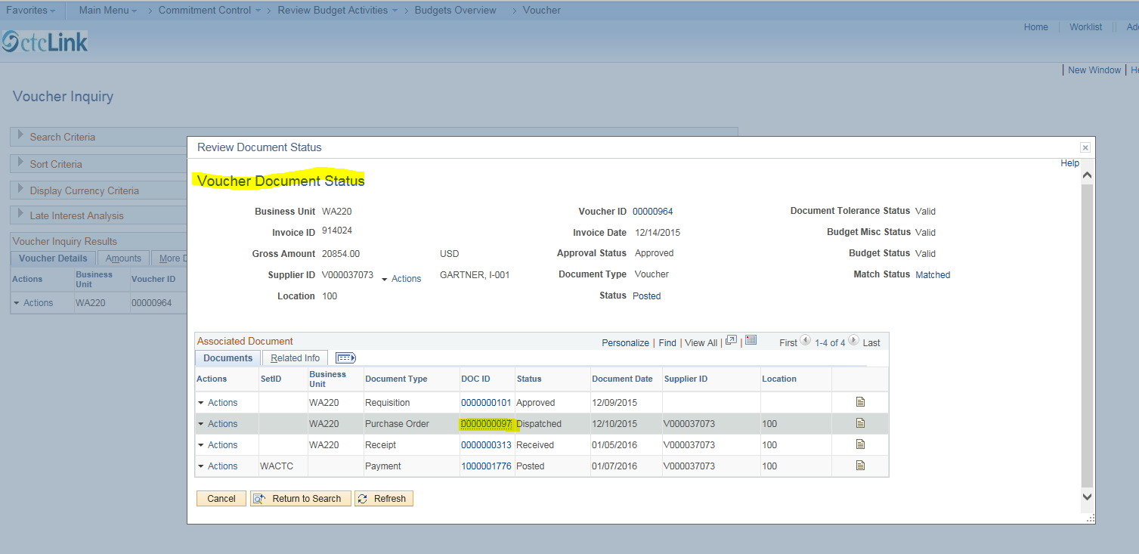

Here is the Purchase Order information. Click on “View Approvals” to inquire about approval status.
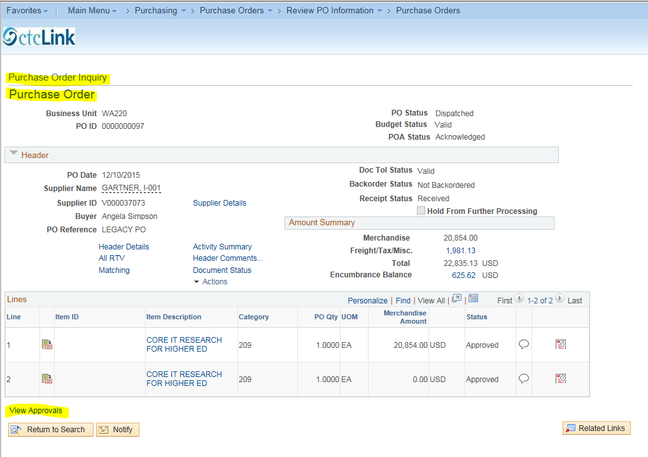

Here is the “View Approvals” page. Next, click on “Return to Purchase Order”.
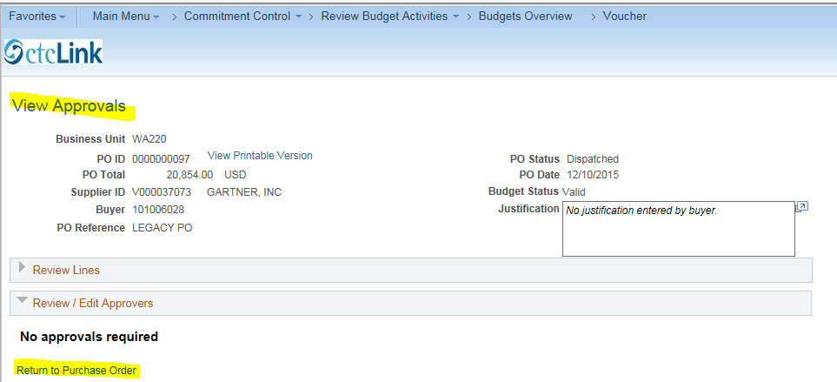
Once again, click the browser tab for “Voucher” to return to the Voucher Document Status screen.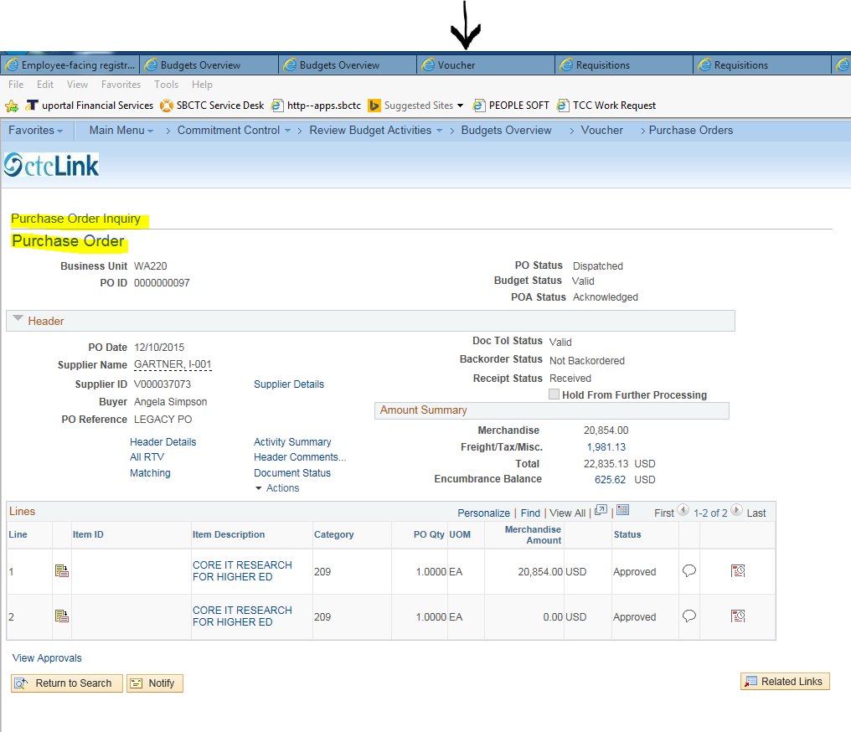

PAYMENT DOC ID
Click on the “Payment” DOC ID (this is the check number). Note that these inquiry instructions have skipped over the “Receipt” DOC ID, as access to this is limited.
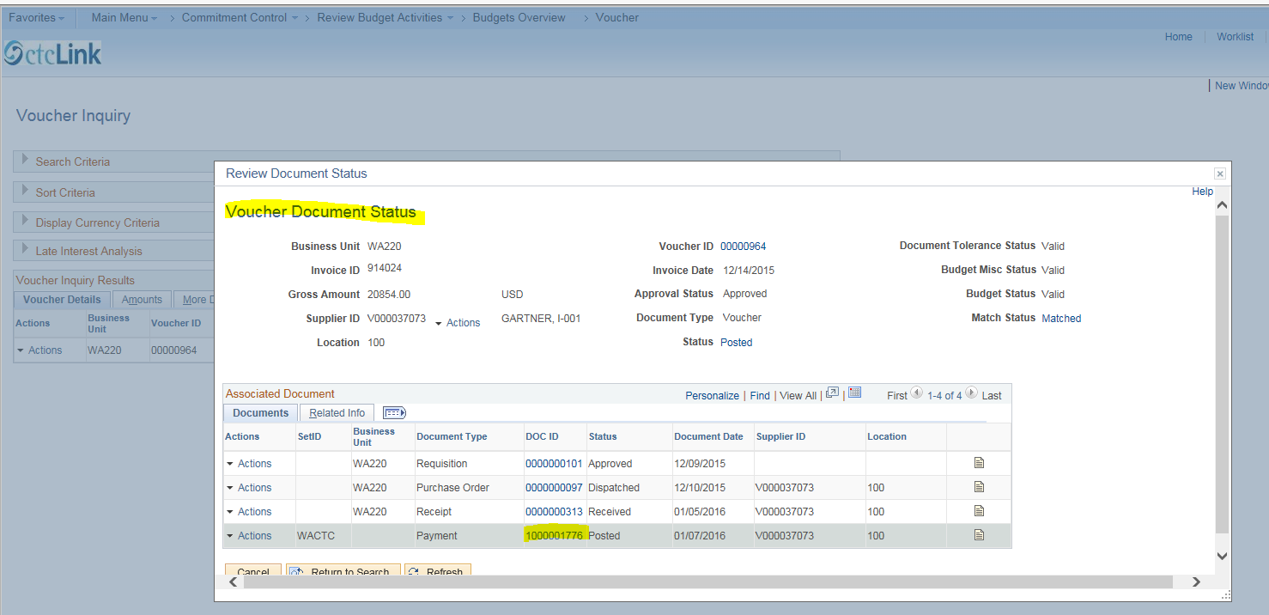
Here is the “Payment Inquiry” screen. Click on the “Payment Reference ID” (the check number), to view the “Vouchers For a Payment” screen.
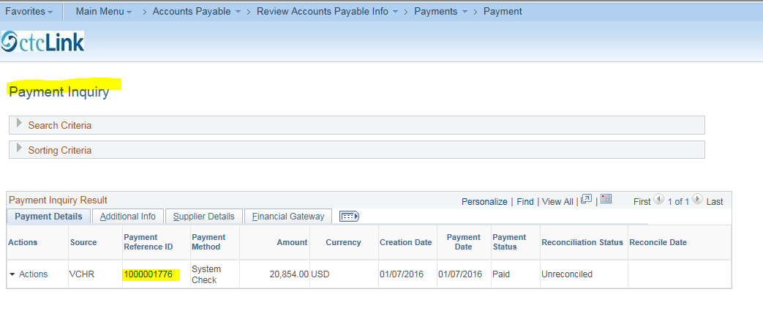
Here is the “Vouchers For a Payment” screen. Click the “Voucher ID” number to return to “Voucher Inquiry” which will give you an opportunity to return to various inquiry screens by clicking “Actions.” (See next screenshot.)
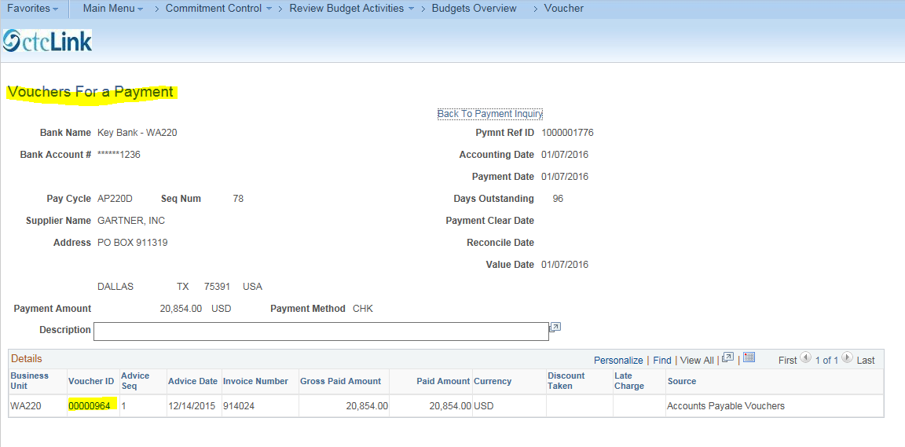

Here again is the Voucher Inquiry screen.
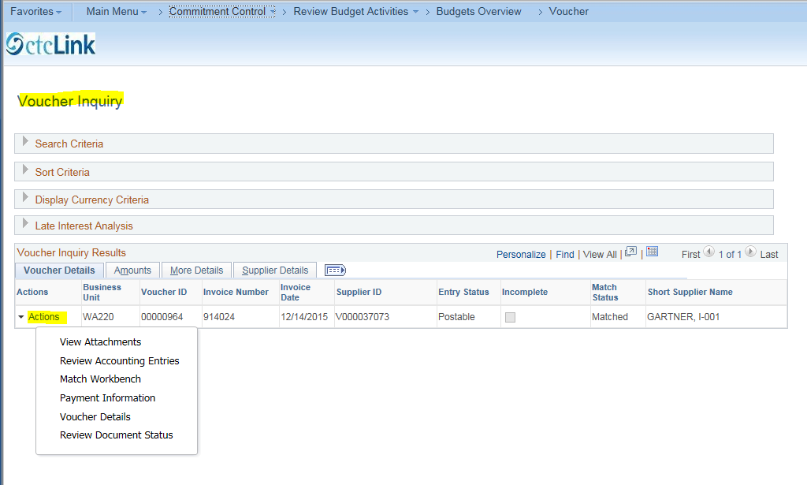

DETAIL KK LEDGER GROUP
Next we will explore Ledger Group, “DETAIL_KK” (Activity Budget). This ledger group inquiry provides financial information on Projects, Activities and Grants.
A Project can be a capital project or a grant award. Every Project must have at least one Activity. Project numbers are ten digits in length, all numeric. Activity numbers are up to five digits in length, and can be all alpha or a combination of alpha and numeric characters.
Please navigate as follows: Commitment Control > Review Budget Activities > Budgets Overview, or simply click “Budgets Overview” in the search ribbon.
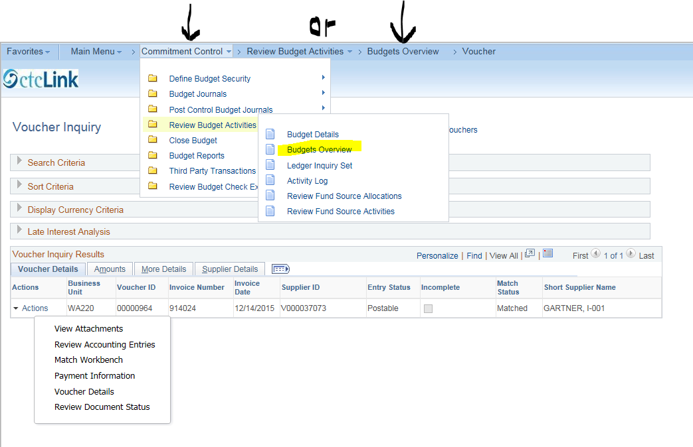
Click “Search” then select your desired “Inquiry Name” from “Search Results”. 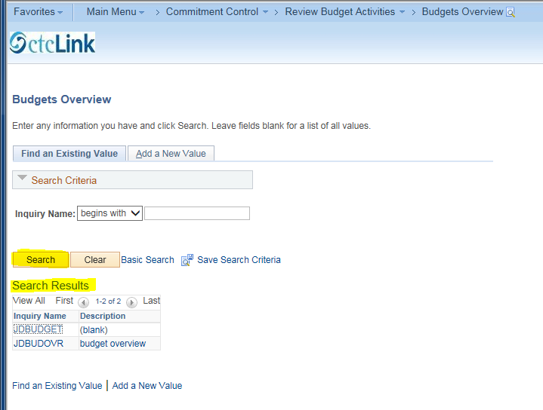
On the “Budget Overview” screen, click the “Ledger Group” search icon and select “DETAIL_KK “ (Activity Budget).
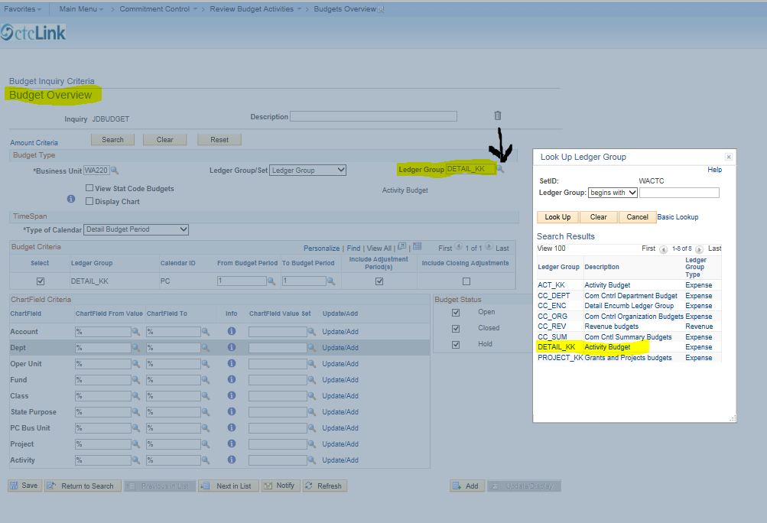

Click the “Search” icon for Activity. A list of project and activity numbers appears along with a description. Note that in this example there are 244 projects (see screenshot below). Scroll down the entire list and you will see that there are capital projects and grants included in this list. You may select the desired project, grant or activity from the drop down list, or you may specify search criteria in the “Look Up Chartfield From Value” section (instructions follow).
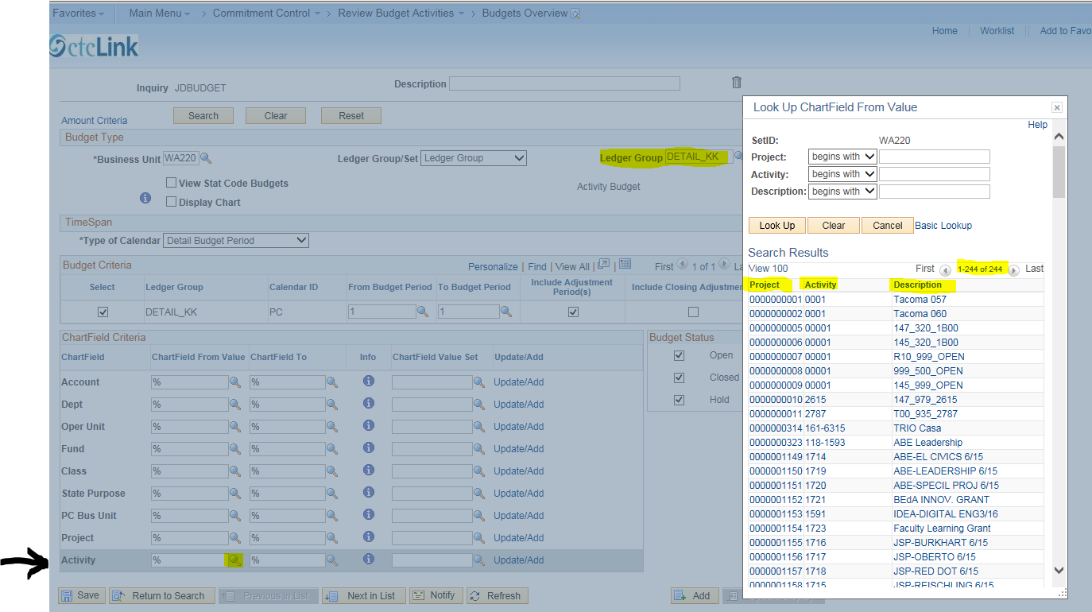

If you wish to inquire about a particular Activity, and if you can only remember that the Project number contains “157”, then click the search icon for Activity, click the “Project” drop down box in the SET ID section. Select “contains,” type “%157” (without quotes) in the search field, click “Look Up,” and a list of all projects containing “157” will appear (see next screenshot).
Please note: the percent sign “%” is the wild character you can use when searching through PeopleSoft. Also, in addition to “contains,” other search criteria include: begins with, =, not=, <, <=, >, >=, between and in.

Select the Activity you are inquiring about. In this example, we will inquire about Activity #EHSP, which is Project #0000001572. Click to select this activity.
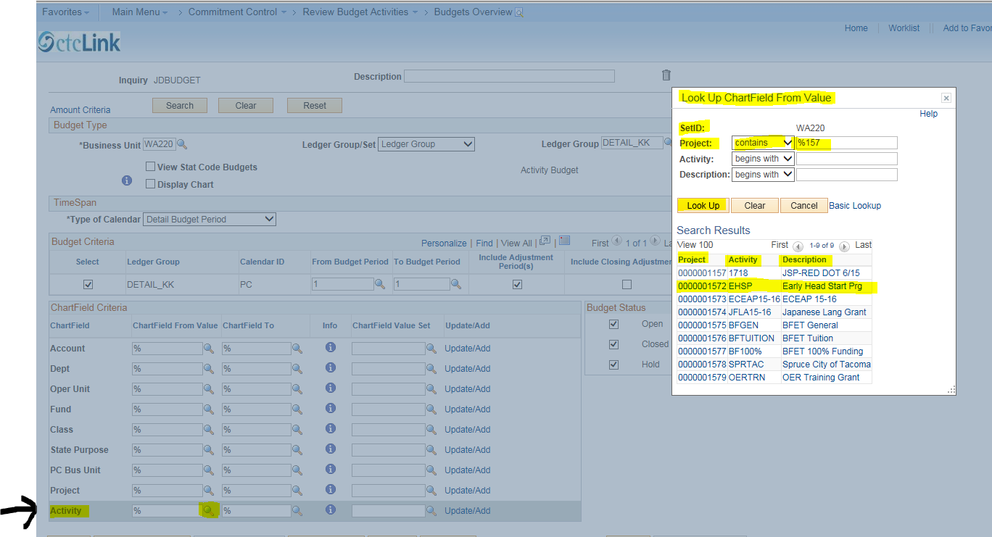

The Activity field is populated for your selection, because it was the chartfield that the “Look Up” was for, even though we searched via a Project number (%157).
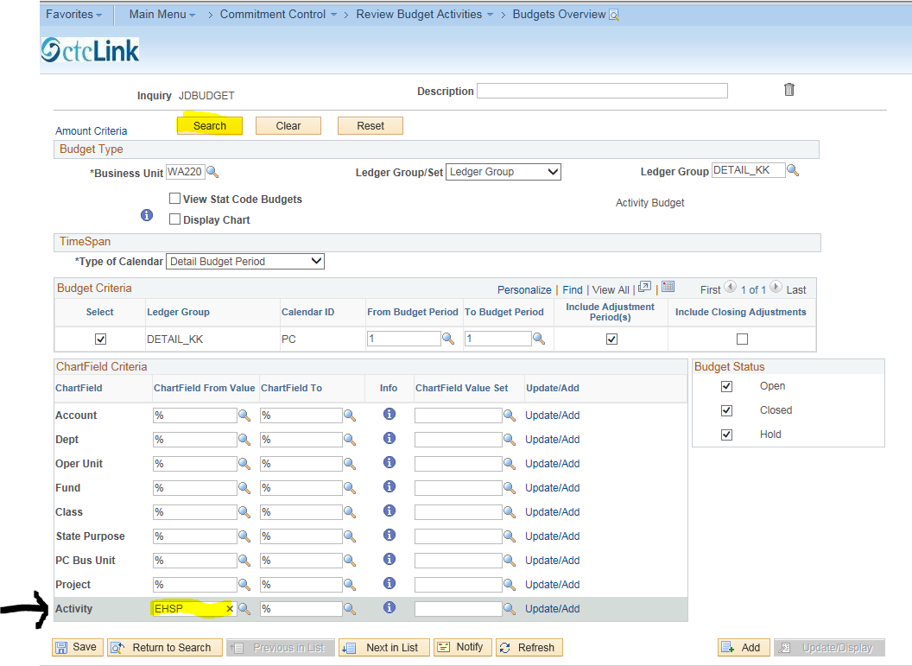
Let’s do a “Look Up” for a Project. On the Budget Overview Screen clear the Activity field that was populated with “EHSP” by clicking in that field, then clicking the “X”. Next, click the search icon for Project. Click the “Project” drop down box in the Set ID section, click “contains”, type “%157” (without quotes), click “Look Up”. Select Project #0000001572. The Project field is populated. Tip: Hover your cursor over the words “Look Up Chartfield From Value”, click and drag to move the list out of your way. You can also adjust the size of the list by hovering over the lower right corner of the list and click/drag.
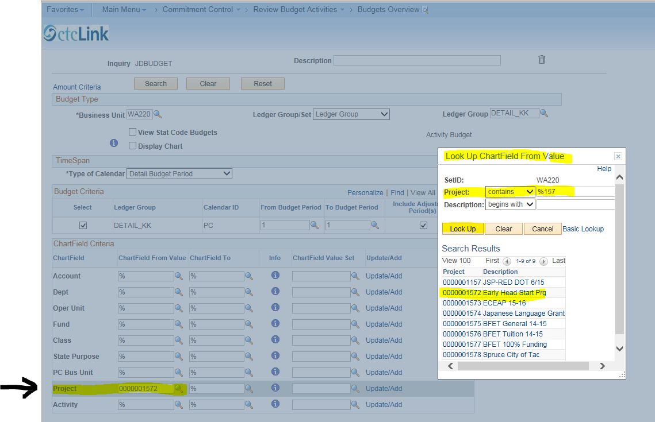

We will now drill into the detail about Project #0000001572. Click “Search” to go to the “Inquiry Results” screen.
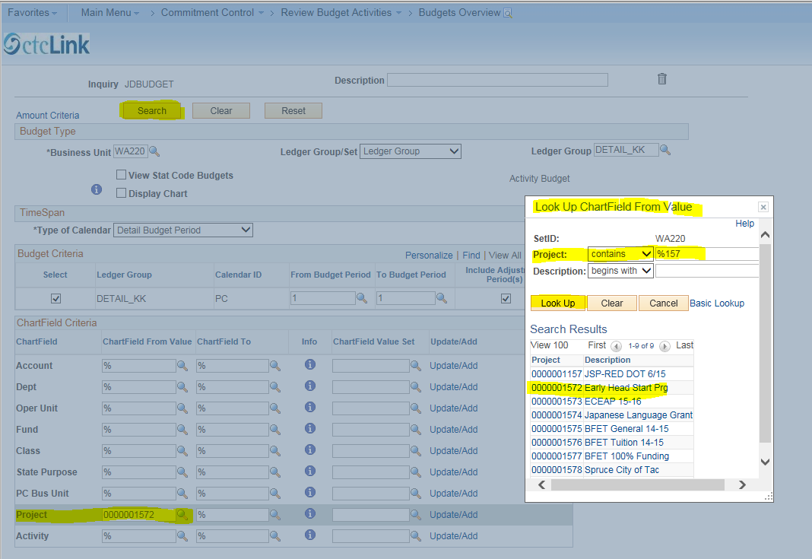

Here is the “Inquiry Results” screen. This screen is similar to the CC_ORG Inquiry Results screen, but also includes Project and Activity numbers. The view below shows the left side of the screen. Use the scroll bar at the bottom of the page to scroll to the right side of the screen.
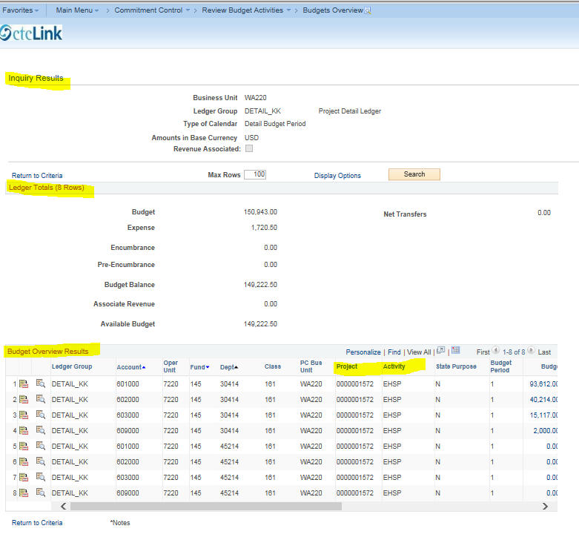

The screen below shows an expense amount of $1,795.50 in the “Ledger Totals” section. That amount is comprised of expense amounts in lines 5 and 6 in the Budget Overview Results section (1,635.00 + 160.50). We will drill to the details for the expense amount in line 5 by clicking the “Show Budget Details” icon (the highlighted icon).
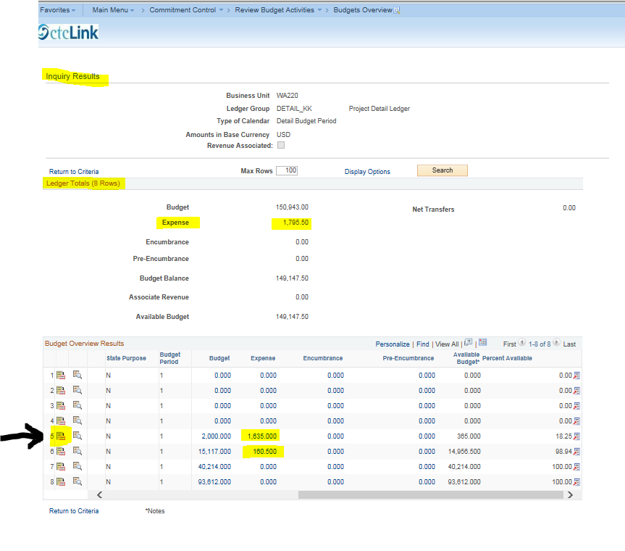

Here is the “Budget Details” screen. This is similar to drilling to details in CC_ORG. Next, click the “Drill to Ledger” icon.
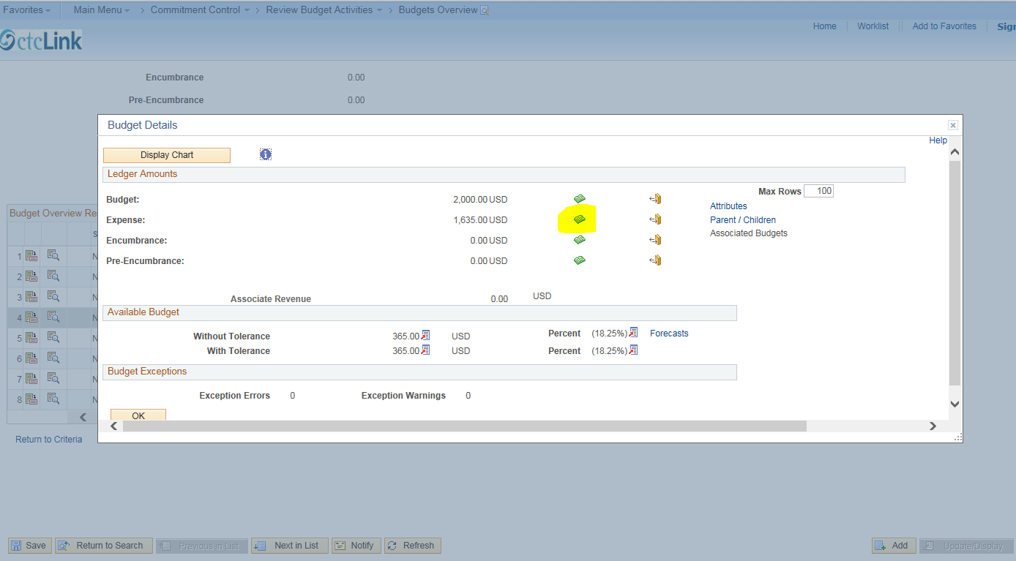

On the “Ledger” screen click “Amounts”, then click the drill down icon to go to the “Activity Log” screen for the line of data you are inquiring about.
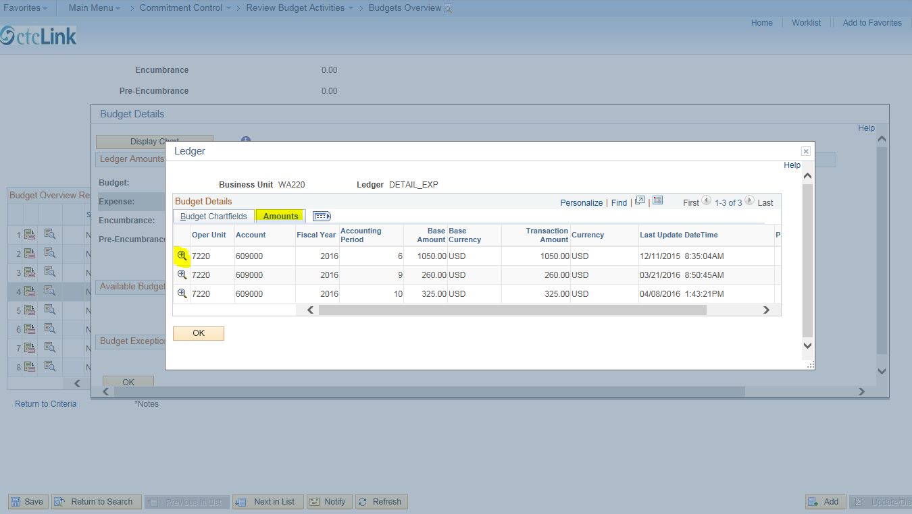
Here is the LEFT SIDE of the “Activity Log” screen. Use the scroll bar at the bottom of the screen to view the rest of the screen. We will drill to the “Payables Voucher Line Drill Down” screen for information about the expenses in first line.
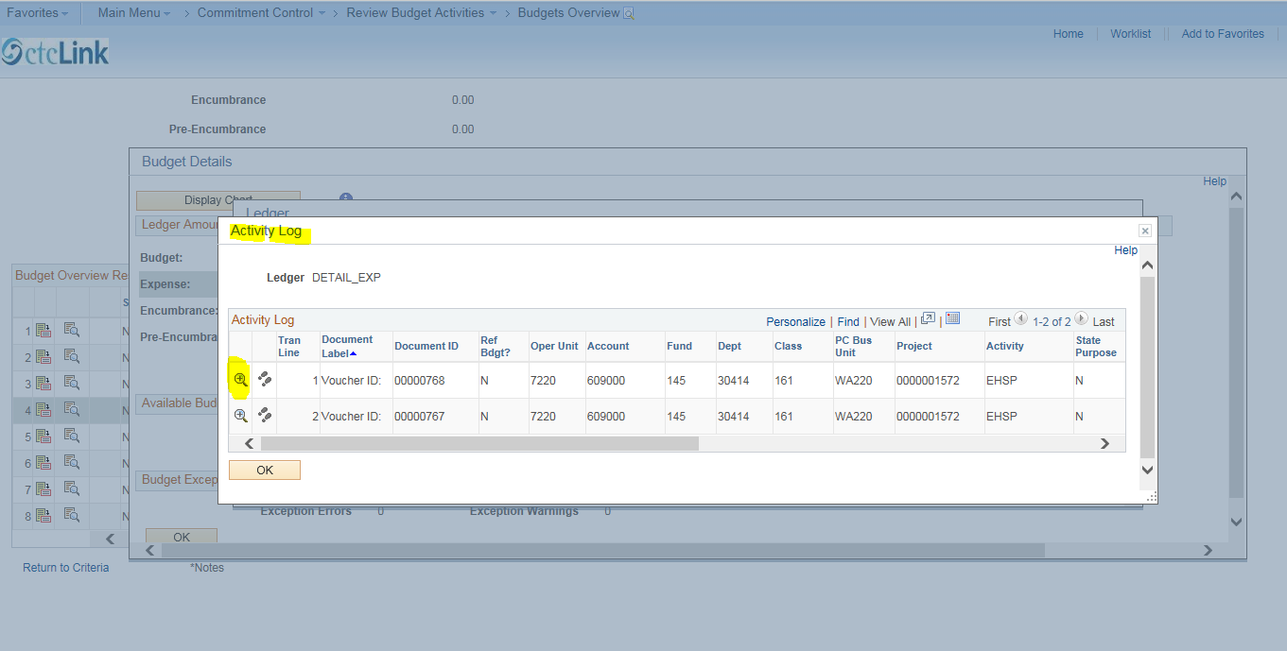
Here is the “Payables Voucher Line Drill Down” screen. Note the chartfield information in the “Transaction Line Details” section. Next, click the “Voucher ID” icon.
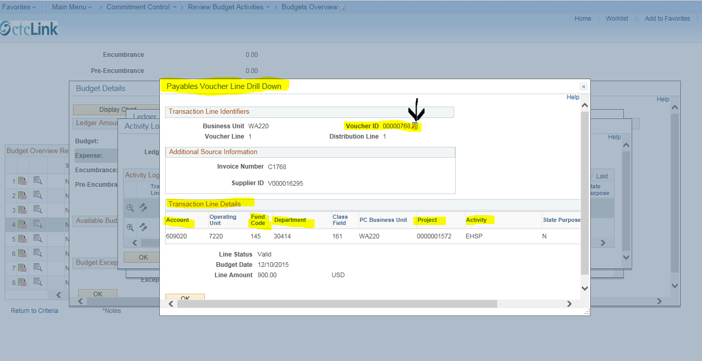

Click “Go to Source Inquiry” to go to the “Voucher Inquiry” screen.
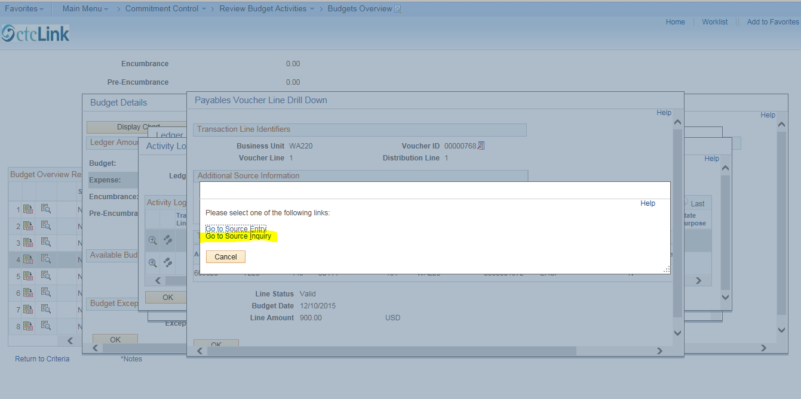

You may now continue your inquiry as you did in the CC_ORG ledger group as was explained earlier.
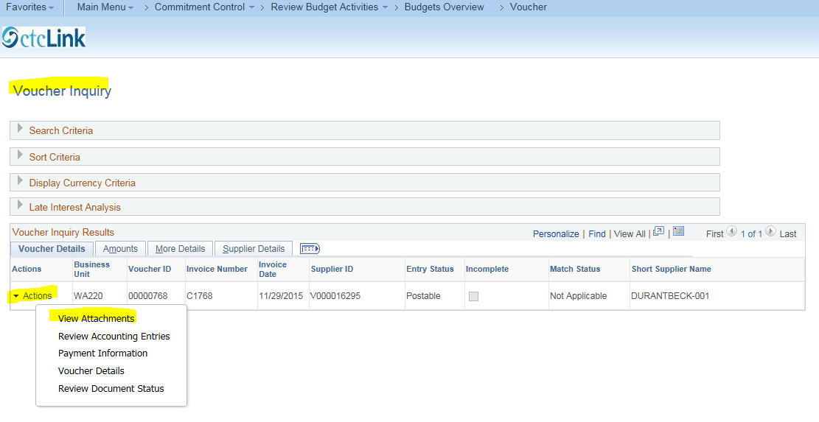

PROJECT KK LEDGER GROUP
Next we will explore Ledger Group, “Project_KK” (Grants and Projects Budgets). Navigate to select the “PROJECT_KK” ledger group.
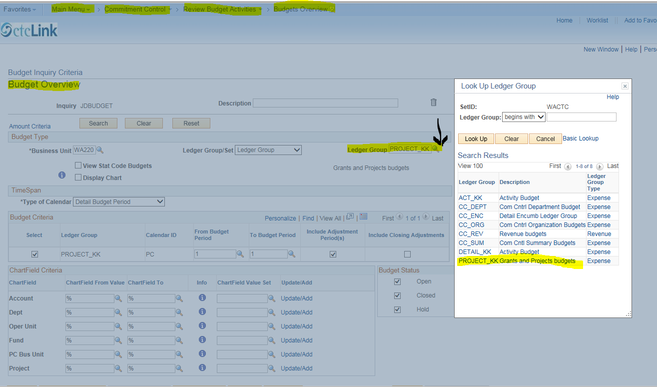

Select the project you are inquiring about. Here we will search for Project #0000001232 “COP Health & Wellness Ctr.” Let’s imagine we can only remember that the project we are searching for contains the word “health.” Using the Look Up feature, click the search icon for “Project,” to open the “Look Up Chartfield From Value” list, click the drop down box for Description, select “contains”, enter the word “health” (without quotes), then click “Look Up”. There are four projects with the word “health” in them (scroll down to see all four). Select #0000001232.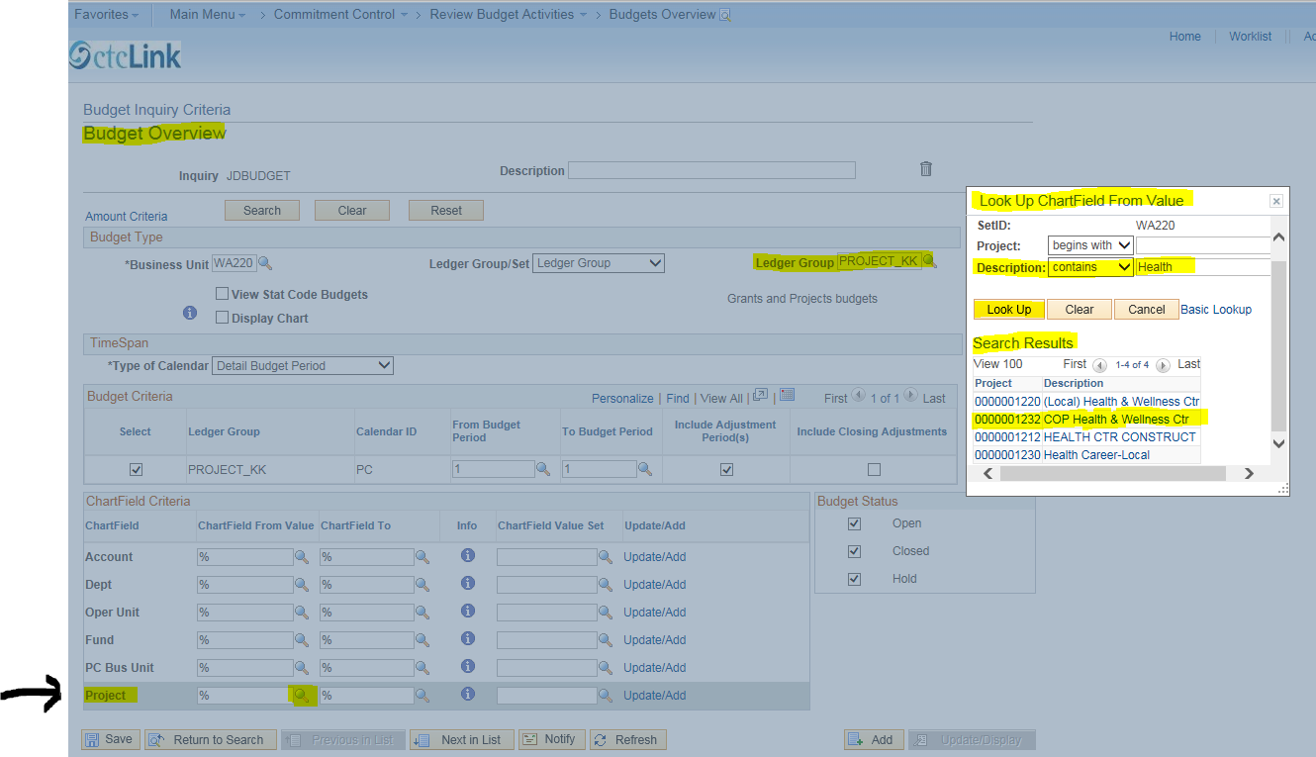
Click “Search” to go to the “Inquiry Results” screen.
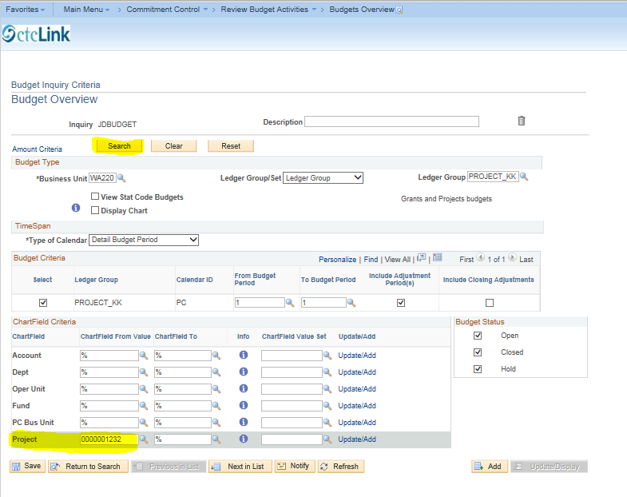
Here is the “Inquiry Results” screen. Click on the “Show Budget Details” icon.
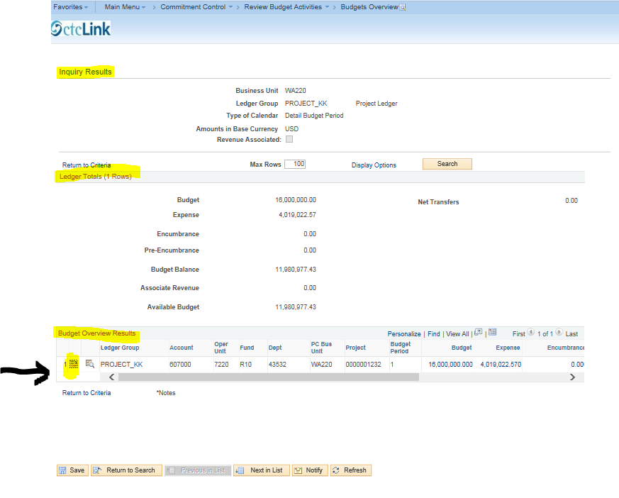
Click the “Drill to Ledger” icon.
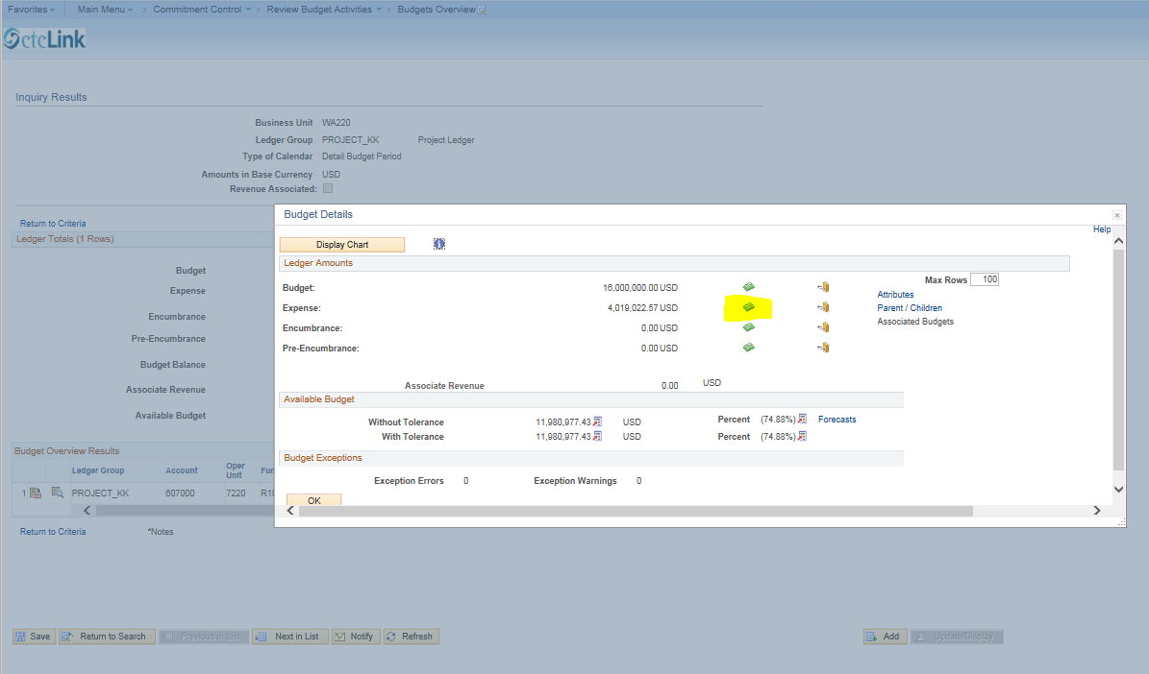

Click the “Show All Columns” icon.
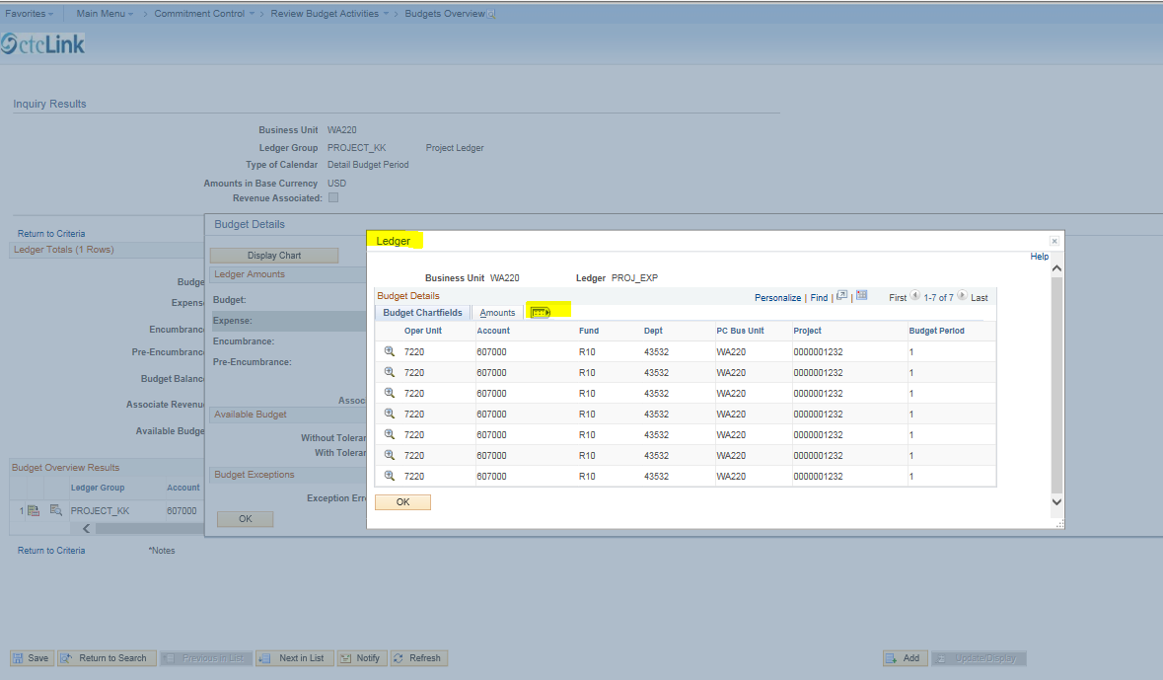

Click the “Drill Down” icon to go to the “Activity Log”.
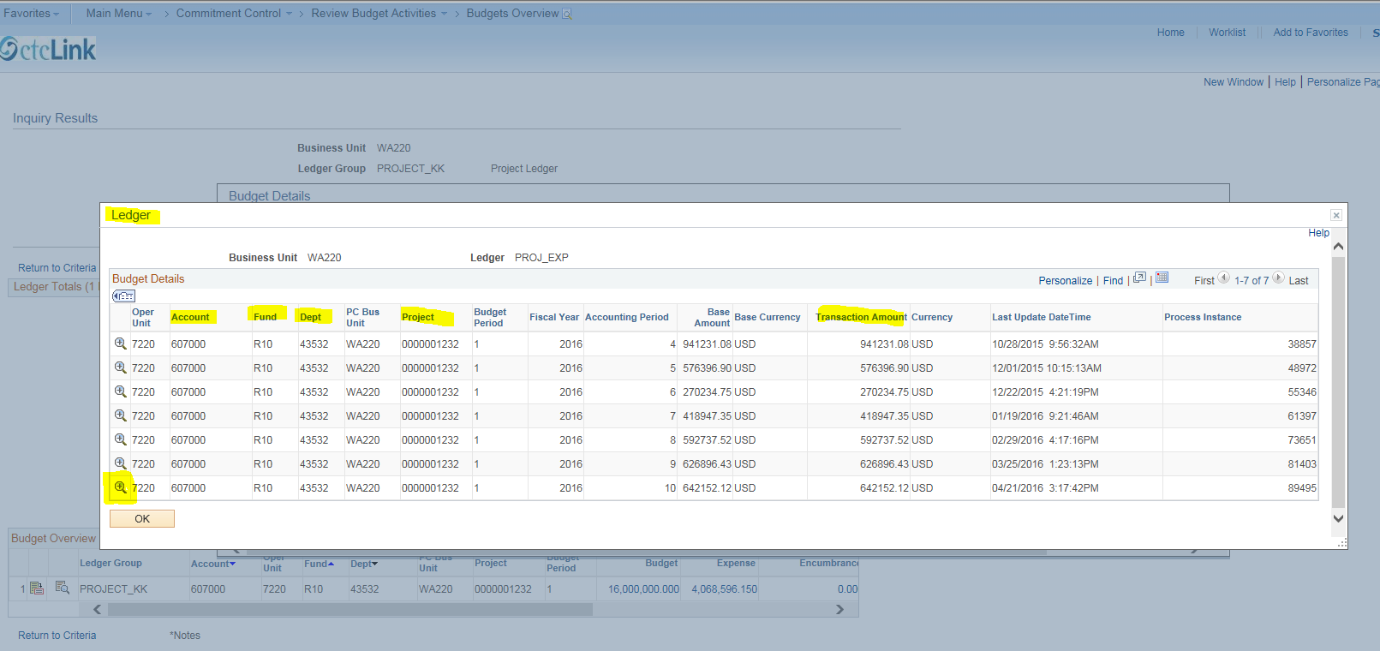

Here is the “Activity Log”. Click the “Drill Down” icon to go to the “Payable Voucher Line Drill Down” screen for the first line of detail.
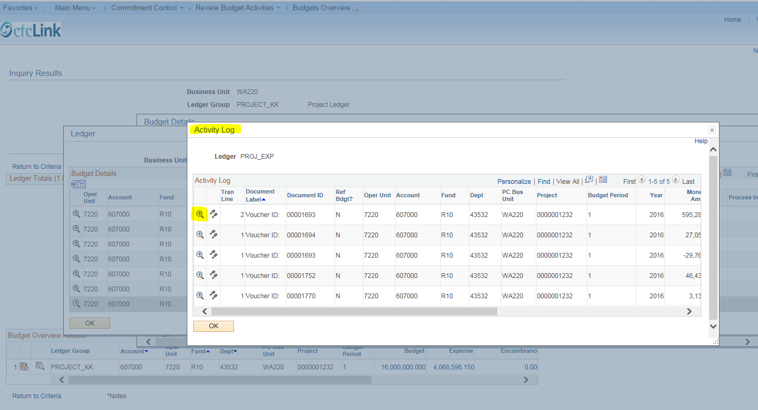

Click the “Voucher ID” icon.
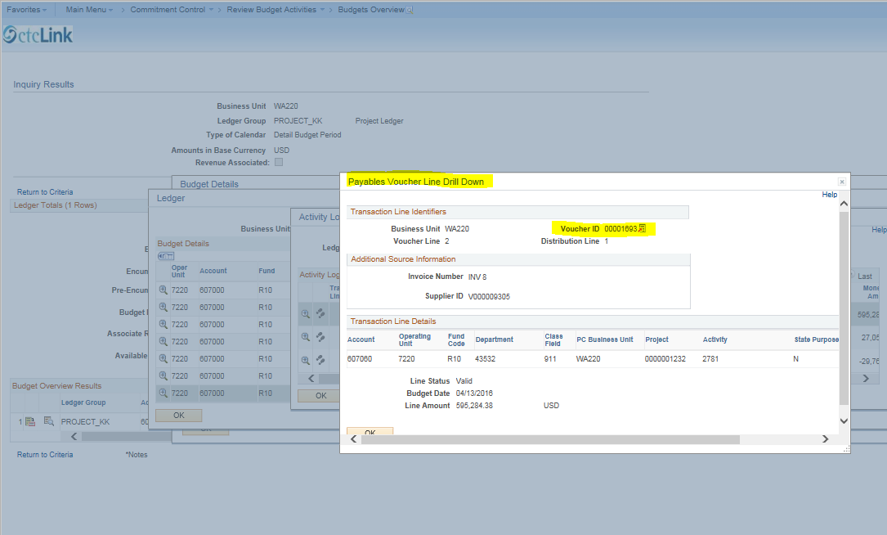

Click “Go To Source Inquiry” to go to the “Voucher Inquiry” screen.
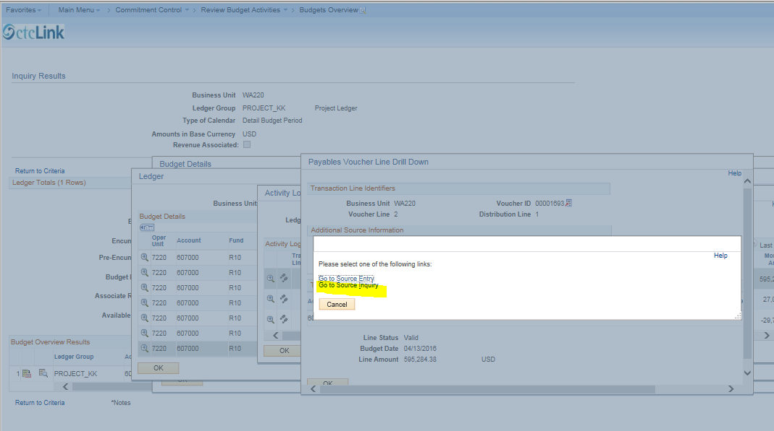

Select the desired “Action”. In this example, click “View Attachments”.
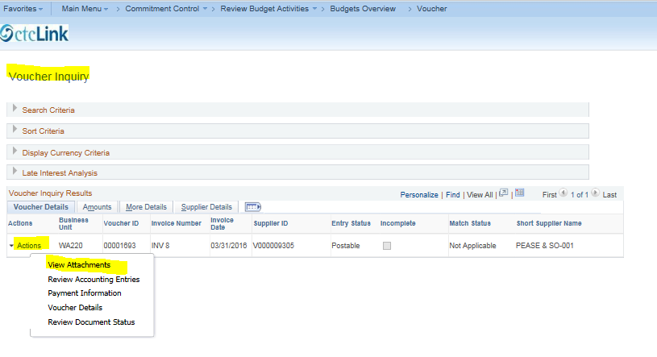

Click the PDF link.
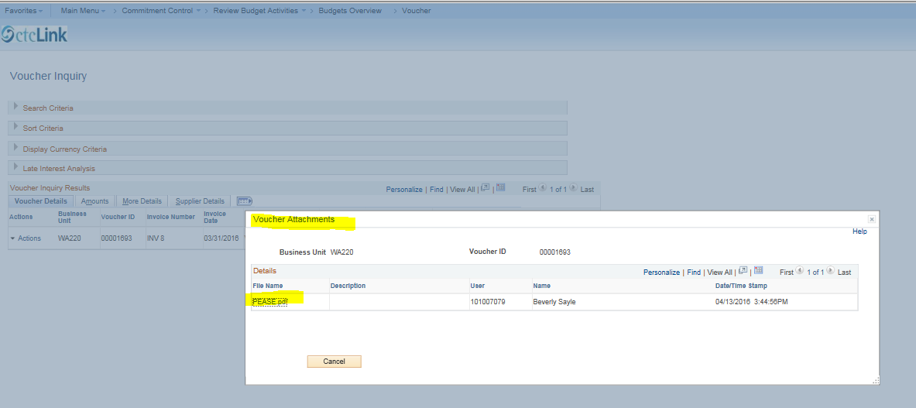

Here is the first page from the PDF (there are nine pages in this particular PDF).
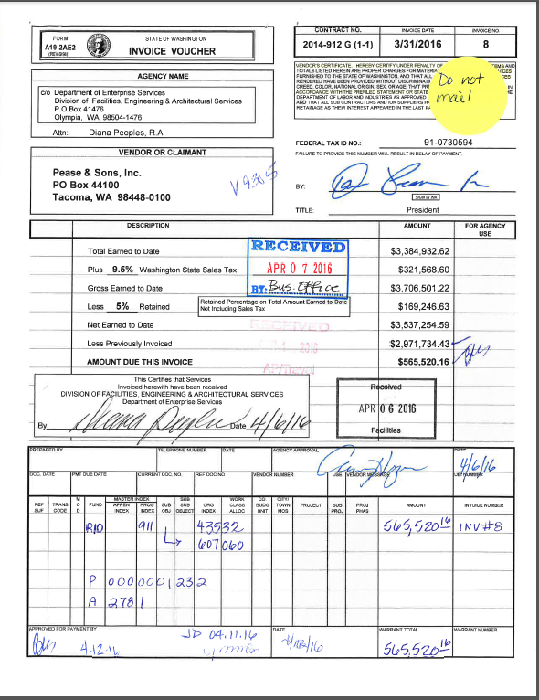

This concludes the instructions for navigating within the Commitment Control (budget) module and drilling to detail within ledger groups CC_ORG, DETAIL_KK AND PROJECT_KK.

GLOSSARY
The following Document Label/Document ID information provides additional transaction details if the user has access.
Voucher ID – the accounts payable document identification number
Report ID – The report identifier
Employee ID – the purchase card (P-card) user identification number
Journal ID – the general ledger journal identification number. CNV indicates that the transaction was converted from Legacy/FMS to PeopleSoft.
Budget Check – This is the process of checking transactions against budget to see if they pass, fail (error out), or pass with a warning. Budget checking results in the following Process Statuses:

Budget Error or Errors Exist – Transaction failed budget check. Budget errors must be corrected in order to complete the transaction.

Budget Warnings – The budget processor issued a warning, but allowed the transaction to be completed.

Business Unit – An identification code that represents a high level organization of business information. Tacoma Community College’s business unit number is WA220.

Encumbrance – Commitment Control ledger type for amounts that you are legally obligated to spend. Contracts and purchase orders are examples of encumbrance transactions. A pre-encumbrance is a Commitment Control ledger type for amounts that you expect to expend, but for which there is no legal obligation to expend. A requisition is a typical pre-encumbrance transaction. Pre-encumbrances DO NOT affect Available Budget amounts.

Chartfield – the various fields that store the chart of accounts and provide the system with the basic structure to segregate and categorize transactional and budget data. The following chartfields comprise the chartstring:

Account - Six digit, general ledger account numbers. Current Assets begin with 1, Fixed Assets begin with 2, Revenues begin with 3, Liabilities begin with 5, and Expenses begin with 6 (Formally “Sub Object.”)
Class - Three digit, general ledger class numbers, all numeric. (Formally called “pro” in FMS).
Fund - Three digit, general ledger fund/appropriation numbers (are alpha/numeric).
Operating Unit – Four digit number that identifies a location. Tacoma Community College’s operating unit number is 7220.
Dept - Five digit, general ledger numbers, all numeric. (Formally called “org” in FMS).
Project – Ten digit numbers to identify capital projects or grants.
Activity – Five digit numbers to identify specific activities within a project or grant.
State Purpose – A chartfield value that is used to comply with IT-related reporting requirements of OFM (Office of Financial Management). There are three State Purpose values:
X = IT Acquisition/New Development
Y = IT Maintenance and Operations
Null = Transaction is not IT related

