Using Learning Mastery in Canvas

The following video tutorial covers everything in this handout:
https://tacomacc.hosted.panopto.com/Panopto/Pages/Viewer.aspx?id=8fc3d9ca-d6ab-42ad-aedd-371973b3044d

Before using Learning Mastery in Canvas, you will need to (1) pull the outcomes for your course into your course shell (alternatively, you can pull in program or degree learning outcomes) and (2) add outcomes to your assignment rubrics.

Adding outcomes to your courses:
- Open your course shell. Click on Outcomes on the left, then click on Group and create a folder for the outcomes for your course (in this example you can see that I have already created a group/folder called LS 101 Outcomes in which to put my course outcomes).
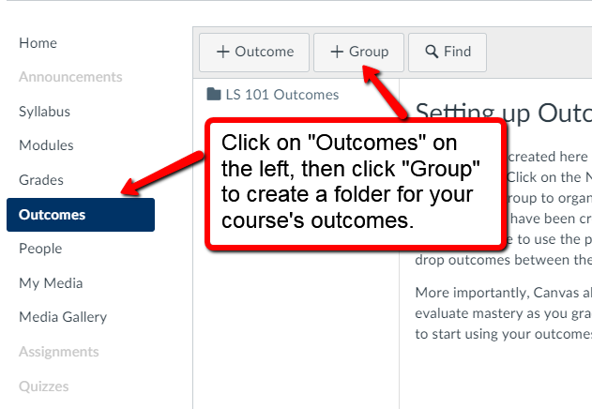
- Once you have created an outcomes folder for your course, click it and then click the Find button to begin searching for your course’s outcomes (in this example you can see that the outcomes for LS 101 have already been pulled into the folder).
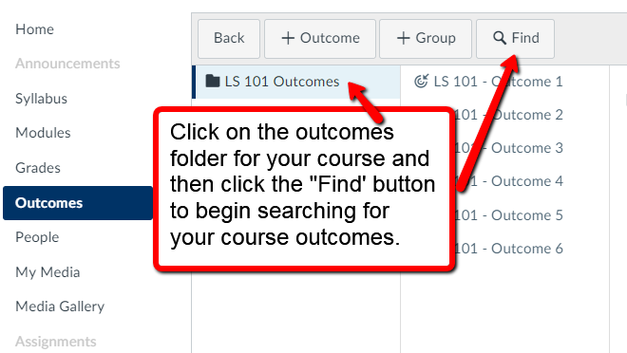

- After you click Find, click on Account Standards and then Tacoma Community College.
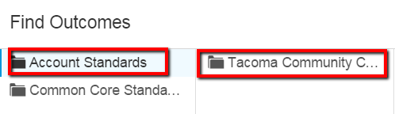
- On the next screen click Courses (alternatively, you can add program or degree learning outcomes, if that is what you are assessing).
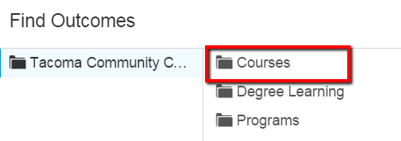
NOTE: e-Learning has already put all course, program, and degree learning outcomes into Canvas, however if you do not see the outcomes for your course or program or if you have revised any of your outcomes, contact e-Learning to have them added or revised.
- Next click the folder for your program and then click the folder for your course (e.g., LS and then LS 101).
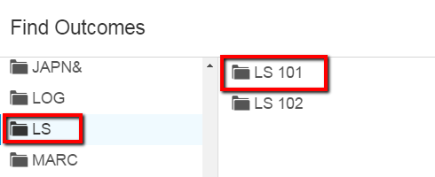

- Finally, click on the outcome that you would like to import to your course (e.g. LS 101 – Outcome 1) and click the Import button at the bottom of the screen. Once you have imported all of the outcomes to your course outcomes folder, you are ready to start building rubrics.
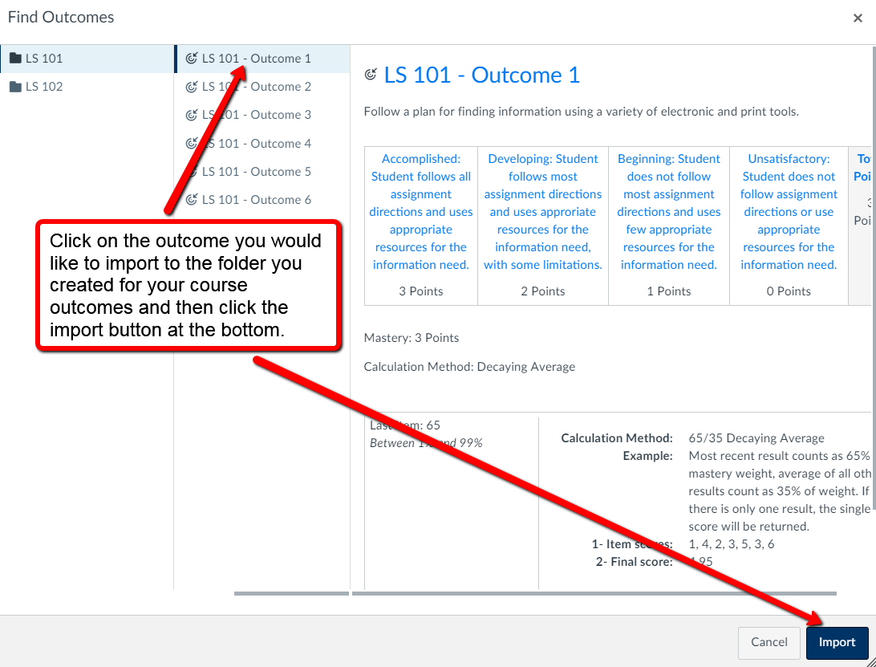
NOTE: If you prefer to administer an assignment on paper and to score it on paper, you can create a placeholder assignment in Canvas and then create a rubric that just consists of the outcomes that the assignment measures. You will then just need to score students’ performance on the outcomes in Canvas and the rest can be done on paper.

Building rubrics with outcomes in Canvas:
- Create a new assignment.
- Add a rubric to the assignment and build it as you normally would.
- Now click Find Outcome to begin adding the outcomes that assignment measures to the rubric.

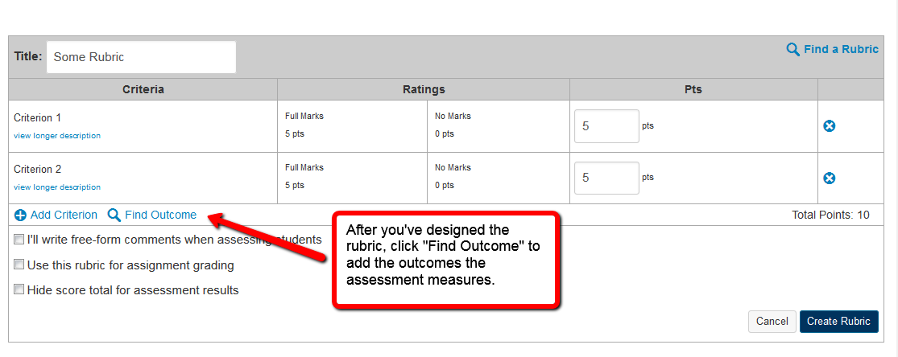

- On the next screen, click on the folder that you created for your course outcomes (e.g., LS 101 Outcomes) and then click the outcome you would like to add to the rubric (e.g., LS 101 – Outcome 3). If you do NOT want to grade students based on their performance on the outcome BE SURE to uncheck the box next to Use this criterion for scoring before clicking Import.
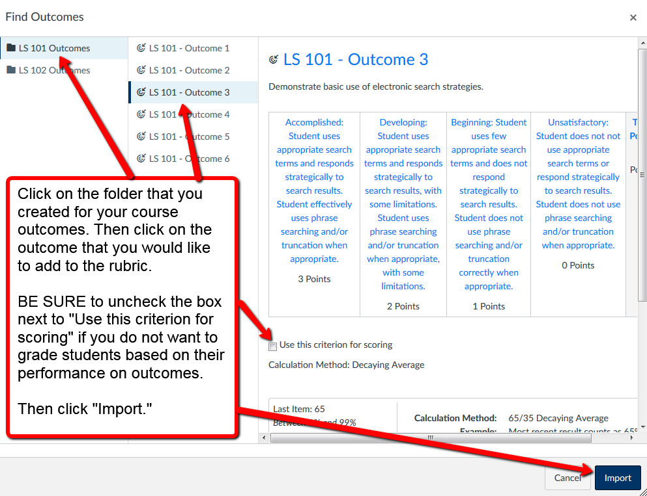

- The rubric will now look something like this (notice that there are no points listed next to LS 101 – Outcome 3 because I chose not to use that criterion for scoring):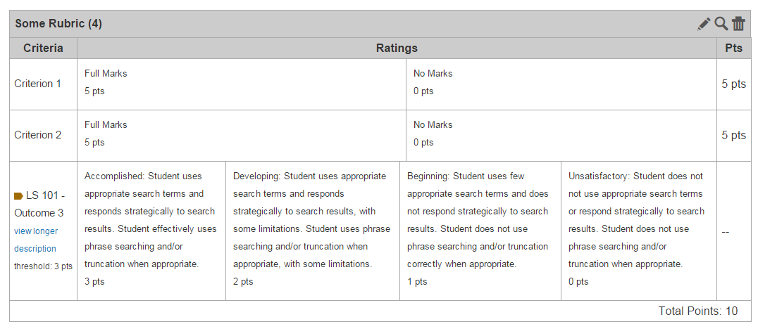

- Students’ final grade for an assignment will not include the score for a particular outcome unless you checked the Use this criterion for scoring box when importing the outcome; however students will be able to see how they are doing on certain outcomes.
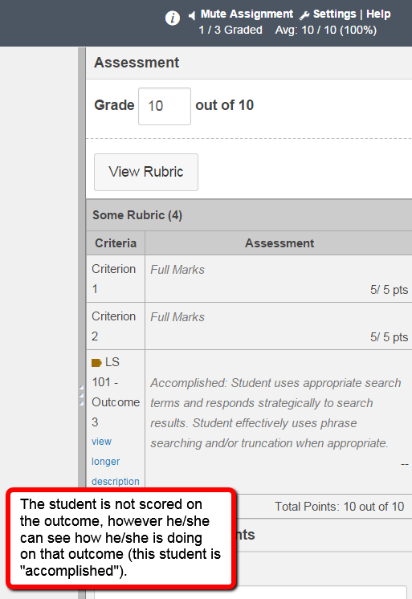

- Aggregate information on how students are doing on each of the outcomes will appear in the Learning Mastery tab (they can also see this; but it does NOT affect their final grade, it just helps them to understand where they might need to improve).

