Core of Knowledge Degree Learning Outcome Assessment

July 2016

Task Force members: Corinne Jarvis, Barbara Peterson, Pam Costa, Darlene Rompogren, Danielle Ritter, Beth Bayer, Jillian Edwards, Benjamin Paganelli, Analea Brauburger (facilitator), and Heather Gillanders (facilitator)

Introduction
In the summer of 2015, ten faculty members met with facilitator Kim Rzeszewicz to review the Core of Knowledge (COK) Degree Learning Outcome (DLO) and design a way to access this DLO. The COK DLO is defined as “Demonstrate a basic knowledge of each of the distribution areas (Written Communication, Humanities, Quantitative Skills, Natural Sciences, and Social Sciences; or, as applicable, specific professional/technical programs), integrate knowledge across disciplines, and apply this knowledge to academic, occupational, civic, and personal endeavors.
The task force members determined that a rich database already exists in ten years’ worth of Program Learning Outcome (PLO) projects. Since each of the 27 programs on campus was assessed at least twice over this ten year span, it was determined that no direct surveying of students of faculty members was necessary and that we could analyze the aggregate data. The goal was to determine whether or how well the PLO projects addressed the COK DLO. The goal was to collect data from past PLO assessment projects that focused on basic knowledge; integration across disciplines; and application to academic, occupational, civic, and personal endeavors.
A rubric was created looking at three specific parts of the COK DLO definition: demonstrating basic knowledge; integrating COK across college disciplines; and applying this knowledge to academic, occupational, civic, and personal endeavors. The task force used the Association of American Colleges and Universities (AAC&U) VALUE (Valid Assessment of Learning in Undergraduate Education) criteria as a starting point in the rubric development but quickly determined that a dichotomous rubric, that answered Yes or No to the research questions, would be easier to analyze.
Ten of the programs were not included in this project either because they did not apply to the DLO assessment work or because they were support programs.
In January seven members of the task force examined the PLO projects of 17 programs across campus. Each reviewer looked at two PLO project reports for each of his or her assigned programs. The results were recorded using Survey Monkey.

Results
The task force evaluated 17 different PLO assessment reports from academic years 2011-2012 (9), 2012-2013 (1), 2013-2014 (6), and 2013-2014 (1).
For the purposes of this project, all of the questions were dichotomous because the task force could determine only if the COK outcome was met or unmet.

Preliminary Question and Result
Preliminary question: Can students graduate without taking any courses identified as teaching the COK DLO?
Result: A random sample of 25 graduate Spring 2016 transcripts showed that students took 5-25 courses within their program that addressed COK.

Research Questions and Results
Question #1 – COK Basic Content: The report demonstrates basic knowledge of distribution area/prof-tech program.
Demonstrating basic knowledge is defined as identifying the PLO in the report and relating the discussion of the project to the identified PLO.
Result: The PLO assessments demonstrated basic knowledge of the distribution area/prof-tech program as evidenced by 88.24% (15) assessed as “YES” and 11.76% (2) assessed as “NO,” illustrated in the following graph:
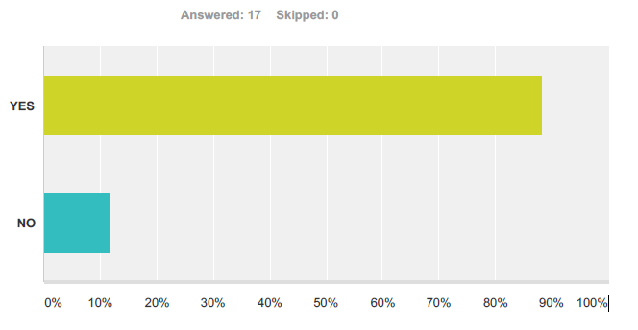
Question #2a – Integration: The report shows assessment of integration of knowledge across disciplines (check all that apply).
Integration of knowledge is defined as making connections or drawing conclusions using examples, facts, or theories from within one’s own discipline or from more than one discipline.
Result: The PLO assessment reports reflected an integration of knowledge across disciplines. A graphic representation of the results follows the list below.
- Written Communication 56.25% (9)
- Humanities 43.75% (7)
- Quantitative Skills 62.50% (10)
- Natural Sciences 37.50% (6)
- Social Sciences 37.50% (6)
- Prof Tech (other than program being assessed) 25.00% (4)
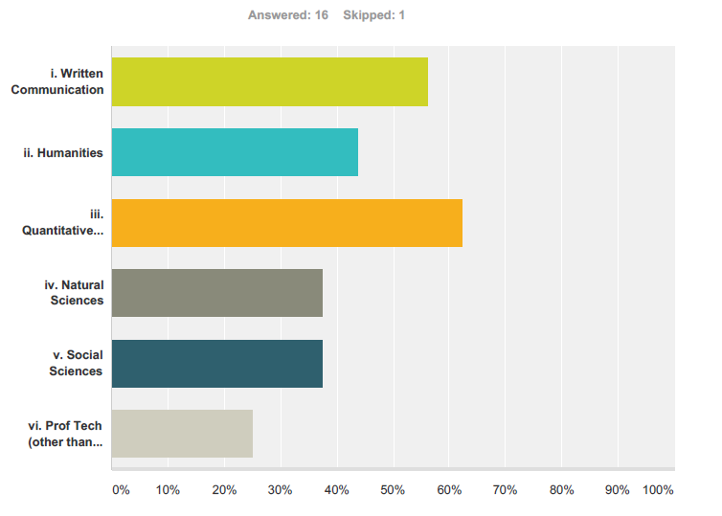
Question #2b – Integration: The report shows assessment of integration of knowledge within the discipline.
Result: The PLO assessments reflected integration of knowledge within the discipline as evidenced by 76.47% (13) assessed as “YES” and 23.53% (4) assessed as “NO”, illustrated in the following graph:
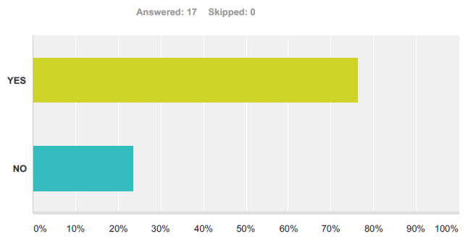
Question #3 – Application: The report reflects assessment of adaption and application of skills, abilities, theories, or methodologies gained in one situation to new situations (check all that apply).
Result: The PLO assessments reflected a relatively high level of application of knowledge in academic and occupational settings, but a relatively low level of application of knowledge in civic or personal life experiences, as shown in the graph following the list below.
- Academic (in school) 93.75% (15)
- Occupational (at work) 81.25% (13)
- Civic or Personal Life Experience (everything else) 25.08% (4)
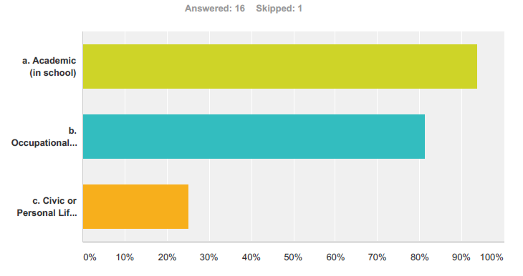

Limitations
There is an overarching systemic limitation across the assessment of DLOs, which therefore impacts the assessment of the PLOs. The main issue is a lack of guiding structure. Specifically, more detailed guidance is needed with respect to what specifically should be included in the reports and how data should be collected. For example, this particular DLO task force struggled with starting our project and determining what to include. This lack of a guiding structure creates a lack of consistency among all DLO projects. Given that PLOs are not uniformly assessed, DLOs also cannot be uniformly assessed.
Initially, the task force identified problems with assessing the COK DLO because it is integrated across all disciplines and it is already measured within PLOs. The final results of our assessment were further limited because there were significant variations in the way annual PLO reports were written, the number of courses evaluated, and the year the report was submitted. Additionally, only one COK task force member read each report.

Composition of the Report
Each of the 17 reports was written by a different author, whose level of training and/or experience with assessment was undetermined. Many of the report questions were subjective and open-ended; also, the report writer may have lacked instruction and/or background on data collection protocol. This contributed to a lack of standardization across program data results. Further, the report writer may not have received any guidance on how to address all of the elements of the PLO, especially students’ application of knowledge to civic and personal endeavors. Lastly, it was unclear how or whether the information was disseminated within the department or program once the PLO assessment report was completed.

Number of Courses
The number of courses assessed by the 17 programs reviewed, ranged from just 1 course to multiple courses in a given program. This variation in the number of courses assessed by each program could have potentially contributed to the low representation of students who were reportedly able to “apply knowledge to civic and personal life experiences” (25%) versus academic (93%) and occupational endeavors (81%) (COK Assessment Results p.10).

Year of the Report
Additionally, the year that the program review was written and subsequently submitted was a major limitation. The reports varied by a span of 4 years (2011-2015), with 53% of the sample generated between 2011 and 2012. Some programs had already been through quality improvement cycles which resulted in changes in their PLOs. Again, such variability between programs could have contributed to skewed results based on the dichotomous scales of this report.

Recommendations
The COK Task Force identified some primary and secondary recommendations.
The primary recommendation is to consider the COK concept itself and eliminate confusion and redundancy in either of two ways:
- Refine the verbiage to clarify the definition of Core of Knowledge. The inclusion of occupational, civic, and personal endeavors in the definition is problematic. Also integration and application are not necessarily included in all PLOs.

- Drop COK altogether from the list of Degree Learning Outcomes. Core of knowledge is already inherent in the Program Learning Outcomes of each department or program, given this fact, stating that “basic knowledge” is a DLO is redundant. It is also potentially confusing because each program has a distinct knowledge core which is not shared across the college.
If the decision is made to keep COK in the list of DLOs, the COK Task Force recommends that the following changes be made to the PLO assessment process:
- Refine the PLO assessment report form and the instructions for completing the form so that they offer better guidance as to what should be documented, how to document it, and how to structure the report.

- Provide feedback to each program chair and to the actual writer of each PLO assessment report. This will help departments/programs to ensure that they are designing assessment projects around measurable outcomes.

- Provide a model/example of an exemplary report as guidance for those in charge of their department’s PLO assessment project and report.

Recommendation to Administration
Providing clear guidelines and a standard process for approaching the assessment of DLOs would enable task forces to evaluate DLO assessment more efficiently and effectively and ensure that the evaluation process is data driven. PLO assessment projects also could use this same type of guidance.

