Course Learning Outcomes Survey, 2014-2015
Lee Sledd, Student Learning Improvement Council
METHOD
The CLO Assessment survey has been made available quarterly online. Typically, 2 invitation emails are sent near the end of the quarter, asking faculty for 15-20 minutes of their time. The intended purpose of the survey is to document that faculty at TCC are thoughtfully assessing course outcomes and reflecting on improvement, and at the same time to prompt reflection on outcomes assessment. The summary below reflects data collected in December, 2014 and March and June, 2015 for that purpose.
DESCRIPTIVES
Faculty members responded to the survey as follows:
Fall ‘14 | 16
Winter ‘15 | 12
Spring ‘15 | 19

5 Faculty members completed the survey 2 quarters; one faculty member completed the survey all 3 quarters, resulting in data from a total of 35 faculty members out of 141 full time and 417 adjunct faculty.

The responses volunteered represent a range of course levels and subjects.

Courses surveyed:
Transitional = 5
100-level = 18
200-level = 15

Disciplines represented (1 instructor/course unless noted)

Accounting (3)
Business (2)
Chemistry (3)
Communication Studies (2)
Computer User
English for Academic Purposes (2)
English as a Second Language
English (6)
Human Services (2)
Library Studies
Psychology
Math (3)
Music
Nursing
Physical Education (2)

Spanish (2)

Total students enrolled in assessed courses (assumes no duplicate enrollments)= 1121

RESPONSES

Q1: Which curriculum-committee approved course learning outcome did you assess? [answers vary]- 44 + 31 ]

Assessment of a total of 75 unique course learning outcomes was represented in the sample; 31 faculty members reflected on 2 outcomes, while 13 reviewed a single outcome.

Q2: What specific teaching activities do you use to help students achieve the objective?

The responses show a wide variety of teaching methods are used by TCC faculty.
A sample of methods and a few detailed descriptions follow.

Reading and lecture
Lecture, text readings
A thesis exercise for each major speech that I go over with each student personally.
Reading, lecture, and discussion focusing on works by authors of various races and
socio-economic backgrounds over a wide historical span.
Weekly lectures, discussion boards and case applications
PowerPoint Panopto recorded lecture; YouTube video
“kill and drill”
Worksheet HWs
Multiple choice

writing
Personal essay. A short autobiography.
essay answer quiz
Graded exercise with short reading, following with short and essay answers
Canvas discussion board posts and replies - Dear Abby type posts
Paragraphs
Essay and Problem Oriented Exams
freewriting
Writing from picture prompts (back-to-back writing - one person describes picture while the other person writes what is said)
Round-Robin writing
Newsletter
Essay
Canvas discussion board posts and replies
Canvas quiz - write the sentence and record
group/interactive
Board game
Matching card game
Circle drills (small group speaking activity)
Interviews & surveys
Oral presentations, in which we try to create a spontaneous situation in which one
student has to communicate with other people; there is an unscripted question and answer session at the end.
Group activities, role play, and oral presentations
Have students present conflict scenarios & discuss best practices to resolve
Guided peer reviews
Collaborative group work
Review homework and have students role play in a team dynamics exercise

Oral presentation example:
The students perform oral presentations on lab reports and on the quarter long project they are required to research throughout the quarter. Students are evaluated using a student/faculty developed grading rubric for the oral presentations. The students present twice on laboratory activities to help them refine their group/technical presentation skills in preparation for the longer oral presentations for the project late in the quarter. The students receive both faculty and peer feedback on the oral presentation on evaluation sheets after the oral presentation.

Instructional sequence example:
In-class practice (I play certain exercise at the piano--intervals, triads, scales, melodies, harmonies--that they need to identify.) I also direct them towards on-line sites they can use to practice on their own. I also encourage them to learn how to play these musical elements on a piano. We also practice sight-singing using solfege (moveable "do"), and they learn the skills they need to practice at home.

ROLE PLAY USING VIDEO example:
Students participate in evolving case scenario via video that takes the students through a patient admission to hospital and de-compensation. Requires the nurse to make decisions at strategic points and scenario adapts based on the decisions made (i.e. patient may die if wrong choices made constantly!)
Project example:
This is the first unit of the course. Students are exposed to five different modes of learning styles and the Jungian personality theory in lecture format. Learnings then complete self reporting inventories to learn more about their own learning preferences. In small groups the individuals share their own results and have an opportunity to verify differences within the group. Prior to the unit quiz the students complete a scenario activity in small groups. To resolve the questions in the scenario the learners must use the information gained from the unit. The final activity for this unit consist of the students each creating a "boxproject" where they can only use pictures, symbols, or images to depict their personal learning styles and personality type.

Instructional sequence incorporating game and writing:
After a two part lecture, small groups of students (3-4) were assigned seven developmental theories to research. Using a guide created by the instructor, each group created a "fact sheet" consisting of relevant information. These were then copied and distributed by the instructor to each learner in the class. Using these fact sheets as study guides the students prepared to compete, as teams, in a "knowledge bowl" type of game. This game was both application of theories as well as a further opportunity to study for an essay quiz that involved applying the learning to a scenario.

A sample instructional sequence:
6 days of activities, 1 review day, 1 exam day
* Brief Lecture
* Collaborative work in groups during class time
* 13 page packet, connects elimination & substitution & graphing methods with a graphic organizer
* 5 page packet, several examples of linear inequalities
* 13 board problems done at home, shared in front of class with work on white board
* 4 online homework assignments,* 1 graded quiz* 1 ungraded quiz
* 1 review day (half of unit)
* 1 exam day (half of unit)

Q3: How are students assessed in achieving this learning objective?

9 out of 19 respondents used multiple modes (2 or 3) of assessing their outcomes.
10 reported using observation
10 reported designing an assignment.
9 reported designing/using an assessment.

Q4: How well did you feel your class achieved this learning objective?
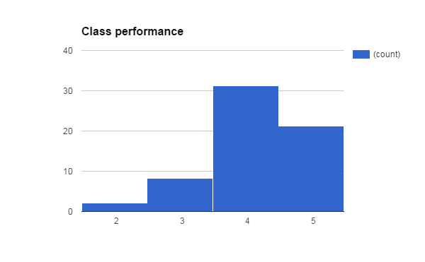
(on a 5 point scale: 1=Did not meet this learning objective & 5= Met or exceeded expectations)
Q5: How well did your assessment(s) measure this objective?
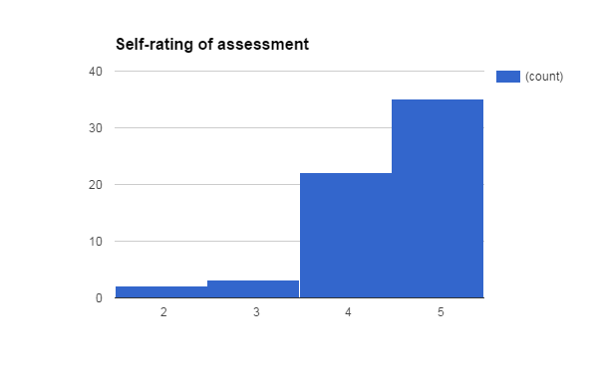
Q6: How well did the most successful students in the class meet this CLO?

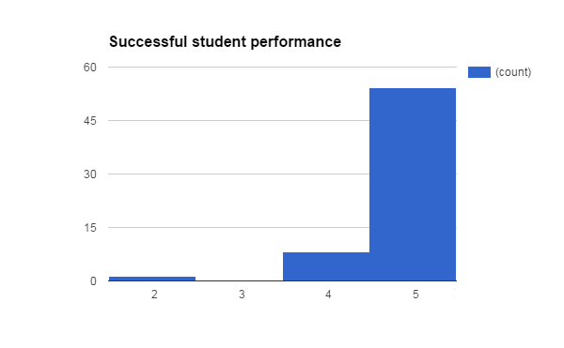

Q7: How well did the average student in the class meet this learning objective?
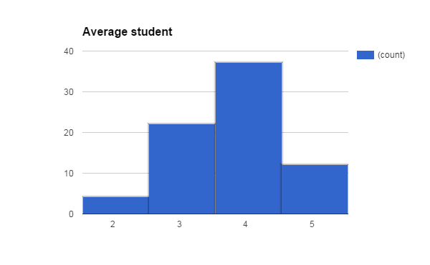
Q8: How well did the least successful student in the class meet this CLO?

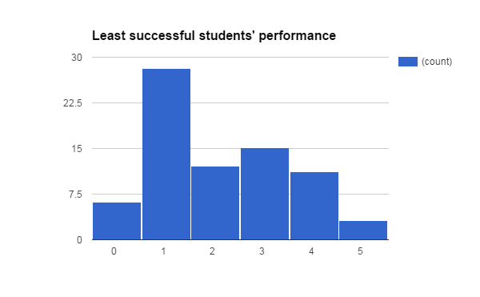

Reflection on survey results and process

The results document a rich breadth and depth of instruction and assessment around course outcomes. Clearly, TCC faculty are involved in a variety of modes of teaching and assessing learning outcomes.
However, a possible shortcoming of the current method is that a relatively small number of faculty respond each quarter, and mostly full time. As with any opportunistic sample, there is a limitation; in this case, perhaps only those confident with their assessment of CLOs bothered to respond. We may want to consider providing incentives for instructors to provide CLO assessment data to improve the response rate.
While this survey is excellent for in-depth, qualitative data, we may also want to explore broader collection of quantitative data. Perhaps this survey can continue, along with collection of CLO data via Canvas. The limitation of collection via Canvas is that it offers a more limited range of assessments, primarily quizzes and writing; and not all instructors use Canvas; however, it has wide use across departments and could automate data collection, saving faculty time and effort. If teachers can be assisted in linking Canvas activities to outcomes, and that data easily collected or exported, we may be able to provide greater evidence of institution-wide assessment to supplement our qualitative data.

Comments about the survey [for SLIC]:

- Very easy to understand and navigate survey...keep it!
- No suggestions. It was short and easy to complete.
- I like its open-endedness and the freedom to describe however we will--though probably simply talking with my fellow EAP teachers would be more effective.
- This survey was easy to complete because the format facilitated the appropriate information needed.
- This lists examples of diff kinds of teaching support but not examples of different means of assessment. That would be helpful as a reminder and to broaden out options.
- This was a very good survey. It is clear that you knew what you wanted to find out before you started writing it (I know you all know that this step isn't necessarily taken in designing assessment!). It gave me an opportunity to reflect and look at different elements of the modules I use to teach to the CLOs I listed for LS 102 in a way that was helpful to me also. At the same time, the survey was not a grinding chore.
- I assume the subjective self-ratings of our class, assessment and students are to prompt reflection, as the data from such items may not be reliable. In addition, I would wager the best students did well, the average students did ok, and the least successful students struggled. Maybe those 3 items could be cut.
- I think it works well.
- The results of the survey should be compiled and reported on after every quarter (or at the beginning of the next quarter)
- I would appreciate defined terms. For example, is the "least successful student" the least successful student that attends class at least 80% of the time? Or the person that scored the lowest on the exam? Or the person that I hadn't seen in a couple weeks so they had the lowest course grade at the time of the unit? I have similar concerns with the terms "average student" and "most successful student." I'm also not sure if a rating of a 5 on my class and assessment implies I think I have no room for improvement, or if it means I think I do a comparable job to my colleagues. This is my first time completing this survey, so perhaps I'm over-thinking and being over-critical on my ability to accurately provide information for the survey purposes.

