LS 101, Introduction to Research, Assessment Project

Prepared by Heather Marie Gillanders, 11/20/15

Introduction
In fall 2014, the library conducted an assessment project for LS 101, Introduction to Research. Our goal was to measure how well students are meeting the course learning outcomes (CLOs), identify areas for improvement, and determine if any of the CLOs needed to be refined/changed.

This project supports the Create Learning goal of the TCC Strategic Plan:
Develop and assess learning outcomes to ensure students transition successfully with the necessary knowledge and skills for further education and responsible citizenship in a global society.

Method
A 30-question pretest and posttest were collaboratively developed by 4 TCC librarians using SurveyMonkey. The questions for both were the same and were developed specifically to address all 7 CLOs for LS 101, each of which is mapped to our program learning outcomes (PLOs).
- Follow a plan for finding information using a variety of electronic and print tools (PLO: 1, 2, 3)
- Generate research questions and create a thesis based on the analysis of resources (PLO: 2, 3, 5)
- Demonstrate basic use of electronic search strategies, such as Boolean operators and phrase searching (PLO: 2)
- Describe the standard criteria that qualify information sources as appropriate to use in academic research projects (PLO: 1, 3)
- Describe and collect the elements necessary for a citation in a standard style (PLO: 4)
- Incorporate information from research into a written product, using appropriate academic style (PLO: 5)
- Identify and explain the differences between major types of information resources (e.g., books, lay periodicals, scholarly journals, wikis, etc.) (PLO: 2)
The pretest was administered at the beginning of Fall 2014, the posttest at the end of Fall 2014, and results were collected by SurveyMonkey. Data analysis was performed by one librarian.
Our goal was for 80% of students to demonstrate attainment of each of the CLOs in the posttest by correctly answering each of the questions.

Results
There were a total of 33 respondents amongst all 3 fall quarter classes (1 hybrid, 2 full online). The total enrollment for these 3 classes was 64, so over 50% of students participated.

As the following table illustrates, students had varied success with achievement of the CLOs.
Skill | CLO | Success rate (Pretest) | Success rate (Posttest) | Gain/Loss
Using appropriate databases | 1 | 76.00% | 81.82% | 5.82%
Narrowing a broad topic | 2 | 63.33% | 79.31% | 15.98%
Identifying an effective research question | 2 | 60.00% | 51.75% | 8.28%
Using appropriate keywords | 3 | 80.00% | 86.90% | 6.90%
Identifying a phrase search | 3 | 78.79% | 90.91% | 12.11%
Using a Boolean operator to narrow a search | 3 | 42.42% | 54.55% | 12.13%
Evaluating a Web site | 4 | 63.27% | 75.76% | 12.49%
Identifying a citation style | 5 | 33.33% | 69.70% | 24.25%
Identifying the journal title within a given citation | 5 | 36.36% | 54.55% | 18.19%
Identifying a paraphrase that is not plagiarized | 6 | 26.67% | 20.69% | 5.98%
Selecting a newspaper article when it is the best source for a given information need | 7 | 66.67% | 69.70% | 3.03%
Selecting a scholarly journal article when it is the best source for a given information need | 7 | 72.73% | 72.73% | 0.00%
Finding a scholarly article | 4, 7 | 76.00% | 81.82% | 11.82%
Identifying the characteristics of a scholarly article | 4, 7 | 63.27% | 75.76% | 12.49%

Table Key
Met 80% benchmark
Within 5% of 80% benchmark
Did not meet 80% benchmark, but improved by at least 10%

Discussion
The CLOs that were the most problematic in this assessment were CLOs 2, 6, and 7. Most concerning were CLOs 2 and 6, in which students actually lost ground as a result of having taken the LS 101 class. Mapping the CLOs to Bloom’s Revised Taxonomy (2001) shows that CLOs 2 and 6 were at the creating level of Bloom’s taxonomy, which is inappropriate for an 100-level, introduction course.
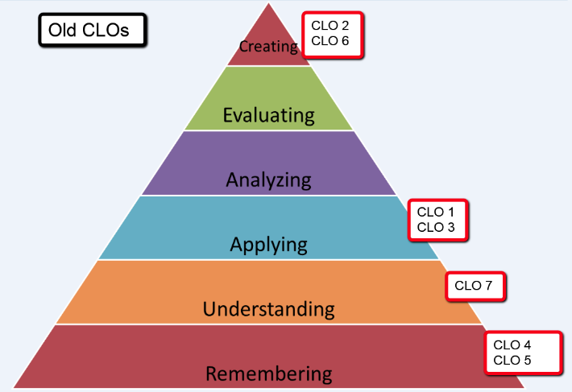
On the other hand while at the understanding level of Bloom’s, CLO 7 also proved problematic for students. This gap in achievement ultimately had more to do with our approach to teaching this concept. The outcome previously read, Identify and explain the differences between, major types of information resources (e.g., books, lay periodicals, scholarly journals, wikis, etc.), however other skills are essential in being able to succeed with this outcome such as an ability to determine how and when a type of source should be used.
It is also important to note that the results of this assessment project were consistent with national information literacy assessment projects.

Changes Implemented
The first step in responding to the data from this assessment was to revise the CLOs. In making these revisions, we consulted Bloom’s Taxonomy and the Association of College & Research Libraries (ACRL) Framework for Information Literacy (2015). These CLOs went to Curriculum Committee in November 2015 and were approved; they read as follows:
The [ACRL] Framework … is called a framework intentionally because it is based on a cluster of interconnected core concepts [i.e. threshold concepts], with flexible options for implementation, rather than on a set of standards or learning outcomes, or any prescriptive enumeration of skills. At the heart of this Framework are conceptual understandings that organize many other concepts and ideas about information, research, and scholarship into a coherent whole.
- Follow a plan for finding information using a variety of electronic and print tools (PLO 1, 2, 3)
- Employ strategic processes of inquiry to guide and refine information needs and search strategies. (PLO 2, 3, 5)
- Demonstrate basic use of electronic search strategies. (PLO 2)
- Describe the purpose of and collect the elements necessary for a citation in a standard style. (PLO 4)
- Develop familiarity with sources of evidence, methods, and modes of discourse. (PLO 5)
- Identify and explain the differences between major types of information resources (e.g., books, lay periodicals, scholarly journals, wikis, etc.) and when and how to use them. (PLO 1, 2, 3)
As illustrated in the figure below, these new CLOs each map to more appropriate levels of Bloom’s for an 100-level, introductory course.
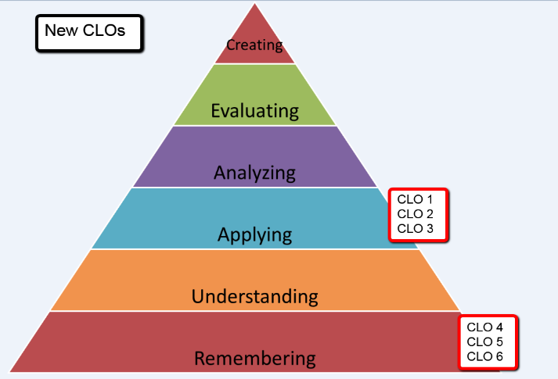
In addition, we are currently in the process of revising the LS 101 curriculum, starting with the assignments and rubrics. As part of this process, we are uploading all of our CLOs to Canvas and tagging all assignments with the CLOs measured. In the future, we will use the Learning Mastery tab in Canvas’ Gradebook to track achievement of the CLOs as opposed to having a separate pretest/posttest. This will not only help to save time, but will ensure consistent assessment of the outcomes, allow instructors to make adjustments during the course if students are struggling with a particular CLO, and enable students to track how they are performing.
Finally, as a result of this and other assessment projects, we will be revising our Program Learning Outcomes (PLOs).

Bibliography
Armstrong, Patricia. “Bloom’s Taxonomy.” Vanderbilt University Center for Teaching and Learning. https://cft.vanderbilt.edu/guides-sub-pages/blooms-taxonomy/.
Association of College and Research Libraries Board. “Framework for Information Literacy for Higher Education.” Association of College and Research Libraries. http://www.ala.org/acrl/standards/ilframework.
Bickerstaff, Susan, Melissa Barragan, and Zawadi Rucks-Ahidiana. “I Came Unsure of Everything: Community College Students’ Shift in Confidence.” CCRC Working Paper No. 48, September 2012.
Bizup, Joseph. "BEAM: A rhetorical vocabulary for teaching research-based writing." Rhetoric Review 27.1 (2008): 72-86.
Deitering, Anne-Marie, Meredith Farkas, and Sara Seely. “Good for What? Teaching Sources for Sustainable Lifelong Information Literacy.” PowerPoint presentation at the Association of College and Research Libraries Conference, Portland, Oregon, March 26, 2015.
Gilchrist, Debra. “Leading with Strategy and Evidence.” PowerPoint presentation at the Library Assessment Conference, University of Washington, Seattle, Washington, August 4, 2014.
Radcliff, Carolyn, Megan Oakleaf, and Michele Van Hoek. “So What? The Results and Impact of a Decade of IMLS-Funded Information Literacy Assessments.” PowerPoint presentation at the Library Assessment Conference, University of Washington, Seattle, Washington, August 6, 2014.

Patricia Armstrong, “Bloom’s Taxonomy,” Vanderbilt University Center for Teaching and Learning, https://cft.vanderbilt.edu/guides-sub-pages/blooms-taxonomy/ (accessed November 19, 2015).
Carolyn Radcliff, Megan Oakleaf, and Michele Van Hoek, “So What? The Results and Impact of a Decade of IMLS-Funded Information Literacy Assessments,” PowerPoint presentation at the Library Assessment Conference, University of Washington, Seattle, Washington, August 6, 2014.
Association of College and Research Libraries Board, “Framework for Information Literacy for Higher Education,” Association of College and Research Libraries, http://www.ala.org/acrl/standards/ilframework (accessed November 19, 2015). See text box on this page.

