Tacoma Community College

CurriQūnet Help

A video version of this document is available at https://tinyurl.com/CurriQunetIntro.

An Introduction to CurriQūnet

The header of most pages in CurriQūnet looks like this:

Clicking on the CurriQūnet logo takes you to your homepage. You can access all proposals using the Curriculum button. If you are involved in reviewing proposals, the Approvals button shows you how many proposals await your review and takes you to the approval process. The Create Proposal button lets you create proposals.

How do I find a proposal?

When CurriQūnet opens, only your proposals are shown. To view other proposals, select the filter & sort icon (the second icon next to the Search window).

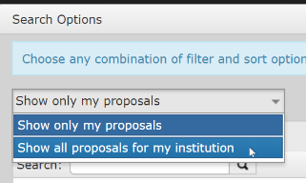
The default option is "Show only my proposals". You want "Show all proposals for my institution".

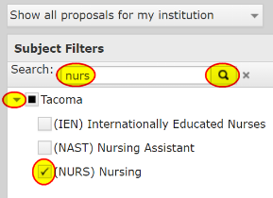
You can quickly limit the course options. For example, to limit the search to NURS courses, type "nurs" into the Search window, then click the Search icon and the triangle next to Tacoma. Finally, select the (NURS) Nursing courses.

Once you have selected all the subjects you want displayed, select Filters and Sort Options. You probably want only the Active courses, though you might want others like Draft, In Review, or Historical proposals. I recommend the Subject and Course # Sort Options:

Then click Apply. You should now have one or more pages of proposals displayed.

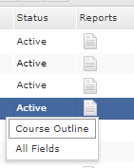
When you click on a proposal, you will see its History. The Course Outline Report contains much of the information in the Course Proposal.

You may also click "View Course Proposal" to see everything in the proposal.

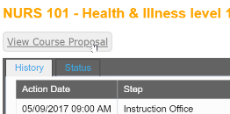

How do I find a Degree, Certificate, or Distinction Pathway Proposal?

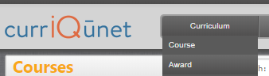
Degrees, Certificates, and Distinction Pathways are grouped under “Awards” in CurriQūnet. To switch from viewing Courses to viewing Awards, click on the Curriculum button at the top of the screen and select Award.

The Filtering and Sorting process is very similar to that for Courses. Again, you probably want "Show all proposals for my institution". For Awards, you may wish to just click the triangle next to Tacoma Program and scroll down to find the Awards you are interested in.

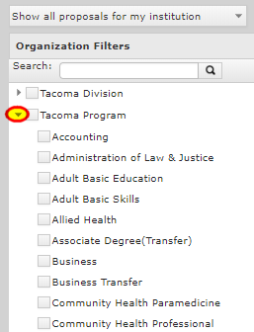

Need More Help?
If you need more help using CurriQūnet please email outcomes@tacomacc.edu.

