Tacoma Community College

CurriQūnet Help

Hold for Changes

Someone in the approval workflow has placed a Hold for Changes on your proposal, sending it back to you so you can make some changes. Now what?

Find your proposal

The first step is to find your proposal. Once a proposal is Launched, it can be found in the Approvals queue. Click on the Approvals button at the top of the CurriQunet page.

You should see your proposal listed with Originator as the position. It is highlighted in pink to help you.

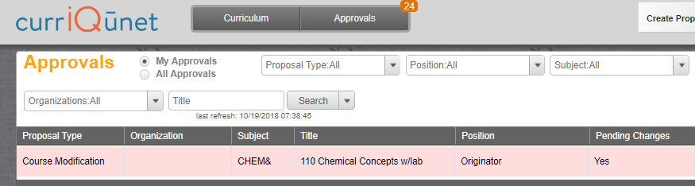

Edit your proposal

Click on the proposal, and you will get the Approval Update for Originator page.

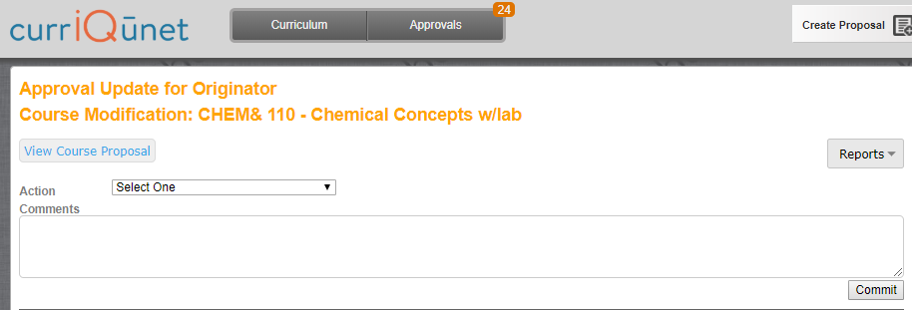

Click the “View Course Proposal” button to edit your proposal.

Return your proposal to the approval queue

Once you are ready to send your proposal back to the approval queue, go back to the Approval Update for Originator page and select “Requested Changes Made” in the Action pull down (where it says Select One). Type any comments you have in the Comments window. Then click Commit. The proposal is now back in the Approvals queue of whoever place the Hold on it.

CurriQunet will send an email to whoever put the hold on the proposal. This happens overnight, so you might want to email that person yourself.

Need More Help?
If you need more help using CurriQūnet please email outcomes@tacomacc.edu.

