COM Assessment Report, Summer 2019
Prepared by Heather Gillanders, CLAC co-chair, Corinne Jarvis, CLAC co-chair, Amunoo Tembo, and Gavin Albright

Introduction
In the 2016-17 academic year, TCC conducted a meta-assessment of all instructional assessment processes and procedures. In addition, TCC had its mid-cycle accreditation visit, which was focused on instructional assessment. One outcome of both was the revision of TCC’s degree learning outcomes (DLOs), which was led by the Student Learning Improvement Council (SLIC). The mid-cycle accreditation team recommended a consistent methodology for DLO assessment. It was therefore decided to use rubrics to evaluate student work that measures each DLO going forward, and for the SLIC committee to lead these efforts. These changes were reviewed by Instructional Council (IC) and subsequently approved in February 2017.
The SLIC committee then changed its name to the College-wide Learning Assessment Committee (CLAC) and revised its mission statement to more accurately reflect its focus on leading DLO assessment. The revised mission statement reads:
Supporting Tacoma Community College’s Create Learning core theme through the planning and coordination of institution-wide assessment, including but not limited to student achievement of degree learning outcomes.
This report is for the Communication (COM) DLO, which reads:
Listen, speak, read, and write effectively and use nonverbal and technological means to make connections between self and others.
The verbiage of this particular DLO was not revised during meta-assessment. It was last assessed in 2011-12 by gathering student work and evaluating it using a rubric.

Method
Faculty representing all divisions scored student artifacts using a rubric. Artifacts came from the following divisions: Communications and Transitional Studies; Arts, Humanities, and Social Sciences; Math, Science, and Engineering; and Health, Business, and Professional Services. A total of 457 individual artifacts from 26 classes are included.
The rubric was adapted with permission from South Seattle College to fit the language of Tacoma Community College’s COM DLO; the TCC rubric used in 2011-12 to assess this outcome was also consulted. Members of the CLAC committee created the first draft, solicited feedback from faculty, and revised the rubrics based on faculty feedback to create the final draft:
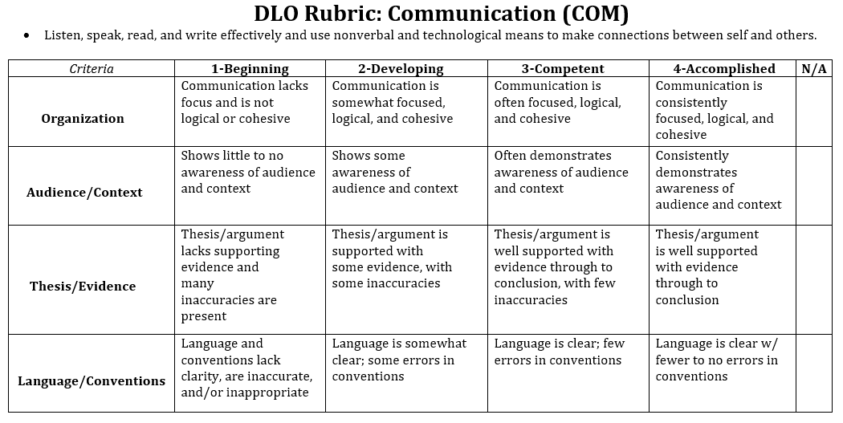
In collaboration with e-Learning, a Canvas shell for the COM DLO was created and all artifacts were uploaded to the shell to be scored using the rubric and to act as a repository of student work for potential future assessment projects. As much as possible, artifacts were anonymized, removing student names and ID numbers. Only those faculty scoring artifacts, CLAC members, and e-Learning have access to these Canvas shells.
All of the faculty who scored the artifacts participated in a norming session prior to receiving their assignments to ensure that the criteria was clear and that all were applying the rubric in roughly the same way. Scores for each criterion for every artifact were transferred into an Excel spreadsheet and analyzed.

Results
On a scale of 1 to 4, where 1 is the lowest and 4 the highest, the average score for all criteria was 3.22, which places students between the competent and accomplished levels. The highest average score was for the audience/context criterion at 3.31, followed by organization at 3.25, then language/conventions at 3.20, and finally thesis/evidence at 3.14.

Celebration of Learning
A total of 59 artifacts from the Celebration of Learning were included in the sample. The results of analyzing the Celebration of Learning artifacts only showed a higher average for each criterion when compared to the averages of all artifacts combined. The highest average score was again for audience/context at 3.71, followed by language/conventions at 3.66, and finally organization and thesis/evidence both had an average score of 3.64.

When Celebration of Learning artifacts are removed, the average for all criteria for the remaining 398 artifacts is lower than it is when all artifacts are combined with the exception of language/conventions. The highest score remains audience/context at 3.25, followed by organization at 3.19, then language/conventions again at 3.13, and finally thesis/evidence at 3.07.

100-level vs. 200-level:
A total of 147 artifacts from 100-level classes were included in the sample. The average for all criteria for these artifacts is lower than it is when all artifacts are combined. The highest average score was language and conventions at 3.15, followed by audience/context and organization at 3.12, and finally thesis/evidence at 3.05.

A total of 302 artifacts from 200-level classes were included in the sample. The average for all criteria for these artifacts is higher than it is when all artifacts are combined. The highest average score was audience/context at 3.42, followed organization at 3.33, then language and conventions at 3.24 and finally thesis/evidence at 3.20.

NOTE: There were too few submissions from Transitional Studies to warrant looking at this group separately.

Professional-Technical Programs
A total of 83 artifacts from the Professional-Technical programs were included in the sample. The average for each criterion was higher than the average for all artifacts combined. The highest average score was again for audience/context at 3.66, followed by organization at 3.61, then thesis/evidence at 3.54, and finally language/conventions at 3.49.

When Professional-Technical artifacts are removed, the average for all criteria for the remaining 374 artifacts is lower than it is when all artifacts are combined with the exception of language/conventions. The highest score is still audience/context at 3.23, followed by organization at 3.16, then language conventions at 3.05, and finally thesis/evidence at 3.05.

Limitations
No statisticians serve on the committee; however, CLAC welcomes any assistance with data analysis in the future. In addition, some assignments were group assignments, while others were to be completed individually; scorers did not weight these assignments differently.

Discussion
Data was sorted in a variety of ways to provide a snapshot of student achievement and identify possible areas of opportunity.
While the scores vary depending on how the data is sorted, audience/context is generally the criterion on which students score the highest, while thesis/evidence is often the lowest. Nevertheless, scores for all criteria are between a three and a four, placing students between the competent and accomplished levels. Given that these skills are developed iteratively over time and students will continue to apply and develop these skills throughout the remainder of their time at TCC, these scores seem appropriate.
Since the rubric used in 2011-12 included different criteria and was adapted from an AAC&U rubric, which is geared toward students at four-year institutions, no accurate comparisons can be made with previous assessment work. However, it can be noted that several challenges identified in the 2011-12 report have been addressed such as; student confidentiality and use of assignments, assignment instructions, the storing of artifacts, and the application of the rubric.

Recommendations
Guided assignments or annotated bibliographies might be a good preliminary step to help students identify supporting evidence and consider how they might use it in a research paper or report. Transparency in Learning and Teaching (TILT) efforts across campus will also be useful in making assignments more transparent and clear to students; faculty who are unfamiliar with TILT might consider attending a PDD event or visiting the TILT website (https://tilthighered.com/) to learn more.
Faculty librarians are also a good resource. Librarians can give guidance on assignment design, provide in-person library research workshops (find the library’s instruction request form here: http://goo.gl/forms/INXzLPG2Tb), design online library research modules for Canvas for online and hybrid classes, or create an on online research guide (LibGuide) tailored for a specific class (see the library’s online research guides here for some examples: http://tacomacc.libguides.com/TCCLibrary/research-guides).
Other important resources to help improve development of assignments include the Writing and Tutoring Center, TCC’s Instructional Designer, relevant PDD sessions, other faculty, the Instructional Assessment Steering Committee (IASC), and CLAC.
Additionally, faculty can also use this report to help inform curriculum revisions in their classes/program or to as a starting point in creating their own assessment project around COM.
Many of these recommendations mirror those made in 2011-12. To see that report, visit the TCC Instructional Assessment Canvas course here (see the Degree Learning Outcome Projects module): https://tacomacc.instructure.com/courses/1299967

