ICD Assessment Report, Summer 2020
Prepared by Corinne Jarvis, CLAC Chair; Heather Gillanders; and Amunoo Tembo

Introduction
In the 2016-17 academic year, TCC conducted a meta-assessment of all instructional assessment processes and procedures. In addition, TCC had its mid-cycle accreditation visit, which was focused on instructional assessment. One outcome of both was the revision of TCC’s degree learning outcomes (DLOs), which was led by the Student Learning Improvement Council (SLIC). The mid-cycle accreditation team recommended a consistent methodology for DLO assessment. It was therefore decided to use rubrics to evaluate student work that measures each DLO going forward, and for the SLIC committee to lead these efforts. These changes were reviewed by Instructional Council (IC) and subsequently approved in February 2017.
The SLIC committee then changed its name to the College-wide Learning Assessment Committee (CLAC) and revised its mission statement to more accurately reflect its focus on leading DLO assessment. The revised mission statement reads:
Supporting Tacoma Community College’s core themes through the planning and coordination of institution-wide assessment, including but not limited to student achievement of degree learning outcomes.
This report is for the Intercultural Collaboration & Diversity (ICD) DLO, which reads:​
Demonstrate successful application of an interdependent, diverse, and multicultural worldview through collaborative engagement.
This DLO is new (and thus it has not been assessed in the past) but is based on a revision of the Living & Working Cooperatively/Valuing Differences (LWC) DLO from the last assessment cycle, which read:
Respectfully acknowledge diverse points of view, and draw upon the knowledge and experience of others to collaborate in a multicultural and complex world.

Method
Faculty representing most divisions scored student artifacts using a rubric. Artifacts came from the following divisions: Communications and Transitional Studies; Arts, Humanities, and Social Sciences; and Health, Business and Professional Services. A combined total of 376 artifacts were submitted for scoring ICD. The participating faculty were able to score 261 artifacts for ICD. From this total, approximately 261 individual artifacts from 13 assignments are included.
The rubric was adapted with permission from South Seattle College to fit the language of Tacoma Community College’s ICD DLO. Members of the CLAC committee created the first draft, solicited feedback from faculty, and revised the rubric based on faculty feedback to create the final draft:
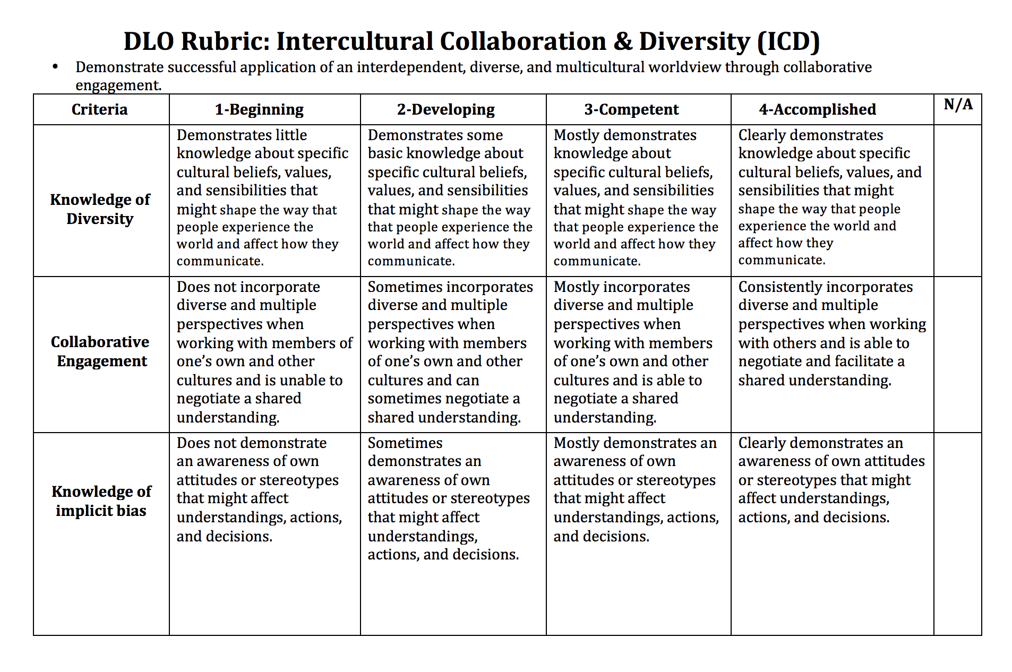
In collaboration with e-Learning, a Canvas shell for the ICD DLO was created and all artifacts were uploaded to the shell to be scored using the rubric and to act as a repository of student work for potential future assessment projects. As much as possible, artifacts were anonymized, removing student names and ID numbers. Only those faculty scoring artifacts, CLAC members, and e-Learning have access to these Canvas shells.
All of the faculty who scored the artifacts participated in a norming session prior to receiving their assignments to ensure that the criteria was clear and that all were applying the rubric in roughly the same way. Scores for each criterion for every artifact were transferred into an Excel spreadsheet and analyzed.

Results

On a scale of 1 to 3, where 1 is the lowest and 3 the highest, the average score for all criteria was 2.82, which places students between the developing and competent levels. The highest average score was for the knowledge and diversity criterion at 3.09, followed by collaborative engagement at 2.85, then knowledge of implicit bias at 2.53.

100-level vs. 200-level:
A total of 243 artifacts from 100-level classes were included in the sample. The average score for each criterion is slightly lower than it is when all artifacts are combined, except for collaborative engagement. In fact, like all the artifacts combined, the highest average score was knowledge of diversity at 3.08, followed by collaborative engagement at 2.95, and finally knowledge of implicit bias at 2.31.

A total of 18 artifacts from 200-level classes were included in the sample. The average score for each criterion is slightly higher than it is when all artifacts are combined, except for knowledge of implicit bias, which was not applicable to the artifacts scored. The highest average score was knowledge of diversity at 3.11, followed collaboration engagement at 3.06.

Professional-Technical Programs
A total of 42 artifacts from the Professional-Technical programs were included in the sample. The average for each criterion was lower than the average for all artifacts combined, except for knowledge of implicit bias. The highest average score was knowledge of diversity at 2.90, followed by knowledge of implicit bias at 2.88, then collaboration engagement at 2.25.

When Professional-Technical artifacts are removed, the average for each criterion for the remaining 219 artifacts is slightly higher than it is when all artifacts are combined, except for knowledge of implicit bias. The highest score is still knowledge of diversity at 3.13, followed by collaboration engagement at 3.11, then knowledge of implicit bias at 2.42.

Limitations
No statisticians served on the committee; thus, no inferential statistical techniques were used for analysis. CLAC welcomes any assistance with data analysis in the future.
Not many of the assignments measured the collaborative engagement criterion so there was likely not enough data to generalize. Additionally, we had a collaborative engagement criterion, though no assignments were group assignments, and most required students to complete assignments individually; scorers did not weigh these assignments differently. The same is true for the knowledge of implicit bias criterion, when scoring for this DLO faculty indicated that there were many assignments in which the implicit bias criterion did not apply. Also, it's important to note that although the scoring of these artifacts took place during the COVID-19 pandemic, the artifacts submitted were from classes and assignments before the pandemic.
The Canvas LMS works well as a repository and to facilitate scoring of artifacts using a rubric, but it does not provide tools for the analysis of individual rubric criterion. Thus, significant time and effort went into the manual data entry of individual criterion scores into MS Excel.
Although we scored data from 100 and 200 level courses, we only scored artifacts from one 200 level course (a psychology course) so it is not realistic to make comparisons between how students are achieving this DLO in a 100 vs 200 leveled course. Additionally, while most of the divisions were represented in our scoring, we scored artifacts from one class in the Health, Business and Professional Services division (RS 170). In fact, most of the artifacts scored were from the Communication and Transitional Studies division. Thus, it is likely that there is not enough data for the ICD DLO assessment to be generalizable since many of the artifacts are from a few rather than all the divisions.
This does not provide a range of details as to how students are achieving this DLO across all the academic divisions. Additionally, most of the assignments used to score the artifacts had some diversity aspect to them which didn’t necessarily mean that they were a great fit for the DLO without details about collaboration and engagement and/or implicit bias.
Since Intercultural, Collaboration and Diversity (ICD) is a newer DLO, this was our first time assessing it. It is also based on a revision of the Living & Working Cooperatively/Valuing Differences (LWC) DLO from the last assessment cycle, which read:
Respectfully acknowledge diverse points of view, and draw upon the knowledge and experience of others to collaborate in a multicultural and complex world.
LWC was last assessed in 2013 where a student survey was used. The taskforce wanted to target students who were ready to graduate in June 2014. The survey was, therefore, primarily administered to students enrolled in 200-level courses with a 100-level prerequisite and those nearing graduation. In addition, a link to a Survey Monkey version of the survey was emailed to all students with more than 60 credits (5000+ students).
The results of the LWC report indicated that overall, TCC students can acknowledge diverse points of view. For example, 81.7% of responses reported to mostly/strongly agree with the statement, “I am tolerant of others with different beliefs.” 89.9% students reported that they mostly/strongly agreed with the statement that they were able to work cooperatively with diverse people. 91.7% of students reported the ability to get along with people from different races/cultures. Specifically, while 77.7% reported to have knowledge of people from different races/cultures. Only 26.9% of students report ever having attended a racial/cultural event such as Ethnic Fest, POW WOWs, Luaus, and the Cultural Diversity Film Festival.

Discussion
Data was sorted in a variety of ways to provide a snapshot of student achievement and identify possible areas of opportunity.
While the scores vary depending on how the data is sorted, knowledge of diversity is generally the criterion on which students score the highest, while knowledge of implicit bias is often the lowest. Nevertheless, scores for all criteria are generally between about a two and a three, placing students between the developing and competent levels. Given that these skills are developed iteratively over time and students will continue to apply and develop these skills throughout the remainder of their time at TCC, these scores seem appropriate yet there is room for improvement.
Since the assessment in 2013, the Degree Learning Outcomes as well as the assessment methods have changed, no accurate comparisons can be made with previous assessment work. However, it can be noted that several challenges identified in the 2013 report have been addressed such as student confidentiality and use of assignments, assignment instructions, the storing of artifacts, and the application of the rubric.
One thing that remained consistent in the two studies was the use of the idea of having diverse points of views. In the 2013 DLO assessment of LWC, the goal was to see how our students had achieved respectfully acknowledging diverse points of view while drawing upon knowledge and experience of others to collaborate in a multicultural and complex world. While this year’s assessment of the ICD DLO was to see how students achieved demonstrating successful application of an interdependent, diverse and multicultural world view through collaborative engagement. The ICD rubric involved criteria such as knowledge of diversity, collaborative engagement and implicit bias. Whereas the LWC student survey asked questions around the likeliness of acknowledging diverse points of view and seeking out experiences from a multicultural world. In 2013 one of the recommendations for future research was to administer a survey to faculty to address alignment between classroom activity and outcomes. While in our most recent assessment, we found that many of the artifacts submitted did not fully address the meaning of diverse points of view, include collaborative engagement or references of implicit bias. In most cases, the artifacts submitted may have shared the term “diverse or diversity” in them while other times it can be assumed that it was the instructor's perception of what diversity is.
Moreover, the 2013 study may have been subjective in the sense of students self-reporting, this assessment of ICD could also be viewed as subjective in that instructors submit student artifacts for the assignments they perceive to align with the DLO being assessed. This assessment illustrated that it is still possible that class activities may not always align with the outcome being assessed and that there is still a need to address meaning of terms used in the outcomes (an understanding of common language is necessary) across campus.
The college’s new Strategic Plan addresses the need to create meaningful learning, advance equity and strengthen student and community success, within the mission. Core Theme #1: Advancing Equity, Diversity and Inclusion. Goal 2 states that “We provide institutional responsibility, awareness and direct action to dismantle systems of oppression.” This is done by developing a shared understanding of common language that reflects our commitment to highlighting, disrupting and ending systems of oppression. With the addition of Equity, Diversity and inclusion in the new plan, it is possible that we may need to revise the ICD DLO once again with the intention of aligning our common language and making sure that there is a shared understanding of the new learning outcome across campus.

Recommendations
Continue to increase the sample size and ensure that samples are representative of all campus divisions. It is also important to consider how students might achieve our learning outcomes outside of instructional divisions and the need to involve assessment practices of student learning outcomes, college wide.
Common language is necessary moving forward- making sure everyone is aware of what the learning outcomes mean and the tools or rubrics we will use to assess before the collection of artifacts begins. This will help us all gain a better understanding of our promise to students as it relates to our shared meaning of Intercultural, Collaboration and Diversity (ICD) or Equity, Diversity and Inclusion.
With the new strategic plan and our campus’ efforts of being an antiracist institution, it may be noteworthy to revise the DLO to align with our institutional goals. Currently, we have some of the common language being used in campus spaces, trainings and the in the new Strategic Plan Core Themes (ex. Equity, Diversity and Inclusion). Accordingly, Intercultural, Collaboration and Diversity may not be consistent with the new language and still presents some gaps with how we might define it collectively.
Degree Learning Outcomes (DLO) assessment is an opportunity for us to review and reflect on how our students are achieving at the college level. To do this effectively, it’s important for us to be on the same page about the relationships we have with each other, our students, the language we use, judgements, services we provide and assignment /artifacts that are formed and disseminated. While working towards being an anti-racist institution, we also have to be mindful of how, “assessment practices can re(produce) power arrangements in order to examine and change them” (Inoue, 2015, pg 300). Moving forward, one way to use our power to create the experience we wish to see for our students may be to negotiate the meaning of our degree learning outcomes along with their rubrics and making the necessary changes needed to be aligned with our institutional goals. To do this, it is also necessary to recognize everyone’s role in contributing to the student experience as well as the institution mission and vision through anti-racist assessment and then tracking our progress in hopes reducing inequity and making continuous improvements.

References

- Inoue, A. B. (2015). Antiracist Writing Assessment Ecologies: Teaching and Assessing Writing for a Socially Just Future. Parlor Press.

