CRT Assessment Report, Summer 2020
Prepared by Corinne Jarvis, CLAC Chair; Heather Gillanders; and Amunoo Tembo

Introduction
In the 2016-17 academic year, TCC conducted a meta-assessment of all instructional assessment processes and procedures. In addition, TCC had its mid-cycle accreditation visit, which was focused on instructional assessment. One outcome of both was the revision of TCC’s degree learning outcomes (DLOs), which was led by the Student Learning Improvement Council (SLIC). The mid-cycle accreditation team recommended a consistent methodology for DLO assessment. It was therefore decided to use rubrics to evaluate student work that measures each DLO going forward, and for the SLIC committee to lead these efforts. These changes were reviewed by Instructional Council (IC) and subsequently approved in February 2017.
The SLIC committee then changed its name to the College-wide Learning Assessment Committee (CLAC) and revised its mission statement to more accurately reflect its focus on leading DLO assessment. The revised mission statement reads:
Supporting Tacoma Community College’s core themes through the planning and coordination of institution-wide assessment, including but not limited to student achievement of degree learning outcomes.
This report is for the Critical Thinking & Problem Solving (CRT) DLO, which reads:
Compare, analyze, and evaluate information and ideas to solve problems.
The verbiage of this DLO previously read:
Compare, analyze, and evaluate information and ideas, and use sound thinking skills to solve problems.
It was last assessed in 2012-13 by gathering student work and evaluating it using a rubric.

Method
In the 2017/18 academic year, the CLAC committee led the process of developing rubrics to evaluate student work for DLO assessment. With permission, a South Seattle College rubric was adapted to fit the language of Tacoma Community College’s CRT DLO. Members of the CLAC committee created the first draft (initially just a single rubric), solicited feedback from faculty (who suggested two rubrics: one for essay-type artifacts and one for STEM artifacts), and revised the rubrics based on faculty feedback to create the final drafts:

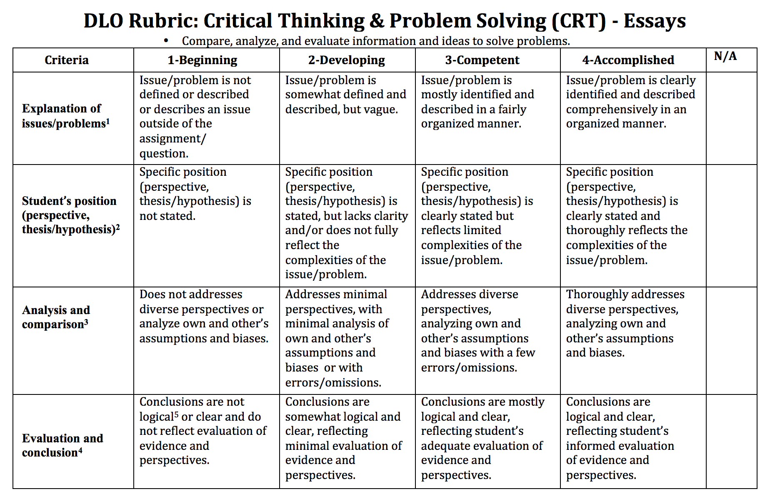
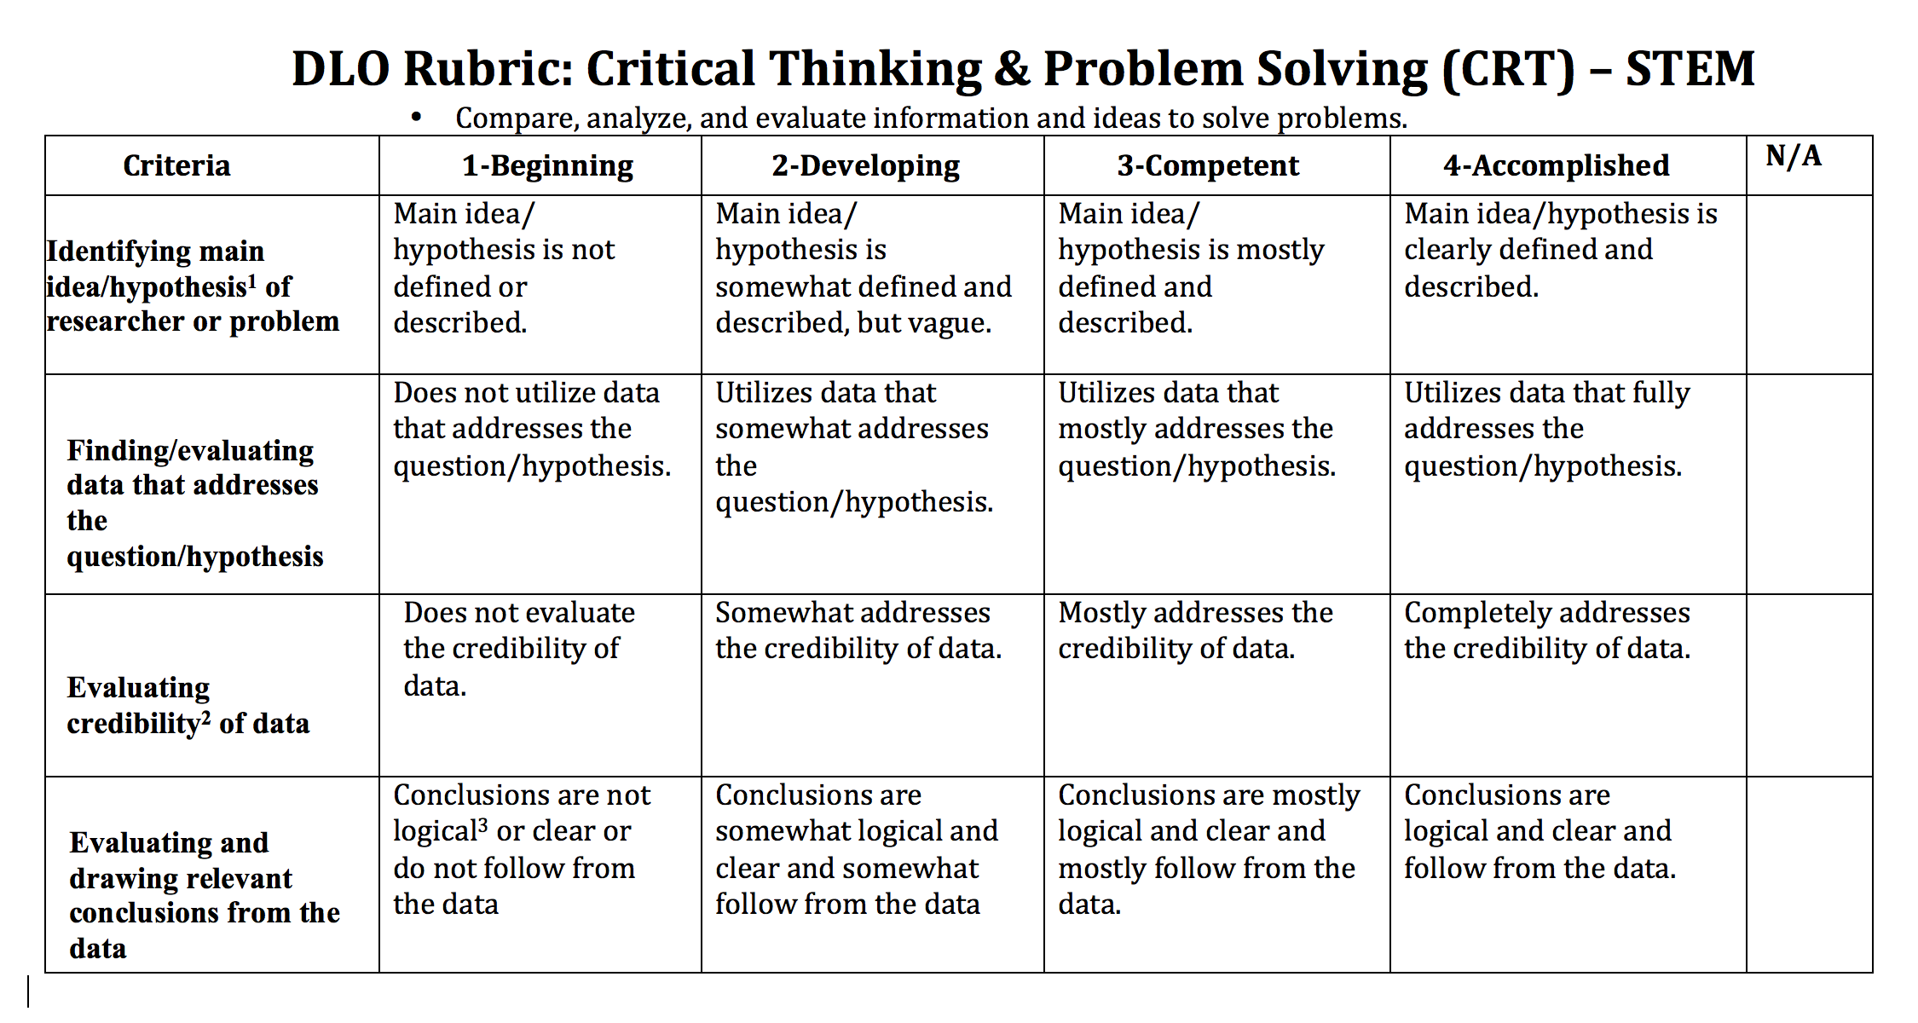

The CLAC committee began collecting student work for the Critical Thinking & Problem Solving DLO in winter quarter of 2019 and continued through fall quarter. The collection process began with an all-faculty email requesting assignments that aligned with the CRT DLO to be submitted by completing a short survey. The survey collected pertinent information such as instructor name, course information, assignment name, instructions, and due date.
In collaboration with e-Learning, a Canvas shell for the CRT DLO was created and all artifacts were uploaded to the shell to be scored using either the CRT-Essays or CRT-STEM rubric and to act as a repository of student work for potential future assessment projects. As much as possible, artifacts were anonymized, removing student names and ID numbers. Only those faculty scoring artifacts, CLAC members, and e-Learning have access to these Canvas shells.
Eighteen assignments were submitted for CRT assessment representing four divisions (Arts, Humanities, and Social Sciences; Health, Business, and Professional Services, Math, Science, and Engineering; and Written and Oral Communications). The assignment submissions resulted in 374 individual artifacts submitted for scoring.
In winter quarter 2020, the CLAC committee invited faculty from across campus to participate in the scoring process. Eight faculty from four campus divisions volunteered to score the student artifacts. Scoring was completed during spring quarter 2020 using two rubrics: one for essay-type artifacts and one for STEM artifacts (lab reports, etc.).
Of the 374 individual student artifacts, 322 were essay-type artifacts, and 52 were STEM artifacts. 340 individual artifacts were scored, approximately 90% of the total. 288 essay-type artifacts and all 52 STEM artifacts were scored.
All of the faculty who scored artifacts participated in a norming session prior to receiving their assignments to ensure that the criteria was clear and that all were applying the rubric in roughly the same way. Scores for each criterion for every artifact were transferred into an Excel spreadsheet and analyzed.

Results

CRT-Essays – All Data
On a scale of 1 to 4, where 1 is the lowest and 4 the highest, the average score for 288 scored CRT-Essays criteria was 3.04, which places students between the competent and accomplished levels. The highest average score was for the Explanation of Issues/Problems criterion at 3.23, followed by Student’s Position (perspective, thesis/hypothesis) criterion at 3.14, then the Evaluation and Conclusion criterion at 3.06, and finally the Analysis and Comparison criterion at 2.73.
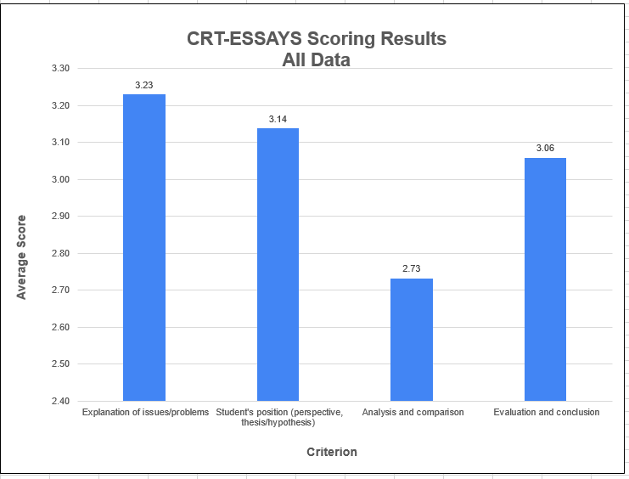

CRT-STEM – All Data
On a scale of 1 to 4, where 1 is the lowest and 4 the highest, the average score for 52 scored CRT-STEM criteria was 3.35, which places students between the competent and accomplished levels. The highest average score was for the Finding/Evaluating Data that Addresses the Question/Hypotheses criterion at 3.54, followed by the Identifying Main Idea/Hypothesis of Research or Problem criterion at 3.40, then the Evaluating Credibility of Data criterion at 3.33, and finally the Evaluating and Drawing Relevant Conclusions From the Data criterion at 3.14.

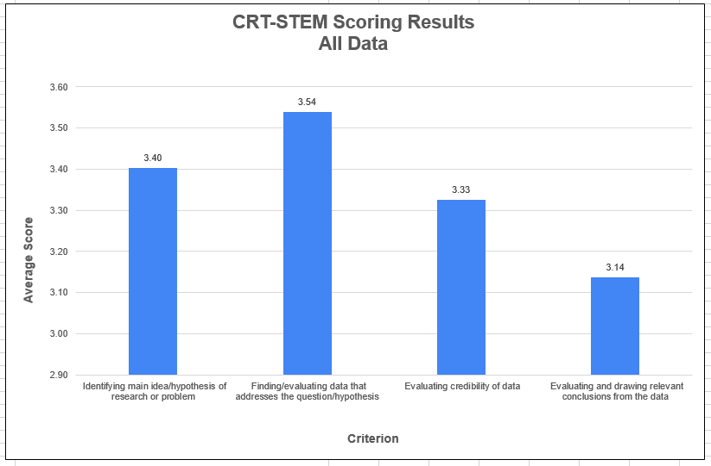

CRT-Essays - 100-Level
A total of 244 artifacts from 100-level classes were essay-type artifacts and 161 were scored, or 66% of the total. The average of all criteria for these artifacts was 3.04. The highest average score was the Explanation of Issues/Problems criterion at 3.17, followed by the Student’s Position (perspective, thesis/hypothesis) criterion at 3.06, then the Evaluation and Conclusion criterion at 2.99, and finally the Analysis and Comparison criterion at 2.87.

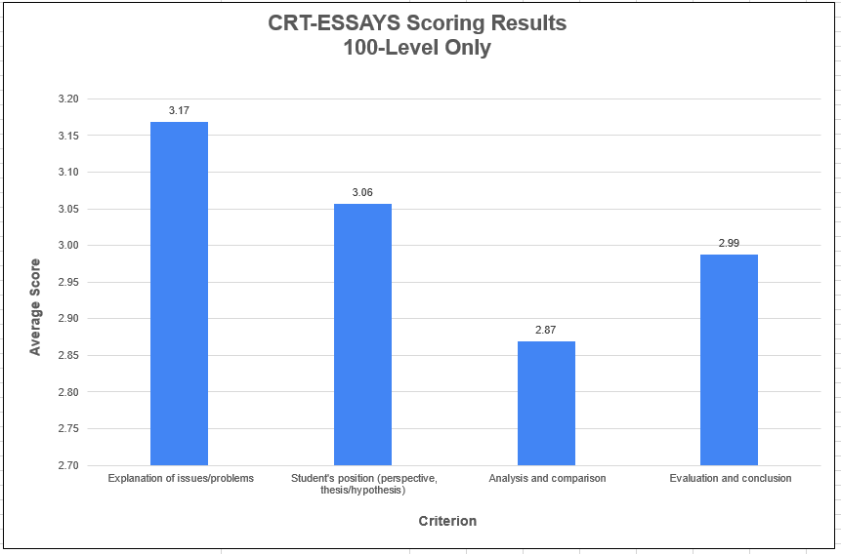

CRT-STEM - 100-Level
A total of 20 artifacts from 100-level classes were STEM-type artifacts and all 20 were scored, or 100% of the total. The average of all criteria for these artifacts was 3.68. The highest average score was the Finding/Evaluating Data that Addresses the Question/Hypothesis at 3.95, followed by the Evaluating credibility of Data criterion at 3.90, then the Identifying Main Idea/Hypothesis of Research or Problem criterion at 3.55, and finally the Evaluating and Drawing Relevant Conclusions From the Data criterion at 3.37.

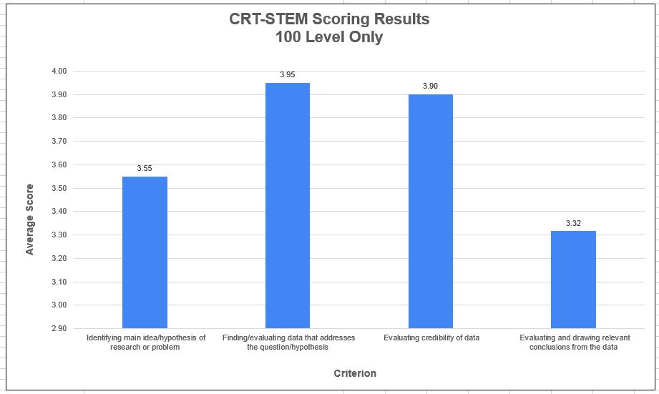

CRT-Essays - 200-Level
A total of 44 artifacts from 200-level classes were essay-type artifacts and 33 were scored, or 75% of the total. The average of all criteria for these artifacts was 3.20. The highest average score was the Student’s Position (perspective, thesis/hypothesis) criterion at 3.97, followed by the Explanation of Issues/Problems criterion at 3.45, then the Evaluation and Conclusion criterion at 3.27, and finally the Analysis and Comparison criterion at 2.27.

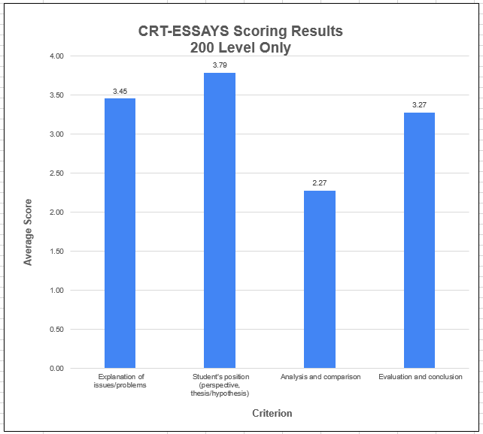

CRT-STEM - 200-Level
A total of 20 artifacts from 200-level classes were STEM-type artifacts and all 20 were scored, or 100% of the total. The average of all criteria for these artifacts was 2.96. The highest average score was the Identifying Main Idea/Hypothesis of Research or Problem criterion at 3.20, followed by the Finding/Evaluating Data that Addresses the Question/Hypothesis and Evaluating and Drawing Relevant Conclusions from the Data criterion, both at 2.95, and finally the Evaluating Credibility of Data criterion at 2.75.

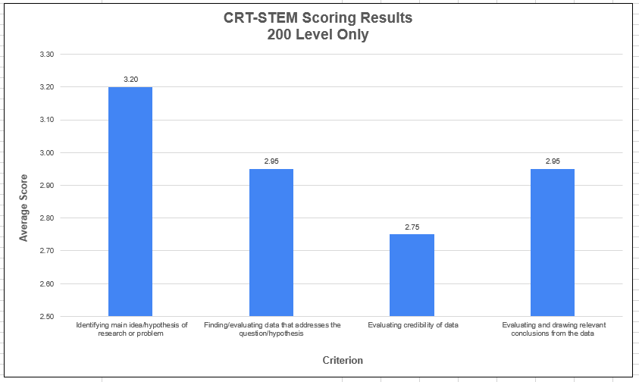

CRT-Essays - 300-Level
A total of 34 artifacts from 200-level classes were essay-type artifacts and all 34 were scored, or 100% of the total. The average of all criteria for these artifacts was 2.97. The highest average score was Explanation of Issues/Problems criterion at 3.29, followed by the Evaluation and Conclusion criterion at 3.18, then the Student’s position (perspective, thesis/hypothesis) criterion at 2.88, and finally the Analysis and Comparison criterion at 2.53.
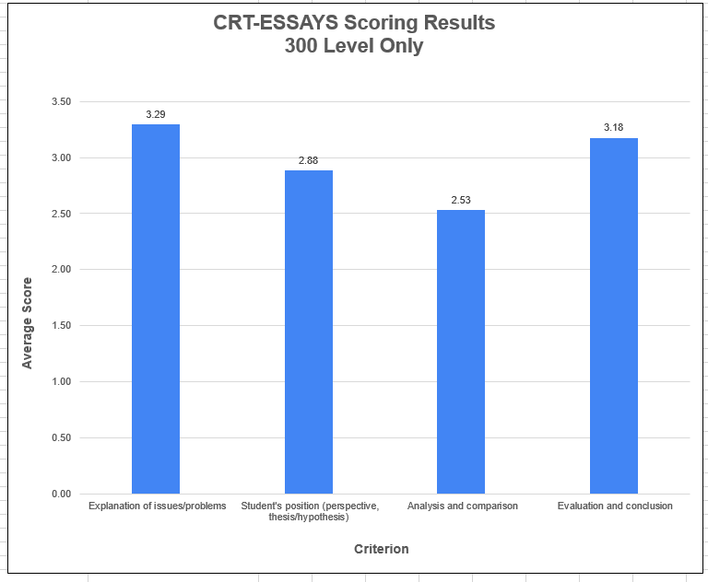

NOTE: There were no 300 level STEM submissions.

CRT-Essays - Professional-Technical Programs
A total of 53 artifacts from professional-technical classes were essay-type artifacts and 42 were scored, or 79% of the total. The average of all criteria for these artifacts was 3.21. The highest average score was the Student’s Position (perspective, thesis/hypothesis) and the Evaluation and Conclusion criterion, both at 3.33, followed by the Explanation of Issues/Problems criterion at 3.29, and finally the Analysis and Comparison criterion at 2.90.
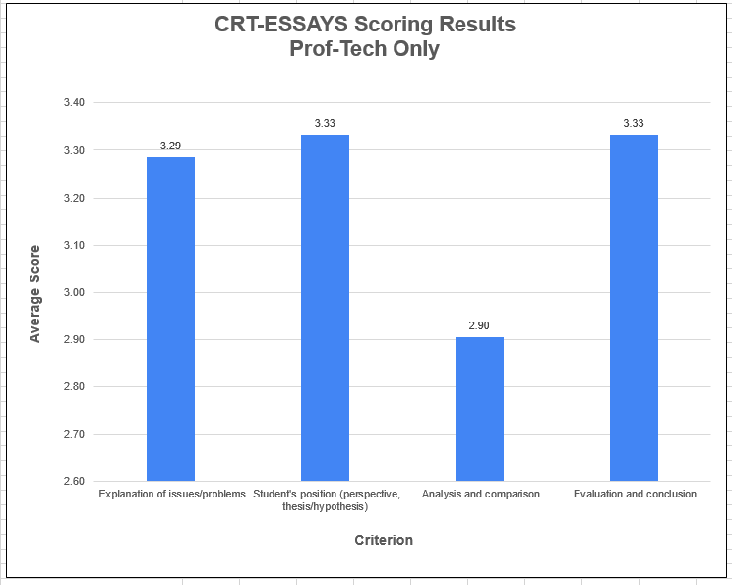

CRT-STEM – Professional-Technical Programs
A total of 12 artifacts from professional-technical classes were STEM-type artifacts and all 12 were scored, or 100% of the total. The average of all criteria for these artifacts was 3.50. The highest average score was the Finding/Evaluating Data that Addresses the Question/Hypothesis criterion at 3.83, followed by the Identifying Main Idea/Hypothesis of Research or Problem criterion at 3.50, then the Evaluating and Drawing Relevant Conclusions from the Data criterion at 3.17. The Evaluating Credibility of Data criterion did not apply to the artifacts submitted. Note: The 12 STEM-Professional-Technical program artifacts were also from 300 level course.
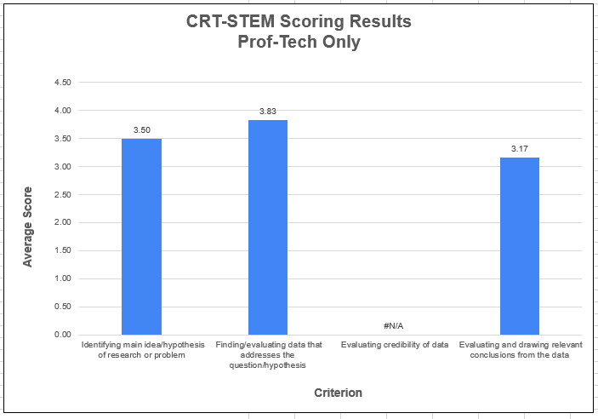

CRT-Essays – All except Professional-Technical Programs
A total of 269 artifacts from non Professional-Technical classes were essay-type artifacts, and 186 of these artifacts were scored, or 69% of the total. When Professional-Technical artifacts are removed, the average for the remaining essay-type artifacts is lower than it is when the artifacts are combined. The average for all criteria for these artifacts was 3.00. The highest average score was the Explanation of Issues/Problems criterion at 3.22, followed by the Student’s Position (perspective, thesis/hypothesis) criterion at 3.09. Then the Evaluation and Conclusion criterion at 2.99, and finally the Analysis and Comparison criterion at 2.69.
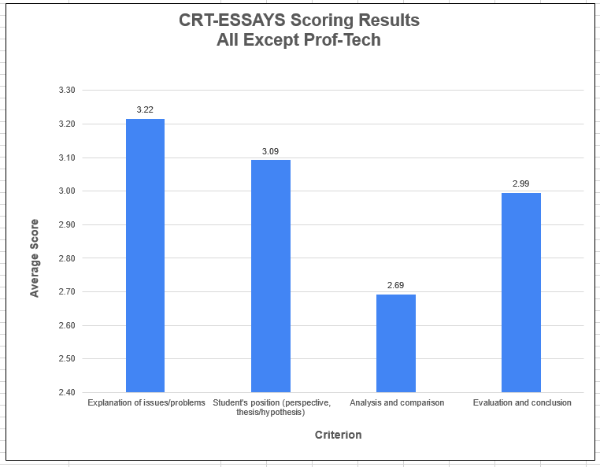

CRT-STEM – All except Professional-Technical Programs
A total of 40 artifacts from non Professional-Technical classes were STEM-type artifacts, and all 40 of these artifacts were scored, or 100% of the total. When Professional-Technical artifacts are removed, the average for the remaining STEM-type artifacts is lower than it is when the artifacts are combined. The average of all criteria for these artifacts was 3.32. The highest average score was the Finding/Evaluating Data that Addresses the Question/Hypothesis criterion at 3.45, followed by the Identifying Main Idea/Hypothesis of Research or Problem criterion at 3.38. Then the Evaluating Credibility of Data criterion at 3.33, and finally the Evaluating and Drawing Relevant Conclusions from the Data criterion at 3.13.
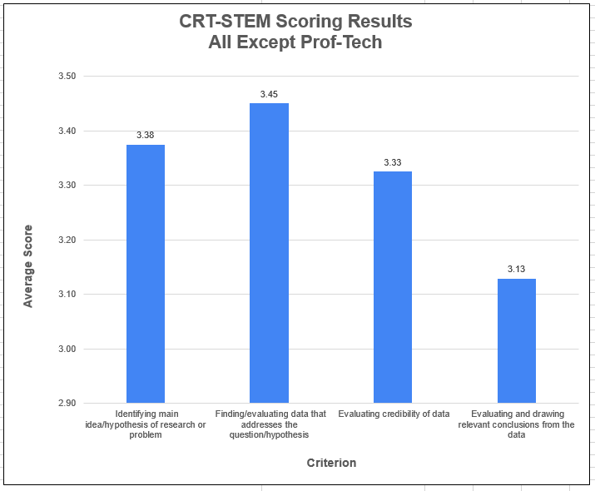
NOTE: There were no submissions from Transitional Studies to warrant looking at this group separately.

Limitations
No statisticians served on the committee, thus no inferential statistical techniques were used for analysis. CLAC welcomes any assistance with data analysis in the future.
The Canvas LMS works well as a repository and to facilitate scoring of artifacts using a rubric, but it does not provide tools for the analysis of individual rubric criterion. Thus, significant time and effort went into the manual data entry of individual criterion scores into MS Excel.
There were only 52 STEM-type artifacts to score, which might not a large enough sample size to generalize the results. The 52 submitted artifacts represented only two divisions on campus (Math, Science and Engineering; and HBPS). Not all of the STEM criterion applied to all of the STEM-type artifacts.
Evaluating the Analysis and Comparison criterion for the essay-type artifacts was problematic in some cases as many assignments did not ask students to address diverse perspectives or analyze their own positions or assumptions.

Discussion
Data was sorted in a variety of ways to provide a snapshot of student achievement and identify possible areas of opportunity.

CRT-Essays
Since the rubric used in 2013 included slightly different criteria and was adapted from an AAC&U rubric, which is geared toward students at four-year institutions, no accurate comparisons can be made with previous assessment work. However, it can be noted that some challenges identified in the 2013 report have been addressed such as: de-identification of artifacts, inclusion of assignment instructions, and the scoring of artifacts using the rubric.
While the scores vary depending on how the data is sorted, the Explanation of Issues/Problems criterion generally received the highest scores, while the Analysis and Comparison criterion most often received the lowest scores. The Analysis and Comparison criterion scores were consistently between two and three, placing students between the developing and competent levels. All other criterion scores were between three and four, placing students between the competent and accomplished levels. Given that critical thinking and problem solving skills are developed iteratively over time and students will continue to apply and develop these skills throughout the remainder of their time at TCC, these scores seem appropriate and similar to the 2013 assessment results.
It was particularly challenging to assess the Analysis and Comparison criterion elements of addressing diverse perspectives and analyzing their own or other’s assumptions and biases. In most cases, students were likely to choose only the sources that supported their thesis so the artifacts did not present opportunity to address diverse perspectives, and many assignments did not ask students to analyze their own or other’s assumptions and biases. Additionally, there seemed to be an overreliance on sources with little analysis and some difficulty comparing sources.

CRT-STEM
The 2013 assessment rubric used different criteria and was adapted from an AAC&U rubric, which is geared toward students at four-year institutions, so no accurate comparisons can be made with the previous assessment work. However, it can be noted that some challenges identified in the 2013 report have been addressed such as; de-identification of artifacts, inclusion of assignment instructions, and the scoring of artifacts with the application of the rubric.
The sample size of STEM-type artifacts might be too small to generalize the results. The scores for these artifacts also vary depending on how the data is sorted. The criterion Finding/Evaluating Data that Addresses the Question/Hypothesis generally received the highest score, while the criterion Evaluating and Drawing Relevant Conclusions from the Data most often received the lowest score. The scores for the Evaluating and Drawing Relevant Conclusions from the Data criterion were in the lower threes, placing students slightly above the competent level for this criterion. All other criterion scores were between three and four, placing students between the competent and accomplished levels. Given that critical thinking and problem solving skills are developed iteratively over time and students will continue to apply and develop these skills throughout the remainder of their time at TCC, these scores seem appropriate, and similar to the 2013 assessment results.

Recommendations
For the most part, the verbiage of the CRT DLO and the rubrics were effective. However, since many assignments did not ask students to analyze their own or other’s assumptions and biases or address diverse perspectives, consider revisiting the verbiage of this specific CRT-Essay rubric criterion.
Faculty are encouraged to use this report to help inform curriculum revisions in their classes/program or to as a starting point in creating their own assessment project around CRT.

