RES Assessment Report, Summer 2020
Prepared by Corinne Jarvis, CLAC Chair; Heather Gillanders; and Amunoo Tembo

Introduction
In the 2016-17 academic year, TCC conducted a meta-assessment of all instructional assessment processes and procedures. In addition, TCC had its mid-cycle accreditation visit, which was focused on instructional assessment. One outcome of both was the revision of TCC’s degree learning outcomes (DLOs), which was led by the Student Learning Improvement Council (SLIC). The mid-cycle accreditation team recommended a consistent methodology for DLO assessment. It was therefore decided to use rubrics to evaluate student work that measures each DLO going forward, and for the SLIC committee to lead these efforts. These changes were reviewed by Instructional Council (IC) and subsequently approved in February 2017.
The SLIC committee then changed its name to the College-wide Learning Assessment Committee (CLAC) and revised its mission statement to more accurately reflect its focus on leading DLO assessment. The revised mission statement reads:
Supporting Tacoma Community College’s core themes through the planning and coordination of institution-wide assessment, including but not limited to student achievement of degree learning outcomes.
This report is for the Responsibility & Ethics (RES) DLO, which reads:
Demonstrate an understanding of what constitutes responsible and ethical behavior toward individuals, the community, and the environment.
The verbiage of this particular DLO was not revised during meta-assessment. It was last assessed in 2014-15, using a student survey approach.

Method
In the 2017/18 academic year, the CLAC committee led the process of developing rubrics to evaluate student work for DLO assessment. With permission, a South Seattle College rubric was adapted to fit the language of Tacoma Community College’s RES DLO. Members of the CLAC committee created the first draft, solicited feedback from faculty, and revised the rubric based on faculty feedback to create the final draft.

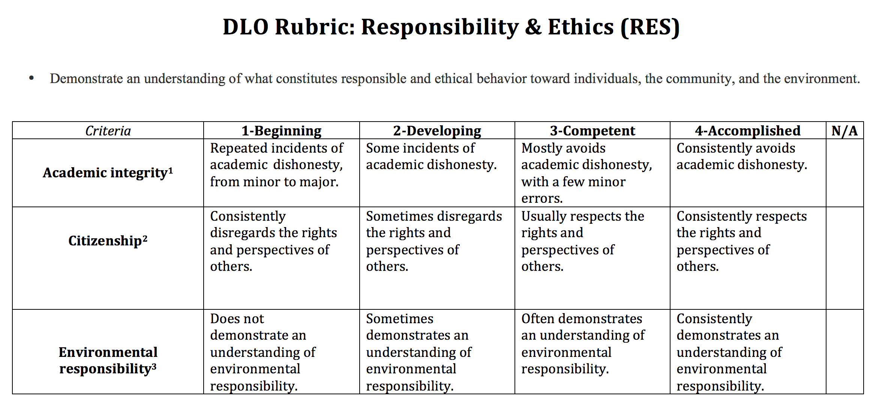
The CLAC committee began collecting student work for the Responsibility & Ethics DLO in winter quarter of 2019 and continued through fall quarter. The collection process began with an all-faculty email requesting assignments that aligned with the RES DLO to be submitted by completing a short survey. The survey collected pertinent information such as instructor name, course information, assignment name, instructions, and due date.
In collaboration with e-Learning, a Canvas shell for the RES DLO was created and all artifacts were uploaded to the shell to be scored using the RES rubric and to act as a repository of student work for potential future assessment projects. As much as possible, artifacts were anonymized, removing student names and ID numbers. Only those faculty scoring artifacts, CLAC members, and e-Learning have access to these Canvas shells.
Twelve assignments were submitted for RES assessment representing three divisions (Health, Business, and Professional Services, Math, Science, and Engineering; and Written and Oral Communications). The assignment submissions resulted in 276 individual artifacts submitted for scoring.
In winter quarter 2020, the CLAC committee invited faculty from across campus to participate in the scoring process. Eight faculty from four campus divisions volunteered to score the student artifacts. Scoring was completed during spring quarter 2020 using the RES rubric.
Of the 276 individual student artifacts, 217 individual artifacts were scored, approximately 79% of the total.
All of the faculty who scored artifacts participated in a norming session prior to receiving their assignments to ensure that the criteria was clear and that all were applying the rubric in roughly the same way. Scores for each criterion for every artifact were transferred into an Excel spreadsheet and analyzed.

Results

All Data
On a scale of 1 to 4, where 1 is the lowest and 4 the highest, the average score for all criteria was 3.11, which places students between the competent and accomplished levels. The highest average score was for the Citizenship criterion at 3.41, followed by Academic Integrity at 3.13, then Environmental Responsibility at 2.80.

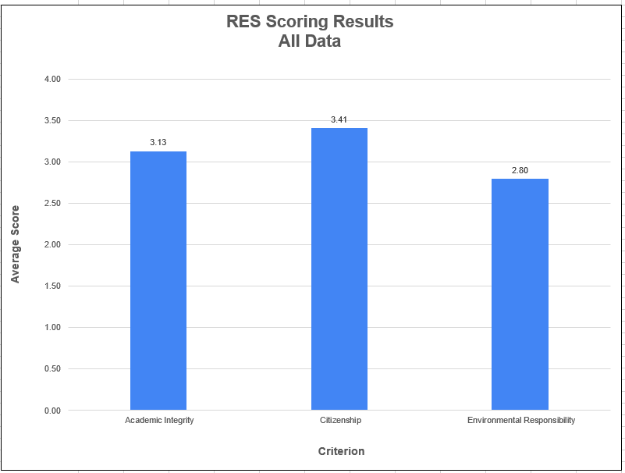

100-Level:
A total of 150 artifacts from 100-level classes were included in the sample. The average for all criteria for these artifacts is 3.08, slightly lower than it is when all artifacts are combined. The highest average score for the 100- level artifacts was Citizenship at 3.43, followed by Academic Integrity at 3.11, and finally Environmental Responsibility at 2.71.
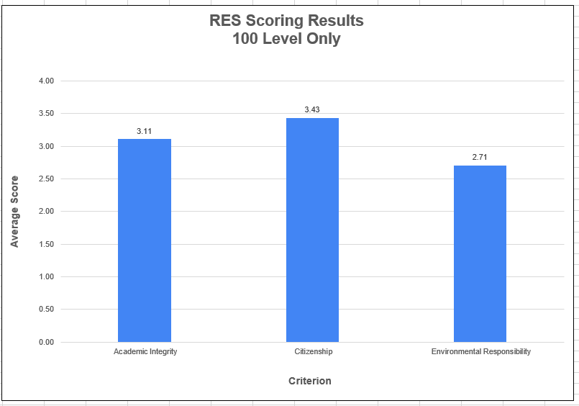

200-Level:
A total of 66 artifacts from 200-level classes were included in the sample. The average for all criteria for these artifacts is 3.23, which is higher than when all artifacts are combined. The highest average score was Citizenship at 3.36, followed by Academic Integrity at 3.20, then Environmental Responsibility at 3.14.
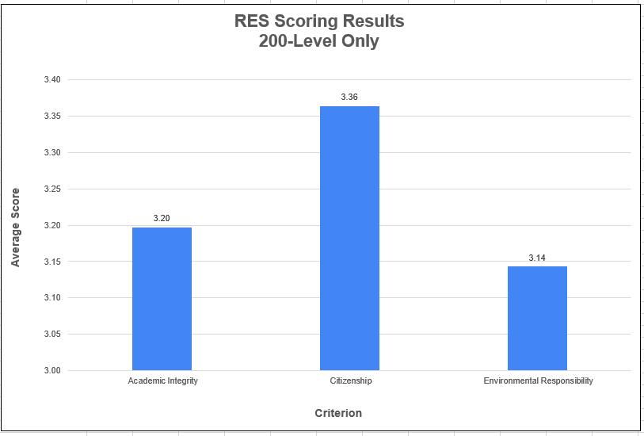

NOTE: Only one of the 200-level assignments measured the Environmental Responsibility criterion; thus, there is likely not enough data to generalize.

Professional-Technical Programs:
A total of 45 artifacts from the Professional-Technical programs were included in the sample. The average for two of the three criterion was higher than the average for all artifacts combined. The artifacts submitted did not measure the Environmental Responsibility criterion. The highest average score was again for Citizenship at 3.67, followed by Academic Integrity at 3.36.
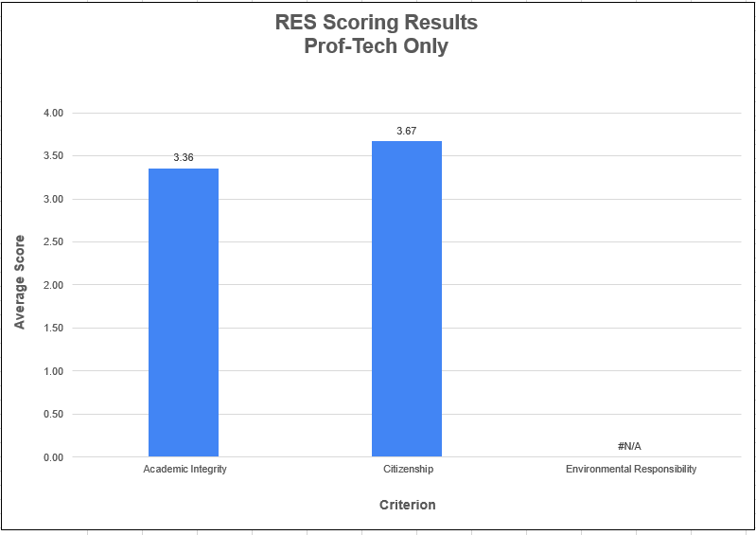
NOTE: Due to the low number of artifacts, there is likely not enough data to generalizable. The Environmental Responsibility criterion was not measured.

All except Professional Technical:
When Professional-Technical artifacts are removed, the average for all criteria for the remaining 171 artifacts is 3.07, slightly lower than it is when all artifacts are combined. The highest score is still Citizenship at 3.34, followed by Academic Integrity at 3.08, then Environmental Responsibility at 2.08.
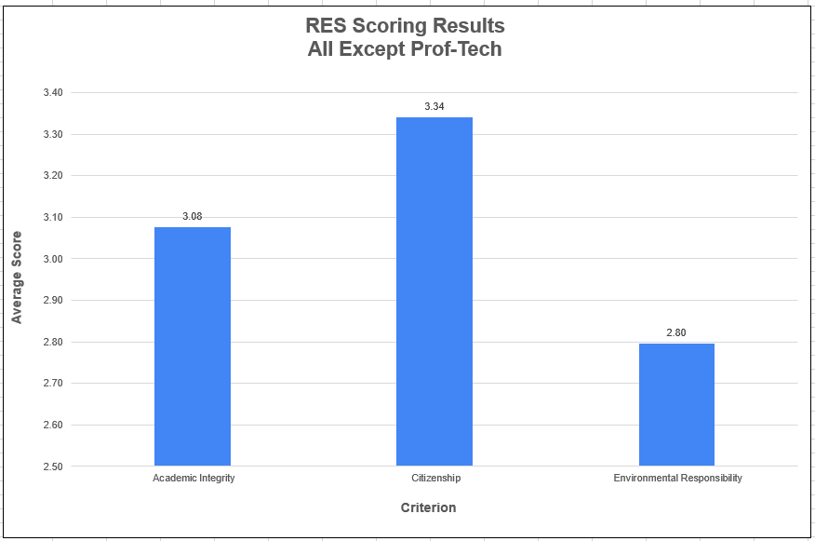

Limitations
No statisticians served on the committee, thus no inferential statistical techniques were used for analysis. CLAC welcomes any assistance with data analysis in the future.
The Canvas LMS works well as a repository and to facilitate scoring of artifacts using a rubric, but it does not provide tools for the analysis of individual rubric criterion. Thus, significant time and effort went into the manual data entry of individual criterion scores into MS Excel.
Only twelve assignments were submitted by faculty to assess this DLO and not all campus divisions were presented. In addition, very few of the submitted assignments measured the Environmental Responsibility criterion. Thus it is likely that there is not enough data for the RES DLO assessment to be generalizable.

Discussion
No direct comparisons can be made with previous assessment work because the 2015 assessment utilized a student survey approach rather than a rubric approach. However it can be noted that in the 2015 assessment, the Individual and Community elements of the RES DLO were met while the Environment element was not. This is a similar result to the current RES DLO assessment.
Recommendations made in 2015 included generating a larger sample size, and creating a syllabus template that clearly defines academic dishonesty. Both of these recommendations have been met. This sample size of 276 was more than double the 2015 size, however, it did not represent all divisions on campus. A syllabus template was recently created by a taskforce, and is scheduled to be implemented campus-wide in the 2020/21 academic year.
The 2015 assessment noted that there was no campus-wide, universal community effort to support the achievement of the environmental responsibility element of this DLO. Nor did the college’s mission, vision, or strategic plan mention environment at the time. The colleges new 2020-2025 strategic plan addresses environmental responsibility through its value statements and core themes. The Responsibility Value states in part “We lead by example through the practice of environmental, institutional, and personal sustainability”. Core Theme #4: Enhancing Institutional Vitality’s second goal states “We promote sustainable practices” and this is done by strengthening environmental sustainability practices. With the inclusion of environmental responsibility in the new strategic plan, a stronger emphasis can be anticipated in the future.
For the current assessment, data was sorted in a variety of ways to provide a snapshot of student achievement and identify possible areas of opportunity.
While the scores vary depending on how the data is sorted, Citizenship is generally the criterion on which students score the highest, while Environmental Responsibility is often the lowest (in the instances that it was measured). Nevertheless, the average score for all criteria was 3.11 placing students between the competent and accomplished levels. Given that these skills are developed iteratively over time and students will continue to apply and develop these skills throughout the remainder of their time at TCC, these scores seem appropriate.

Recommendations
Continue to increase the sample size and ensure that samples are representative of all campus divisions.
For the most part, the verbiage of the RES DLO and its rubric was effective. However, since many assignments did address environmental responsibility, consider forming a taskforce to identify additional ways faculty can include this element in their course assessment.
Faculty are encouraged to use this report to help inform curriculum revisions in their classes/program or to as a starting point in creating their own assessment project around RES.

